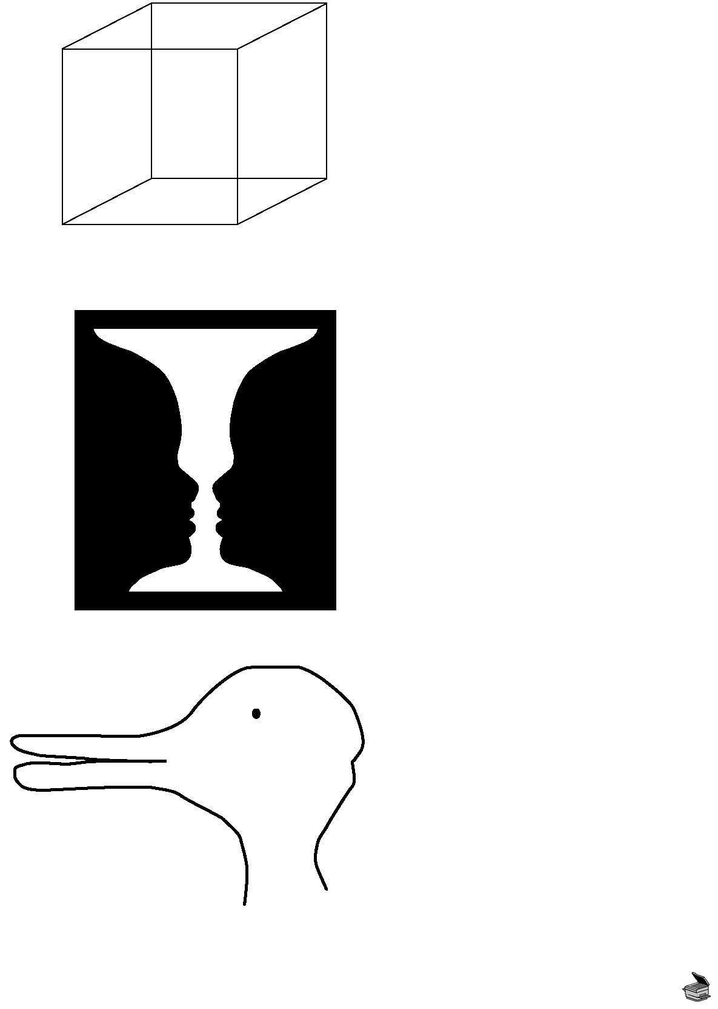
Copyright © 2012 May be reproduced for classroom use only. McGraw-Hill Ryerson Limited. ISBN: 9780070739673
Optical Illusions
How do these images challenge empiricism and point toward social constructionism in the formation of knowledge?
Necker Cube

Rubin’s Vase

Jastrow’s Duck-Rabbit

BLM 11.3

