• Academic versus applied learners | • Gifted students
• English-language learners | • ADHD
• Behavioural students | • Learning disabled
• Talented athletes | • Ontario scholars
• University/College/Workplace | • Are there other categories you can think of?

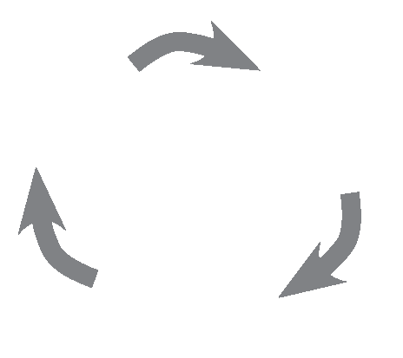

Labelling Students
In his essay “Making Up People,” Canadian philosopher Ian Hacking (1936– ) draws on Foucault, Heidegger, and Wittgenstein to consider how certain categories for people arise in history, giving us an historical ontology that tries to overcome the long-standing divide between nominalism and realism (see textbook page 285). Sometimes, we invent a category, such as Attention Deficit Hyperactivity Disorder (ADHD), which requires the collection of data by identifying specimens that satisfy the criteria for membership in the set. The process establishes a feedback loop whereby we produce numerous cases all of a sudden, giving rise to what seems like an epidemic. Finding more candidates validates the original designation and diagnosis.

Questions:
1. Consider the categories or labels we use in education today (see below). Which of the following categories do you think actually exist, and which are discursively made up?
disrupted sleep increases fatigue
fatigue diminishes ability to cope with stressors in a healthy way
inability to cope with stressors disrupts sleep
BLM 12.2
Copyright © 2012 May be reproduced for classroom use only. McGraw-Hill Ryerson Limited. ISBN: 9780070739673

2. What is the evidence that corroborates the existence of these categories and education? How would you justify your claim to knowing they exist as discrete or real categories?
3. Do you have, or need to have criteria for membership in these conceptual categories? (See textbook page 307 on the role of criteria in critical thinking.)
4. Considering Hacking’s essay title, “Making Up People,” can you explain how epistemology again overlaps with ontology?

This is a visual example of a feedback loop in sleep deprivation. Can you draw a visual feedback loop that demonstrates the labelling of students by placing them in categories?

