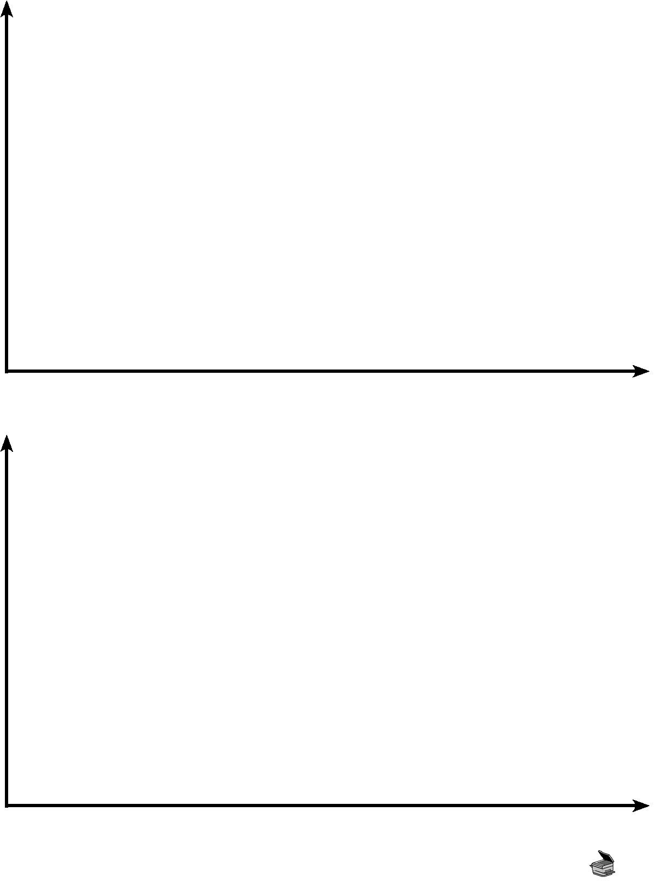
Graphing Scientific Progress
Use the two blank graphs below to carry out the exercise described in Figure 13-7 (on page 332 of your textbook). Be prepared to defend your graph(s), explaining the slope or movements of the line with examples drawn from history.

Copyright © 2012 May be reproduced for classroom use only. McGraw-Hill Ryerson Limited. ISBN: 9780070739673
scientific knowledge
scientific knowledge
time
time
BLM 13.5

