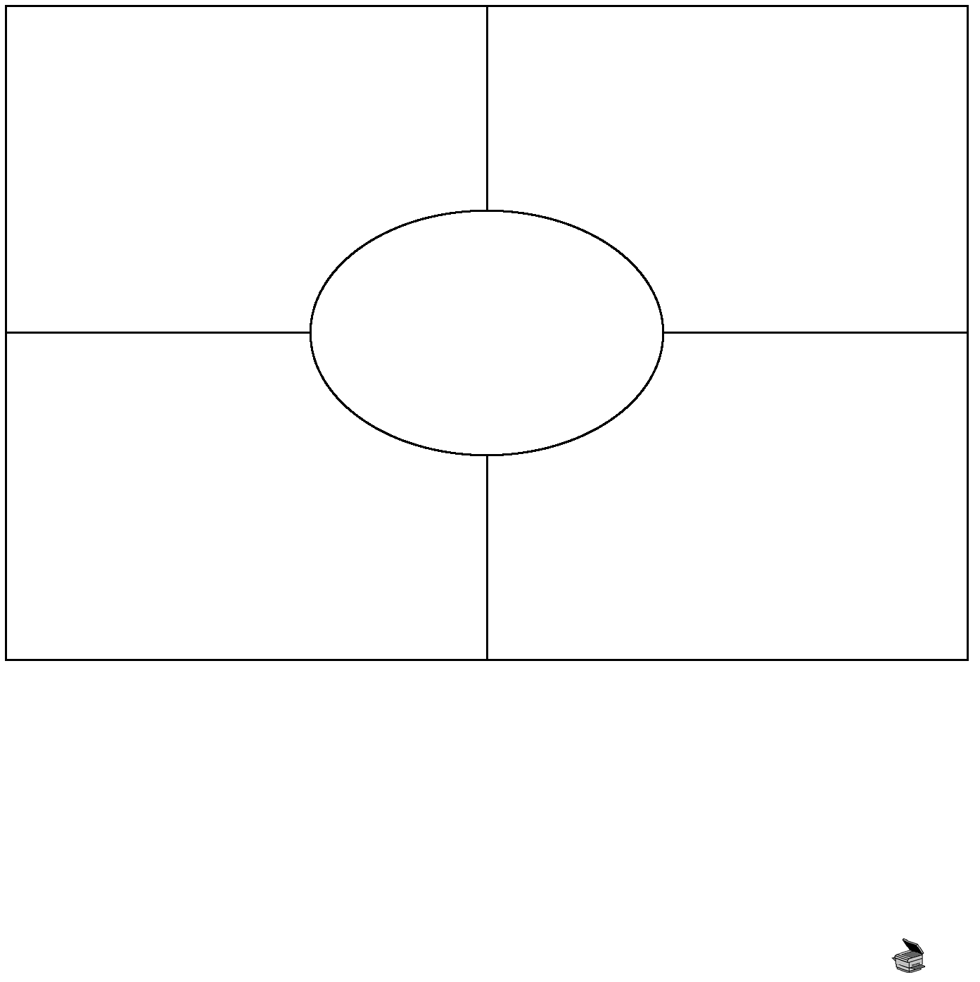
Copyright © 2012 May be reproduced for classroom use only. McGraw-Hill Ryerson Limited. ISBN: 9780070739673
Four-Corners Debate: Theories of Art
Debate this question: Which theory of art applies best to Kandinsky’s Black Lines (Figure 19-4, on page 473 of your textbook)?
Instructions: Use this organizer to help you prepare for the debate. First, write down a description of each theory in the boxes provided (see pages 476-478 of your textbook to read about these four aesthetic theories). Next, consider what aspects the theories have in common. Write these common attributes in the centre of the diagram.
Formalism Representationalism

Expressionism Institutionalism

Reflection: After the debate, which theory do you think fits the painting best? When you changed paintings, did the theory you selected still fit? With which theory (and painting) do you feel the greatest affinity? Is it possible to use more than one theory on a single work of art without running into contradiction (antithesis)?

BLM 19.2

