Copyright © 2012 May be reproduced for classroom use only. McGraw-Hill Ryerson Limited. ISBN: 9780070739673
BLM D
Initial thesis (stance/position): ____________________________________________
______________________________________________________________
______________________________________________________________
______________________________________________________________
Main arguments (premises), supporting evidence, thinkers, and theories:
1. ______________________________________________________________
______________________________________________________________
______________________________________________________________
2. ______________________________________________________________
______________________________________________________________
______________________________________________________________
3. ______________________________________________________________
______________________________________________________________

What are your conclusions?
What are your conclusions? ______________________________________________
______________________________________________________________
______________________________________________________________
______________________________________________________________
Revised or modified thesis (if necessary): _____________________________________
______________________________________________________________
______________________________________________________________
______________________________________________________________

Argument Builder
Use the outline approach (A) and/or the mental map approach (B) to assist you in developing an argument.
A. Outline Approach
Topic sentence: ______________________________________________________

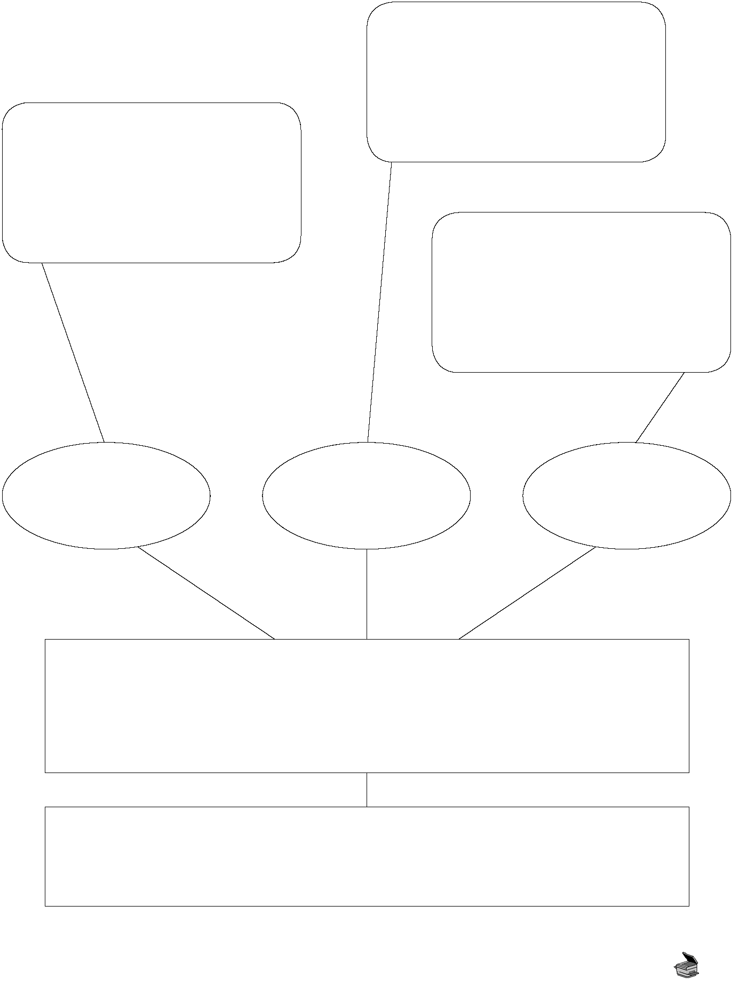
BLM D Continued
Copyright © 2012 May be reproduced for classroom use only. McGraw-Hill Ryerson Limited. ISBN: 9780070739673
Thesis (stance/position)
Topic sentence
B. Mental Map Approach
Supporting ideas or claims
Associated thinkers/philosophers

