Canada’s Population in 2000 by Age and Gender

Population Pyramid Summary for Canada
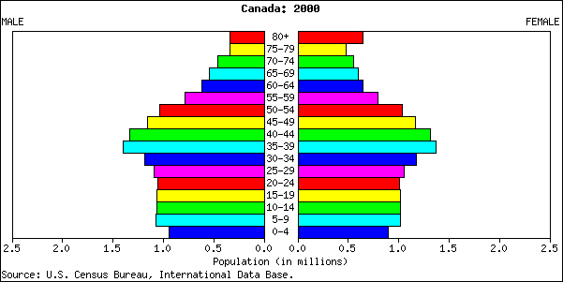

a) What does the distribution tell you about the population?

b) Why might city planners or a town council be interested in this information? Explain.

c) Approximate the mean and the median age for each gender.

