Logical Logarithms

When you use exponential equations, you might work with values that are either very large or very small. In an exponential equation, the exponent changes. In cases where the exponent does not change but the base changes, you work with a logarithmic equation.

The inverse of an exponential function, y = b^{x}, is x = b^{y}. This function can be written as a logarithmic function, y = log_{b} x.

Questions
1. What are the domain and range of a logarithmic equation?

2. Identify three examples of
a) an exponential function
b) a logarithmic function

3. Change the following exponential equations into logarithmic form.
a) 2⁴ = 16 c) 5⁴ = 625 e) 3^{–2} =
b) = 10 d) 10^{–3} = 0.001 f) 10⁰ = 1

4. Change the following logarithmic equations into exponential form.
a) log₃ 81 = 4 c) log 0.1 = –1 e) log₈ = –2
b) log 100 = 2 d) log₈₁ 9 = f) log₃ 81 = 4

___________________________________________________________________

You can graph exponential and logarithmic equations as shown.
logarithmic equation with a base of 2
f(x) = log₂ x
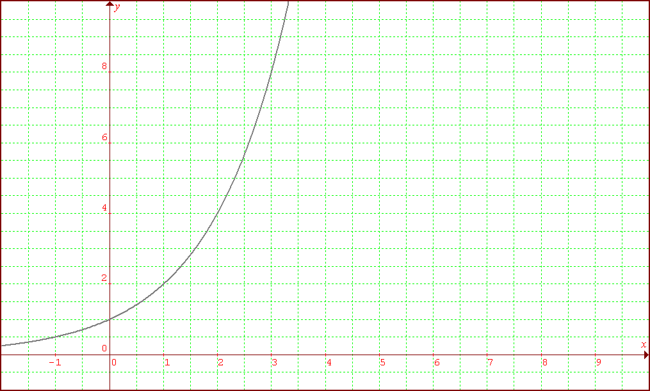
f(x) = 2^{x}

exponential equation with a base of 2

  - In the first graph, every time the x-value, or exponent, increases by 1, the y-value doubles.

Question

5. In the second graph, when x = 2, the value of the function equals 1. Why?

___________________________________________________________________

A logarithm is simply a different way of writing an exponent. When working with logarithms, keep in mind the basic features of exponential functions.

Questions

6. Indicate which of the following logarithmic expressions are defined. For those that are not defined, state the reason.
a) log (–100) = x e) log₀ 1 = x
b) log₂ 1 = x f) log 10 = 1
c) log _{–5} 125 = x g) log₅ 0 = x
d) log₁ 10 = x h) log₃ 1 = 0

7. Solve each logarithmic equation. Identify the equivalent exponential equation for each question.
a) log₂ 8 = d) log =
b) log₄ 1 = e) log₂₅ 5 =
c) log 10 000 = f) log₇ =

