College Technology 12 Final Exam Answers

1. B
2. A
3. C
4. D
5. B
6. D
7. A
8. A
9. D
10. D
11. B
12. sin 225° = ; cos 222° = ;
tan 225° = 1
13. a) 55° b) 77° c) 72°
14. a) 18.5 m b) 30.6 cm c) 14.7 km
15. a) 4 b) 120º
c) 40º to the right d) 2 up
e) {x} f) {x, –2 ≤ y ≤ 6}
16. a) 70.9 N
b) 20.3° counterclockwise from the horizontal
17. a) S70ºW b) 160º
18. a) b) 25
19. −4
20. a) 4 b) −5
21. log₂64 = 6
22. a) 3 b) negative
c) As x −∞, y ∞, and as x ∞, y −∞.
d) The third differences are equal.
e) domain: {x}; range: {y}
23. 13
24. 10x + 24
25. 1.9 Canadian gallons
26. a) sin = , cos = ,
tan =
b) 129˚
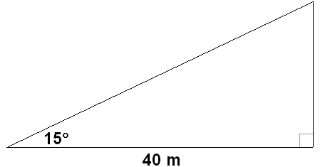
27. a)

b) Yes. The vertical distance from the water level of the river to the underside of the bridge is approximately 10.7 m. The height of the mast is 10 m. The clearance will be approximately 0.7 m.
28. A = 85.9°; B = 54.7°; C = 39.4°
29. a) Vertically stretched by a factor of 2; horizontally compressed by a factor of ; shifted horizontally 30˚ left; shifted vertically 1 down
b) period: 120˚; amplitude: 2;
phase shift: 30˚ left; range:
{x, –3 ≤ y ≤ 1}
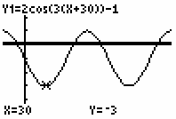
c)

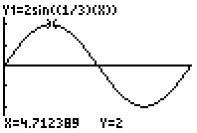
30. a)

period: 1080˚; amplitude: 2; no phase shift; no vertical shift

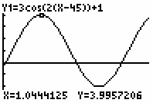
b)

period: 180˚; amplitude: 3; phase shift: 45˚ right: vertical shift: 1 up
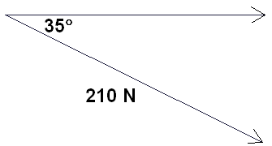
31. a)

b) 172.0 N
c) 120.5 N
32. a) 345.4 km b) S75.8˚E
33.
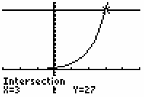
34. a)

b) −1
35. a) A = 2000(1.0225)^{2t}
b) $2389.66
c) Yes
d) No
36. odd; f(−x) = −f(x)
37. a) cubic b) third differences
c) 13 000 d) 13 500

38. a) 4x³y²(x – 4y³)
b) (x + 2)(x – 10)
c) (4a + 5b)(2a − 3b)
d) (d + 5)²
e) 3m(m + 2)(m − 3)
f) (4x + 9y)(4x – 9y)
39. a) length: x + 4; width: x + 3; height: x
b) length: 8 cm; width: 7 cm; height:
4 cm
40. a) x = –6, x = –2
b) a = , a =
c) m = , m =
41. a) 3
b) as x −∞, y −∞, and as x∞,
y ∞
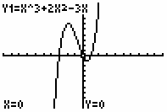
c) x-intercepts: −3, 0, 1; y-intercept: 0
d)

42. a) 100.5 cm³
b) 7.6 m
43. a) 40.8 cm
b) 589.0 cm²
44. 10 cm
45. $244.95
46. 0 km/h. The resultant vector has a magnitude of 0.

