College Technology 12 Final Exam

Multiple Choice
Circle the best answer for each of the following questions.
1. If cos = , then
A sin = B sin =
C sin = D sin =

2. The period of the function
f(x) = 3 cos + 1 is
A 180° B 120° C 30° D –30°

3. Joshua runs 24 m to the east, and then
7 m to the south. The magnitude of the displacement vector of his run is
A 5 m B 17 m C 25 m D 31 m
4. (2x³y⁵)(−3x²y⁴) is equal to
A 5xy B x⁶y²⁰
C −x⁵y⁹ D −6x⁵y⁹

5. If 9^{4x + 2} = 3^{2x – 3}, then the value of x is
A B C D

6. The function f(x) = 2x³ − 1
A has point symmetry about the origin
C has line symmetry about the x-axis
B has line symmetry about the y-axis
D has neither point symmetry nor line symmetry

7. If f(x) = 3x⁴ – 2x³ + 4, then x = −3 is equal to
A 301 B 185 C –185 D –455

8. The function y = 2(x – 3)³ intersects the
x-axis
A once
B twice
C four times
D does not intersect the x-axis

9. The real roots of the polynomial function
f(x) = x³ + 5x² – 14x are
A 0, 2, 7 B −2, 1, 7
C −2, 0, 7 D −7, 0, 2

10. IfACB and ADB are two inscribed angles that are both subtended by the same chord, AB, as shown in the diagram below, then

A ACB + ADB = AOB
B ADB = AOB
C BCA = BDA
D A, B, and C are all true.

11. The magnitude of perpendicular vectors is
A always the same
B sometimes the same
C never the same
D zero

Short Answer
Write answers to each of the following questions.

12. State the exact values of the three primary trigonometric ratios for 225°.

13. Use a calculator to find each value of to the nearest degree, where 0º ≤ ≤ 90º.
a) sin = 0.8143
b) cos = 0.2175
c) tan = 3.1246

14. Determine the length of the indicated side, x, for each of the following triangles. Round to one decimal place.
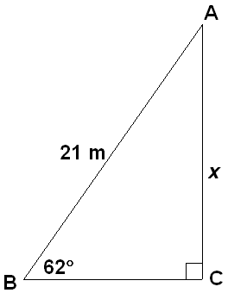
a)

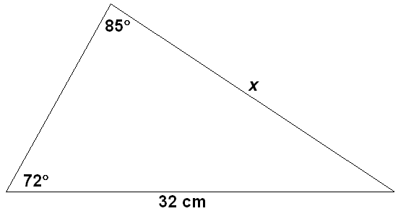
b)

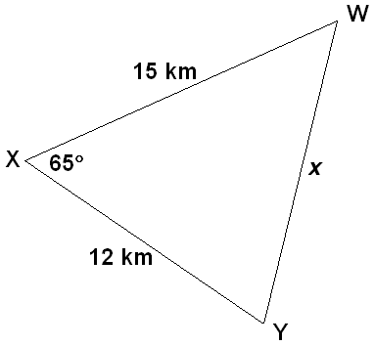
c)

15. Consider the function
y = 4 sin [3(x − 40º)] + 2.
State the
a) amplitude
b) period
c) phase shift
d) vertical shift
e) domain
f) range

16. Two vectors, and , are placed head-to-tail as shown in the diagram.

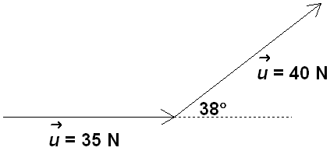
a) Determine the magnitude of the resultant vector, + , to the nearest tenth of a newton.
b) Determine the direction of the resultant vector, + , to the nearest tenth of a degree.

17. a) Express 250° as a quadrant bearing.
b) Express S20°E as a true bearing.

18. Evaluate each of the following. Express your answers as fractions in lowest terms.
a)
b)

19. If 5^{–x} = , determine the value of x.

20. Evaluate each of the following.
a) log₄ 256
b) log₃

21. Write 2⁶ = 64 in logarithmic form.

22. Consider the polynomial function
f(x) = −2x³ + 4x² − 3x + 5.
a) State the degree of the function.
b) State the sign of the leading coefficient
of the function.
c) What can you determine about the end behaviour of the function from the degree of the function and the sign of the leading coefficient of the function?
d) What do you know about the values of the third differences for this function?
e) State the domain and range of the function.

23. Evaluate f(x) = 4x³ − 5x² + 2x – 3 for x = 2.

24. The area of a rectangle is given by
f(x) = 6x² + 31x + 35. Determine an expression for the perimeter of the rectangle.

25. A cylindrical flower vase has a diameter of 20 cm and a height of 30 cm. Calculate the volume, in Canadian gallons, of the water in the vase if it is filled to a depth of 28 cm. Round your answer to the nearest tenth of a Canadian gallon.
(Note: 1 L = 1000 cm³;
4.546 09 L = 1 Canadian gallon)

Extended Response
Write complete solutions to each of the following questions.

26. The point (−4, 5) is a point on the terminal arm of angle in standard position.
a) Determine the exact primary trigonometric ratios of .
b) Determine the measure of angle to
the nearest degree.

27. A point at water level is 40 m away from a point on the river directly below a horizontal bridge over the water. The angle of elevation to the underside of the bridge is 15˚.
a) Draw a diagram to represent this situation.
b) If the vertical height from water level to he highest point of a sailboat is 10 m, will the sailboat have at least 0.6 m in clearance? Justify your answer.

28. Solve ∆ABC, shown in the diagram. Round to the nearest tenth of a degree.
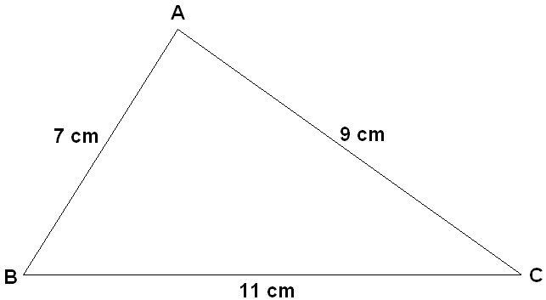

29. a) Describe the transformations on
f(x) = cos x that would result in
g(x) = 2 cos [3(x + 30˚)] − 1.
b) State the period, amplitude, phase shift, and range of g(x).
c) Graph g(x) showing two complete cycles.

30. Sketch one cycle of each of the following functions. State the period, amplitude, phase shift, and vertical shift.
a) y = 2 sin x
b) y = 3cos [2(x − 45°)] + 1

31. Nikola is pushing on the handle of his sister Dana’s stroller with a force of 210 N acting 35˚ below the horizontal.
a) Draw a diagram to illustrate this situation.
b) Determine the magnitude of the force pushing the stroller horizontally, to the nearest tenth of a newton.
c) Determine the magnitude of the force pushing the stroller vertically, to the nearest tenth of a newton.
32. A small SUV (sports utility vehicle) travels southeast at 80 km/h for 1.5 h and then east at 100 km/h for 2.5 h.
a) Determine the magnitude of the SUV’s displacement, to the nearest tenth of a kilometre.
b) Determine the quadrant bearing of the car, to the nearest tenth of a degree.

33. Evaluate . Express your final answer as a fraction in lowest terms. Show your steps.

34. a) Solve 3^{x} = 27 graphically. Check your answer.
b) Solve 64^{3x – 1} = 16^{2x – 4} algebraically. Check your answer.

35. An investment of $2000 earns 4.5% interest, compounded semi-annually.
a) Write an equation to model the amount, A, that the investment is worth as a function of the time, t, in years.
b) How much will the investment be worth after 4 years?
c) If you triple the initial investment, does the final amount also triple? Show your work.
d) If you leave the investment for triple the time, does the amount of interest also triple? Show your work.

36. Determine algebraically whether the function f(x) = 2x³ + 5x is even, odd, or neither. Explain how you know.

37. The population, P, of a town can
be modelled by the function
P(t) = 2t³ − 4t² +70t + 13 000, where
t is the time, in years, from the present.
a) What type of function is P(t)?
b) Which finite differences are constant for this polynomial function?
c) What is the population of the town now?
d) What will the population of the town be in 5 years?

38. Factor each of the following expressions completely.
a) 4x⁴y² – 16x³y⁵
b) x² − 8x − 20
c) 8a² − 2ab −15b²
d) d² + 10d + 25
e) 3m³ − 3m² − 18m
f) 16x² – 81y²

39. The volume of a wooden box is modelled by the polynomial expression x³ + 7x² + 12x, with the height of the box being the shortest dimension.
a) Determine expressions for the length, the width, and the height of the wooden box.
b) Determine the dimensions of the wooden box if x is 4 cm.

40. Solve each of the following.
a) x² + 8x + 12 = 0
b) 8a² – 14a – 15 = 0
c) 6m² − 5m − 4 = 0

41. Consider the function f(x) = x³ + 2x² – 3x.
a) State the degree of the polynomial function.
b) Determine the end behaviour of the function.
c) Determine the intercepts of the function algebraically.
d) Use the information from the above to sketch a graph of the function.

42. The formula V = πr²h is used to determine the volume, V, of a cone with radius r and height h.
a) Determine the volume of a cone with radius 4 cm and height 6 cm. Round your answer to the nearest tenth of a cubic centimetre.
b) Determine the height of a cone with volume 200 m² and radius of 5 m. Round your answer to the nearest tenth of a metre.

43. a) Determine the length of the arc of a circle with radius 18 cm and a central angle of 130°. Round your answer to the nearest tenth of a centimetre.
b) The central angle of a sector of a circle with radius 30 cm is 75°. Determine the area of the sector. Round your answer to the nearest tenth of a square centimetre.

44. The distance from the centre of a circle to a point outside the circle is 26 cm. The length of the tangent drawn from this point to the circle is 24 cm. What is the length of the radius of the circle?

45. Kim is planning to paint the outside walls of her garage. The length of the garage is 22 ft, the width is 12 ft, and the height of the walls is 9 ft. She will not paint the door, which is 7 ft by 10 ft. There are no windows. She would like to use 2 coats of paint. Each
can of paint that she buys will cover approximately 24.5 m², and the cost for one can of paint is $48.99. Determine the total cost, before taxes, for the number of cans of paint she will have to purchase.

46. Greg cycles 20 km from his house in Kingston to Sydenham, then 10 km to Harrowsmith, and finally 30 km back to his house in Kingston, all in a total of 1 h. Determine his average velocity for the trip. Justify your answer.

