Chapter Test Answers

Chapter 1 Test

1. C
2. a)
b) –
c) –1
3. a) 0.9397
b) –0.9063
c) –0.3640
4. a) sin θ = , cos θ = –, tan θ = –
b) θ = 141°
5. Example: The triangle associated with
(180° + A) would be the same as that for A,
but it would be in quadrant II or III, where
the value of the cosine is negative.
So, cos (180° + A) = –0.2463.
6. a) quadrants I or II
b) quadrants II or III
c) quadrants I or III
7. a) quadrants I or IV
b)
c) sin β = , tan β =
8. a) 135° or 315°
b) 135° or 225°
c) 60° or 120°
9. 2.3 m
10. a) i) 5.6713
ii) 11.4301
iii) 57.2900
b) Example: As the angle gets closer to 90°, the tangent of the angle becomes very large.
c) For angles close to 90°, the opposite side, y, approaches 1, while the adjacent side, x, approaches 0. When the angle becomes 90°,
tan 90° = , which is not defined.
11. a) 52° or 128° b) 100° or 260°
c) 165° or 345°
12. a) 7.7 m b) 43.9 cm

13. 37°
14. a)
70°
45°
100 m
B
A

b) 63.6 m
15. When given all three sides of a triangle, use the law of cosines to determine an angle. When given two sides and the angle contained between them, use the law of cosines to determine the side opposite the angle.
16. The cars are 142.6 km apart.
?
200 km
160 km
45°
17. a)
b) 63°
18. Q = 110°, p = 39.9 m, r = 51.3 m.

19. a)
tee
tee
hole
hole
50 yd
50 yd
250 yd
250 yd
10°
10°

b) Example: The ball could be 50 yd short of the hole or 50 yd past the hole. The information given causes an ambiguous case triangle: the angle at the second shot and the distance from the tee to the hole are unknown. Therefore, there are two possible triangles that match the given information.
c) 271.0 yd or 221.4 yd
20. a)
20°
45°
30°
20 m
cat
dog
firefighter
90°
90°
b) 23 m

Chapter 2 Test

1. B
2. a)
x | y = cos x
0° | 1
30° | 0.8660
60° | 0.5
90° | 0
120° | –0.5
150° | –0.8660
180° | –1

b) Example: There are no duplicates but the values for angles between 90° and 180° are opposite of those from 0° to 90°.
c) Example: The values will be the same, but may be opposite. Values in quadrant III will match those in quadrant II, while those in quadrant IV will match those in quadrant I.
d) Example: The values for angles from 0° to 360° would begin to repeat for angles greater than 360°.
e) Example: One full cycle of each graph is produced when the terminal arm goes once around the circle, through an angle of 360°.
3. a) 0°, 180°, 360°
b) 90°
c) 270°
4. a) 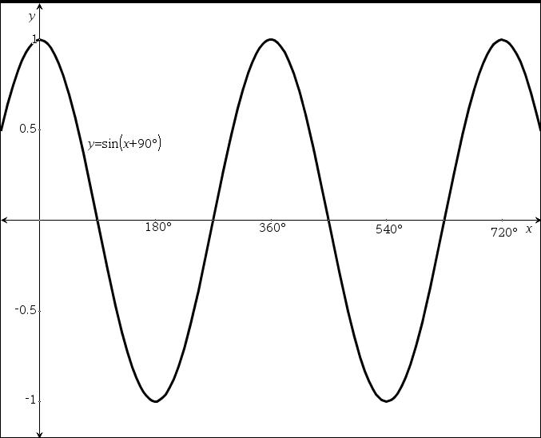
b) y = cos x. Example: The sine and cosine functions are identical, except they differ by a horizontal shift of 90°. When y = sin x shifts 90° left, it is identical to y = cos x.
5. a) 45° and 225°
b) Example: For both of these angles, the opposite (y) and adjacent (x) are equal, making the sine and cosine of these angles equal as well.
6. a) 30°, 210°, 390°
b) These three points can be the beginning, end, and middle of one full cycle of the graph, making it easy to fill in between them and then extend the graph.
7. a) period: 180°; amplitude: 5; phase shift: 45° to the right
b) Example:
Step 1: Use the phase shift to plot the first point at (45°, 1).
Step 2: Use the period to plot the end of one full cycle, 180° right of the point from Step 1. The point will be (225°, 1).
Step 3: Plot the point midway between the two points already plotted.
Step 4: Draw one full cycle of the graph.
Step 5: Stretch it vertically by a factor of 5 or simply change the vertical scale.
Step 6: Extend the graph to the left and right.

8. a) h = 9 sin x
b) h = 9 sin x + 10
9. a) Example:
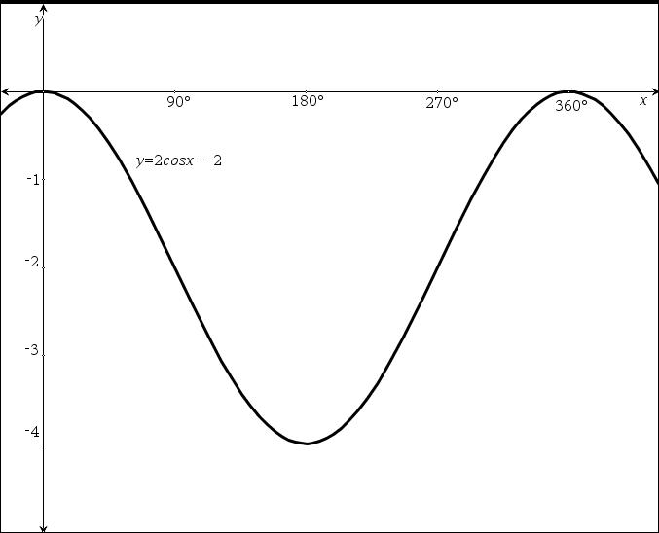
b) Example: y = 2 cos x – 2

c) Yes. Equations showing horizontal shifts and/or reflections in the x-axis will also work. However, the amplitude must be 2 and the vertical shift must be 2 down.
10. y = 4 sin [2(x + 60°)] + 3 or
y = 4 sin (2x + 120°) + 3
11. a) Both are cosine functions; both have been stretched vertically by a factor of 5, giving an amplitude of 5; neither has a horizontal or vertical shift.
b) The graph of f(x) has been compressed horizontally by a factor of 2, giving a period of 180°. The graph of g(x) has been stretched horizontally by a factor of 2, giving a period of 720°, and g(x) has been reflected in the x-axis.
c)
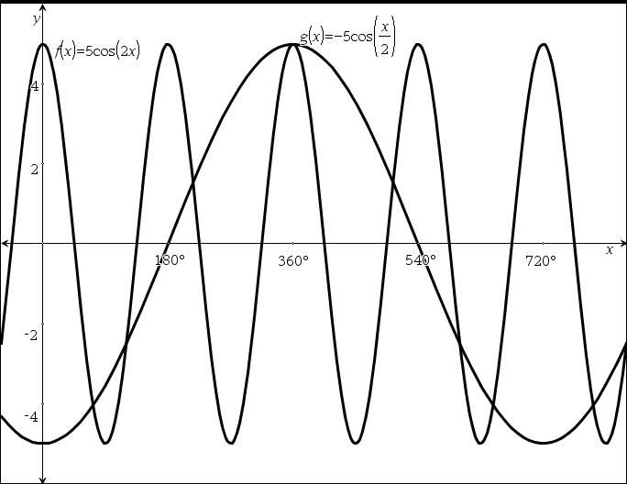
12. a) i) period: 180°, amplitude: 5, horizontal shift: 45° right, vertical shift: 1 up, range:
{y | –4 ≤ y ≤ 6}
ii) 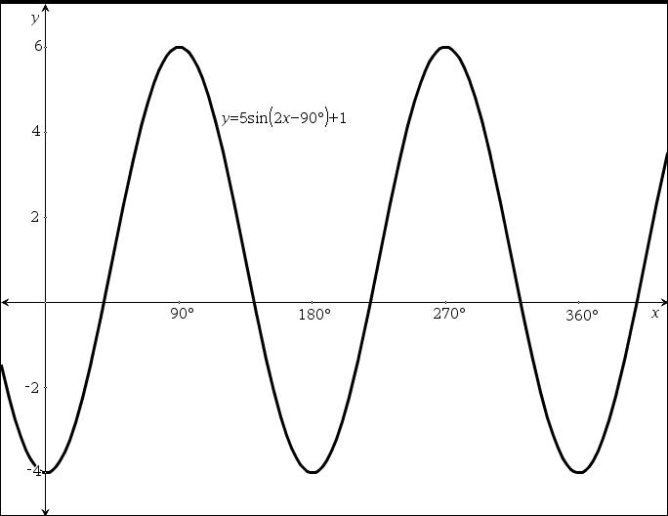
b) i) period: 1080°, amplitude: 3, horizontal shift: none, vertical shift: 2 down, range:
{y | –5 ≤ y ≤ 1}
ii) 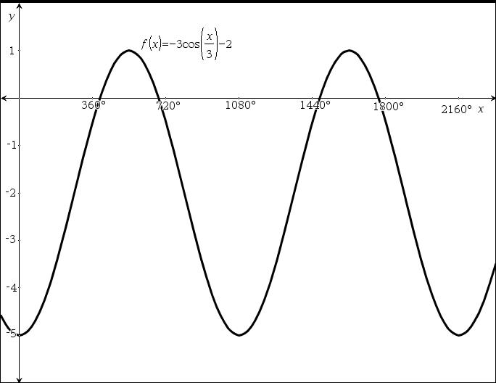
13. a) 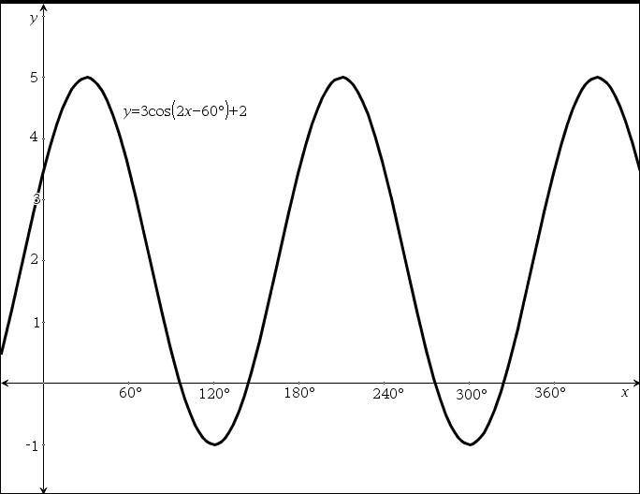
b) y = 3cos (2x – 60°) + 2 or
y = 3cos [2(x – 30°)] + 2
14. a) Example: The amplitude of the graph would increase. A louder sound has waves that cause more movement in a receiver (like an eardrum or stereo speaker). This happens because the difference between the maximum (or top of the wave) and the minimum (or bottom of the wave) is larger.
b) A higher pitch is also known as a higher frequency, or more sound waves in a given amount of time. This would result in a smaller period.
15. a) domain: {x };
range: {y | 0 ≤ y ≤ 1}
Example: Because f(x) = sin² x is the square of
sin x, the negative values all become positive. This results in the minimum y value being 0 while the maximum value is still 1.
b) 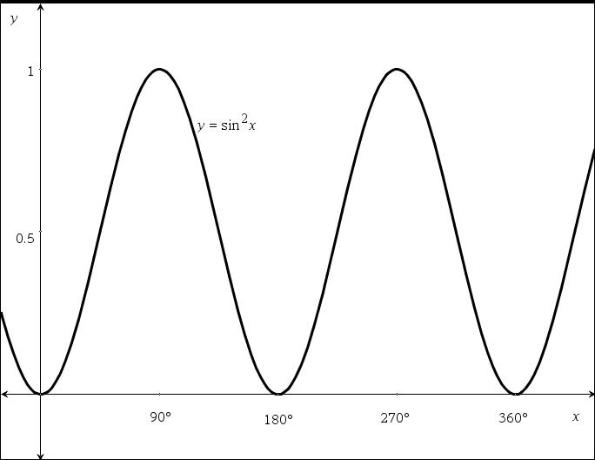
c) 180°
16. a) y = cos (360x)
b) y = cos or y = cos
c) i) 10 s
ii) 0.4 m
iii) y = 0.4 cos or y = 0.4 cos (36x)
17. Example:
a) d for days
b) One period would be 365 days because that is the length of one year. The orbit of the Earth around the Sun is what causes the change in the length of our days.
c) range: {h | 8.1 ≤ h ≤ 15.9}, where h represents the hours of daylight per day
d) 15.9 – 8.1, or 7.8, would be twice the amplitude, so the amplitude is 3.9. The vertical shift would be the midpoint between 8.1 and 15.9, so the vertical shift is 12.
e) Example: h = 3.9 cos + 12 or h = –3.9 cos + 12
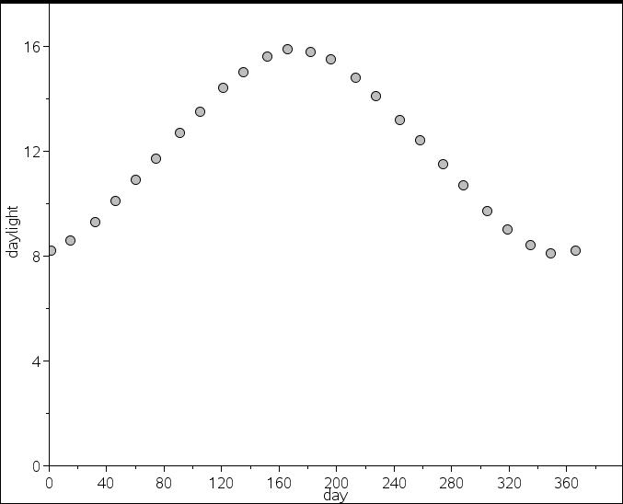

Chapter 3 Test

1. a) scalar b) vector c) scalar
d) scalar e) vector
2. a) weight b) velocity
c) displacement
3. a) S20°W b) 135°
4. False. Opposite vectors are any vectors that are opposite in direction and equal in magnitude.
5. Displacement of 20 km in the direction N40°W or on a bearing of 320°.
6. a) 25 km east b) 450 km/h south
7. a) 10.3 units b) (7, 8) c) (–3, 2)
8. a)
8 km
6 km

b) 10 km
c) quadrant bearing of N53°E or bearing of 53°
9. a)
30 km
20 km
8 km

b) 29.7 km c) N48°E
10. a) 130 km/h
b) Example: 0 km/h. The helicopter returns to its starting point, so the resultant displacement is
0 km. The resultant velocity is 0 km divided by time. This gives an average velocity of 0 km/h.

11. a) 376 km/h
b) 2280 m
12. a) 1738.7 N
b) 465.9 N
13. a)
b)
c)
d)
14. a)
= 8 km north
= 3 km east
b) 8.5 km
c) 21°
15. and have the same direction.
16. a)
20 km/h
5 km/h

b) 5 h 9 min
c) N14°W
17. a)
50 km/h

14 km/h

75°

b) magnitude: 63.6 km/h; directions: N78°E
18. a) 188.4 N
b) 16° from the direction Han is pulling
19. a) horizontal: 69 N; vertical: 190 N downward
b) The horizontal component would remain the same. The vertical component would change from 190 N to 110 N downward. This would make it easier to move the lawnmower because

instead of being pushed slightly downward,
and therefore adding to the weight of the lawnmower, the mower is being pulled slightly upward, taking weight off the lawnmower.

Chapter 4 Test

1. a) a⁶ b) b⁵ c)
d) e) 16a⁴b¹² f)
g)
2. a) 1 b) c)
d) 8 e)
3. a) b) 3a³ c)
4. a) 269.37 b) 41.57
c) 0.11 d) 8.55
5. (–5)² = (–5)(–5)
= 25
The base is –5.
–5² = (–5)(5)
= –25
The base is 5 so the negative applies after 5 is squared.
6. a) b)
7. x ≥ 0
8. 3.6 cm
9. a) {x } b) {y | y > 0}
c) (0, 1)
d) There is no value of x for which 3^{x} equals 0. Negative values of x such as –100, –1000,
–10 000, etc. result in very small values of y,
but y will never equal 0.
10. a) They are exponential functions; the asymptote is the x-axis; they all pass through the point (0, 1); all are increasing functions.
b) They have different bases; the higher the base, the steeper the graph (the value of y gets larger more quickly as x becomes large).
11. Example: Graph y = 2^{x} and y = 25 on the same set of axes. Determine the point of intersection of the two graphs; on the
TI-Nspire™ CAS, this can be done using the Trace function. The solution is the x value of the point of intersection.
12. a) A = 100 × 1.01^{n}
b) $126.97 c) 70 months
13. = 2^{–1}
Apply the exponent law:
= (2^{–1})^{x}
= 2^{–x}
Therefore, y = is the same as y = 2^{–x}.
14. a) a > 1 b) 0 < a < 1 c) a ≤ 0
15. a) V = 200 000 × 1.04^{n}
b) $648 679.50
16. a) n = 2000 × 0.9^{d}
b) 15 days
17. a) 30% b) $21 428.57
c) V = 21 428.57 × 0.7^{n} d) $605.30
e) 8.6 years old
18. a) x = 6 b) x = –4 c) x = 6
19. a) x = 5
b) The x-coordinate of the point of intersection of the graphs defined by y = 2^{x + 3} and y = 4^{x – 1} are the solution to the equation 2^{x + 3} = 4^{x – 1}.
20. a) 10³ = 1000 b) log ₂128 = x
21. a) 4 b) –2 c)
d) –2 e)
22. Example: log_{a}1 represents the exponent on base a that will result in 1. The exponent that will result in 1 is 0 (for any base greater than 0).
23. a) Take the points from the graph of y = 2^{x} and reverse the x- and y-coordinates to give points on y = log₂x. For example, (0, 1) and
(1, 2) are on the graph defined by y = 2^{x}, so (1, 0) and (2, 1) are on the graph defined by y = log₂x.
b) They are reversed. The domain of y = 2^{x} is the range of y = log₂x, while the range of y = 2^{x} is the domain of y = log₂x.
24. a) 3 b) 3 c) 2.3
25. a) n = 500 × 2^{h} b) log₂40 = h
c) 5:19 pm Monday

Chapter 5 Test

1. a) yes b) yes c) no
d) yes e) no
2. a) yes b) no c) no
d) yes e) no
3. a) domain: {x }; range: {y | y ≥ 0}
b) domain: {–2, –1, 0, 1, 2}; range:
{–8, –1, 0, 1, 8}
c) domain: {0, 1, 2, 3, 4}; range: {–4, 0, 2, 4}
d) domain: {x }; range: {y }
4. a) even degree, negative leading coefficient
b) odd degree, positive leading coefficient
5. Example: For a polynomial function, the maximum number of x-intercepts is less than or equal to the degree of the function.
6. Example: If there are no x-intercepts, it must be an even function. Every polynomial function of odd degree will go from positive to negative or vice versa and, therefore, must cross the
x-axis.
7. a) x = –10, 0, 5 b) x = 1
8. a) x = 2 b) x = –1
c) The degree is 3. As x gets large and positive, the value of y also gets large and positive. As x gets large and negative, the value of y also gets large and negative.
d)
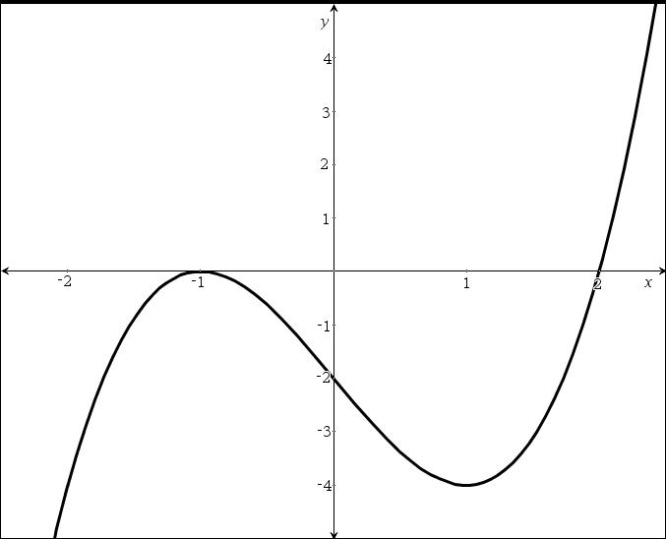
9. f(x) = ax²( x + 2)(x – 2), where a > 0. Example: The x-intercepts are –2, 0 and 2, which means x,
(x + 2) and (x – 2) are factors. Because the graph crosses the x-axis at –2 and 2, the exponent for
(x – 2) and (x + 2) is one (or another odd number). Because the graph does not cross at the x-axis at 0, the exponent for x is 2 or another even exponent.
10. a) even b) odd
c) neither d) odd
11. Example: Yes, there is a difference. For a function of odd degree, the largest exponent for the variable is odd; the graph for the function does not necessarily have any symmetry. An
odd function is symmetrical about the origin;
f(a) = –f(–a) for all values of a.
12.
x
y

13. Examples:
Method 1: Graph the function and then use the Trace function. Go to the desired x value (or type the x value) and read the corresponding y value.
Method 2: Graph the function, and then go to the Table and view the x and y values.
Method 3: Graph the function. Press CALC, then value, and type the desired x value.
14. a) (x – 5)(x + 2) b) 5(a – 3b)(a + 5b)
c) (2r – 3)² d) 25(2x – y)(2x + y)
e) (4x + 5)(3x – 8)
15. a) A(2) represents the area when the width of the sidewalk, x, is 2 m.
b) 96 m² c) 1.7 m
16. a) (x + 7)(x – 2)
b) Example: In factored form, y = x² + 5x – 14 becomes y = (x + 7)(x – 2). To determine
the x-intercepts, set y equal to 0, giving
0 = (x + 7)(x – 2), for which the solution is
x = –7 or x = 2.
17. a) 15 m
b) 4 s. In factored form, h(t) = –5t(t – 4) meaning its height is 0 when t = 0 or t = 4.
c) It will reach its maximum height when t = 2 (halfway between t = 0 and t = 4). Maximum height is 20 m.

Chapter 6 Test

1. a) 16a²b⁴ b) 36x⁵y³
2. a) 12a⁴ + 21a³ – 15a² b) 2πr² + 2πrh
c) 4m² + 36mn + 81n² d) 5x² + 30x – 135
e) 10a² – 27ab – 28b²
3. a) six terms
b) Example: Multiply the first term of the binomial by each of the three terms of the trinomial. Then, multiply the second term of the binomial by each of the three terms of the trinomial. In the case of (x – 4)(x² – 6x + 8),
x(x² – 6x + 8) + (– 4)(x² – 6x + 8).
4. a)
2h + 3
h + 2
h
b) (h + 2)(2h + 3) or 2h²+ 7h + 6
5. a) a = 0 or a = –3
b) b = –2, b = 0, or b = 1
c) m = – or m = 5
d) x = –2, x = 0, or x = 2
e) y = – or y =
6. a) x = 0
b) Example: He divided both sides by x, which should not be done because x = 0 is a solution to this equation and dividing by 0 is not possible.
c) He should subtract 6x from both sides, then divide by a common factor of 3x.
7. b = 2, c = –3
8. a) x =
b) a = 2 or a = –2
9. a) x = 12.2 or x = –12.2
b) r = 4.2
10. a) 2.2 b) 2.1
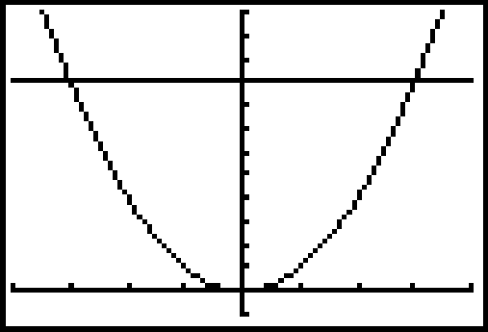
11. a)

b) The x-coordinates of the points of intersection are the solutions to the equation x² = 9, so x = 3 or x = –3.
c) If you graph y = x² and y = –9 on the same axes, there are no points of intersection, so there are no real roots to the equation x² = –9.
12. a) The graphs are identical, except the graph defined by y = x² has been shifted 1 unit to the right.
b) Example: The solution to x² = 16 is x = 4 or
x = –4. So, the solution to (x – 1)² = 16 is the same, but shifted 1 unit to the right, giving x = 5 or x = –3.
13. a) 12.9 cm
b) The equation has two solutions: x = 12.9 or
x = –12.9. However, in this situation, x represents the side length of the cube, which cannot be negative.
14. a) 4x + 14 b) 18 cm
15. a) i) P = 2000, i = 0.03, n = 10
ii) A = 2687.83
b) 4%
16. a) 6.5 m b) $432
c) The area, and therefore the cost, increases by a factor of 1.2² or 1.44 times the original $300. So, 300(1.44) = 432.
17. a) The volume increases by a factor of 2, or it doubles.
b) quadratic
18. exponential
19. a) i) 8 times the volume
ii) 4 times the surface area
b) Example: Volume involves three dimensions multiplied together, so the volume is
(2)(2)(2) = 8 times greater. The formula becomes V = 8lwh or 8 times the original volume. Area involves two dimensions multiplied together, so the area is (2)(2) = 4 times greater. The formula becomes SA = (4)(2)(lw + lh + wh) or 4 times the original surface area.
c) The volume triples. The formula becomes
V =3lwh or 3 times the original volume.
20. a)
h = 10
b) 2[(5)(10) + 5h + 10h] = 400
h = 10
c) Example: Both methods are appropriate. However, it may be easier to substitute numbers in first, since simplifying numbers is often easier than manipulating variables. It is important to know how to solve algebraically for h, in case the calculation needs to be repeated using different numbers or used in a spreadsheet or other computer application.

Chapter 7 Test

1. 6.5 cm²
2. a) 1.6 m²
b) 47 cm
3. a) 1.7 m
b) $41.20
4. a) inside of the pipe (cylindrical); outside of the pipe (cylindrical); two identical ends in the shape of a ring
b) 48 ft²
c) 187 ft²
5. a)
25 cm
80 cm

b) 55 cm
c) 35 179.3 cm³
6. a) 846.6 cm³
b) 1 000 000 cm³
c) 1181 bricks
d) 924.9 cm²
7. They should double the height of the can to double the volume. If they double the radius, it will increase the volume by a factor of 4.
8. a) 6.2 cm
b) 10.0 cm
c) Example: Expect the sphere to have a smaller surface area because circular shapes are more efficient than rectangular shapes.
d) SA_{sphere} 484 cm²
SA_{cube} 600 cm²
The sphere has a smaller surface area.
e) Cubes or boxes are more commonly seen than spheres.
f) No. Example: Less packaging is required for spheres. However, spheres are more difficult to make, do not stack efficiently, and can roll away.
9. 34.4 miles per gallon
10. a) 4 cm
b) 73.7°
11. a) 60°
b)
c) Arc PQ should be a little more than 10 cm. Chord PQ = 10 cm because the triangle is equilateral, and arc PQ is a little longer than chord PQ.
d) 10.5 cm
12. A secant intersects a circle at two points and passes through the interior of the circle, while a tangent touches a circle at only one point and does not pass through the interior of the circle.
13. a) 100°
b) 50°
c) 90°
d) 40°
14. a) 13 m
b) 60 m²
15. a) Example:

b) Yes.
In ΔOAB:
OB = 50 cm (radius)
PB = 40 cm (half of 80-cm chord)
∠OPB = 90° (property of chords)
So, OP = 30 cm (Pythagorean theorem)
In ΔOCD:
OC = 50 cm (radius)
CQ = 40 cm (half of 80-cm chord)
∠OQC = 90° (property of chords)
So OQ = 30 cm (Pythagorean theorem)
Therefore, OP = OQ because they are both
30 cm long.
16. a) 120°
b) 125.7 km/h
17. 736.3 m²
18. a) 128 cm²
b) 106.3°
c) 44.7 cm²

