The Geometer’s Sketchpad ® 4
The Menus
File: Open, save, close, and print documents.
Edit: Edit, such as cut and paste, as well as undo and redo actions and set preferences.
Display: Control the appearance of an object, and label, hide, or animate objects.
Construct: Construct new geometric objects based on selected objects in your sketch.
Transform: Apply geometric transformations to selected objects.
Measure: Make measurements on objects, and perform calculations.
Graph: Create grids and axes for plotting points.
Window: Switch among open windows within The Geometer’s Sketchpad®.
Help: Access the help files.
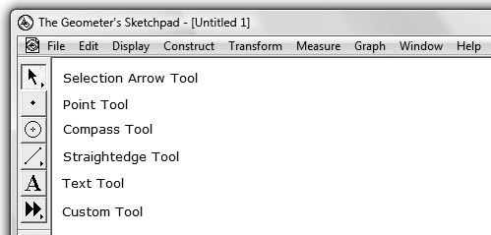
The Toolbox
Selection Arrow Tool: Select, move, and transform objects in a sketch.
Point Tool: Draw points.
Compass Tool: Draw circles using the centre and a point on the circle.
Straightedge Tool: Draw line segments, lines, and rays.
Text Tool: Create text boxes, which can be merged to label points and lines.
Custom Tool: Select from existing custom tools, or define your own.
Creating a New Sketch
• To create a new sketch window, on the File menu, click New Sketch.
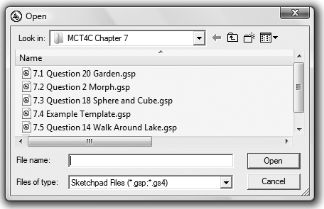
Opening an Existing Sketch
• On the File menu, click Open….
• Navigate to the directory in which the sketch you wish to open is saved.
• Click the name of the sketch you wish to open. Click Open.
Saving a Sketch
To save a sketch for the first time:
• On the File menu, click Save.
• Navigate to the directory in which you wish to save the sketch.
• The Geometer’s Sketchpad® will give the sketch a name in the Filename text
box. To use that one, click Save.
OR
• Change the name as desired in the
Filename text box. Click Save.
To resave a previously saved sketch:
• On the File menu, click Save.
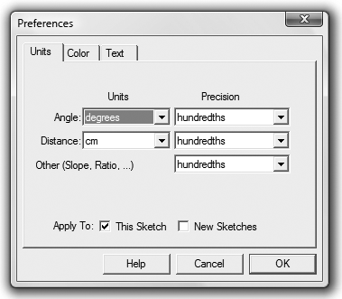
Closing a Sketch Without Exiting The
Geometer’s Sketchpad®
• On the File menu, click Close.
Exiting The Geometer’s Sketchpad®
• On the File menu, click Quit.
Setting Preferences
• On the Edit menu, click Preferences….
• Click the Units tab.
• Select the desired units and precision for Angle, Distance, and Other.
• Click on the Text tab.
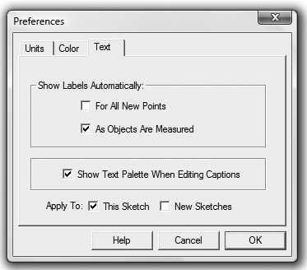
• If you select Show Labels Automatically/
For All New Points, The Geometer’s Sketchpad® will automatically label points as you create them.
• If you select Show Labels Automatically/ As Objects Are Measured, The Geometer’s Sketchpad® will automatically label measurements you define.
By clicking the appropriate box(es) next to Apply To:, you can also choose whether your selected preferences for Units/Text will apply to only this sketch or to this sketch as well as all new sketches.
Selecting Points and Segments
• Click the Selection Arrow Tool. The mouse cursor appears as an arrow.
• Move the cursor to the point or segment you wish to select. When the cursor becomes a horizontal arrow, click the point or segment, and it will be selected.
• To select more than one point or segment, repeat the above step for each item.
Deselecting
• To deselect a single point or segment, move the cursor to the point or segment you wish to deselect.
• When the cursor becomes a horizontal arrow, click and the point or object will be deselected.
• To deselect all selected items, click any white space.
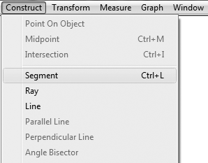
Constructing Line Segments
• Click the Point Tool, and create two points in the workspace.
• Click the Selection Arrow Tool, and select both points.
• On the Construct menu, click Segment.
OR
• Click the Straightedge Tool.
• Move the cursor to the workspace.
• Click and hold the left mouse button.
• Drag the cursor to form the segment.
• Release the mouse button.
• If you hold down the Shift key while dragging the mouse, you can draw horizontal, vertical, or special angled lines.
Constructing Triangles
• Click the Point Tool, and draw three points in a triangular shape in the workspace.
• Click the Selection Arrow Tool, and select the three points.
• On the Construct menu, click Segment.
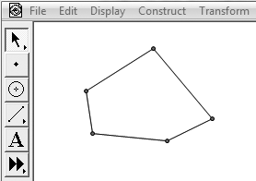
Constructing Polygons
• Click the Point Tool. Draw four or more points in the workspace.
• Click the Selection Arrow Tool, and select all the points in either clockwise or counterclockwise order.
• On the Construct menu, click Segment.
Constructing Parallel Lines
To construct a line parallel to an existing line or segment:
• Click the Point Tool, and place a point above or below the existing line.
• Click the Selection Arrow Tool, and select the point and the line.
• On the Construct menu, click Parallel Line.
Constructing Perpendicular Lines
To construct a line perpendicular to an existing line or segment:
• Click the Point Tool, and place a point above or below the existing line.
• Click the Selection Arrow Tool, and select the point and the line.
• On the Construct menu, click Perpendicular Line.
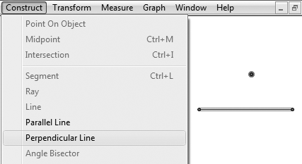
Constructing a Midpoint
To construct a midpoint on an existing segment:
• Click the Selection Arrow Tool, and select the segment.
• On the Construct menu, click Midpoint. The midpoint of the segment will be displayed.
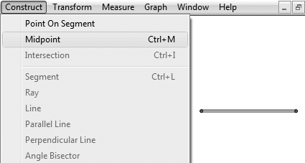

Finding Measures
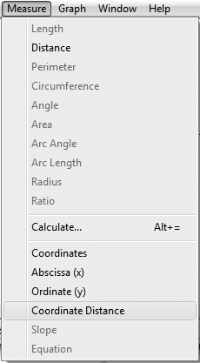
Note: For all measures, The Geometer’s Sketchpad® will display
the desired measure using the units and precision selected in Preferences… on the Edit menu.
To measure the distance between two points:
• Select the two points.
• On the Measure menu, click Distance.
To measure the length of a line segment:
• Select the two points.
• On the Measure menu, click Length.
To measure an angle:
• Select the three points that form the angle. Make sure that the second point selected is the vertex of the angle.
• On the Measure menu, click Angle.
Note: Measuring length or distance measures the screen distance. If you change the scale on your sketch, the measurement will not change. If you want the measurement to change with the scale, select Coordinate Distance rather than Length or Distance.
Constructing and Measuring Polygon Interiors
Note: The Geometer’s Sketchpad® will measure the perimeter and area of a polygon. However, you must construct the interior of the polygon first.
To construct the interior:
• Select all the points representing the vertices of the polygon.
Example: For a quadrilateral, select four points. Be sure to work either clockwise or counterclockwise around the figure.
• On the Construct menu, click Quadrilateral Interior.
Note: The Geometer’s Sketchpad® will call the polygon by its correct name up to six sides, after which it will use Polygon Interior in the Construct menu.
To measure the perimeter and area:
• Click the polygon interior.
• On the Measure menu, click Perimeter.
• Click the polygon interior.
• On the Measure menu, click Area.
