Fathom™
Fathom™ is a dynamic statistical software package. It will allow you to enter, modify, graph, and analyse data. The following overview will provide you with what you need to use Fathom™. The instructions work for Fathom™ 1 and Fathom™ 2. Screens shown here were created using Fathom™ 1.
Start Fathom™
To access Fathom™, double-click the Fathom™ icon. This is located either on your desktop or on the Start menu.
The Menu Bar
The menu bar contains all the standard Fathom™ functions.
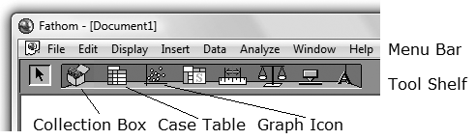
File Menu
Use this menu to open and save a Fathom™ document.
Edit Menu
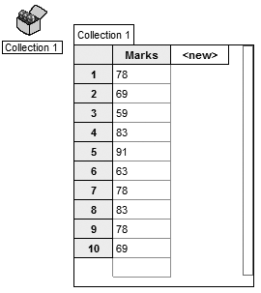
Use this menu to copy or cut selected items and to paste previously copied items. You can also use this menu to undo operations you have performed in Fathom™.
The Tool Shelf
The Tool Shelf contains icons of the key objects. You can place new objects in the workspace by clicking on the desired icon and dragging to the workspace.
Case Table
To create and enter data into a case table:
• Drag the Case Table icon into the workspace.
• Click <new>. Type the attribute name you would like for the data, such as Marks, and press Enter.
• Click in the box beside 1, type the data, and press Enter.
• Continue until you have entered all the data items.
Collection Box
As you enter data into the case table, a small treasure chest will appear automatically and fill with gold balls. This is called a Collection Box. Each gold ball represents one row of data in the collection box.
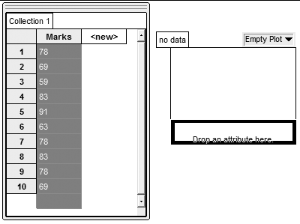
Graph Box
To create a graph of the data you have entered:
• Drag the Graph icon from the Tool Shelf into the workspace.
• Place the cursor over the name attribute you gave your data. The cursor will change to a hand. Click and the hand will change to a fist; all the data will be highlighted.
• Drag the fist over to the Drop an attribute here line, which is along the horizontal axis of the graph. Let go of the mouse button.
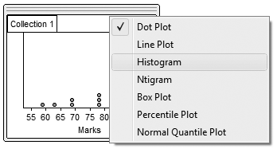
• A dot plot of the data will appear.
• To change this to a histogram, click the words Dot Plot in the right corner of the graph box.
• Select Histogram from the list.
• To change the appearance of your graph, double-click the body of the graph. An information box will appear. You can edit any item that is displayed in blue.
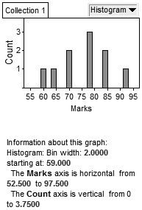
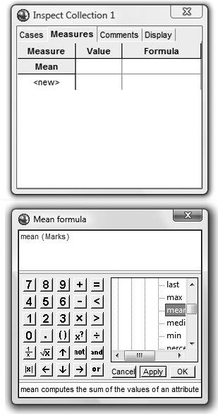
To Find the Mean and Median
Mean
• Right-click either the graph or the case table.
• Click Inspect Collection on the pop-up menu.
• On the Measure tab, click <new>, and type Mean.
• Right-click under the formula heading, and click Edit Formula on the pop-up menu.
A box resembling a calculator will appear.
• Click the + next to Function, then the + next to Statistical, and finally the + next to One Attribute.
• Scroll down the list of functions, and double-click mean.
The word mean, followed by a pair of brackets, will appear in the display.
• Type the name of the attribute, Marks, inside the brackets.
Click OK.

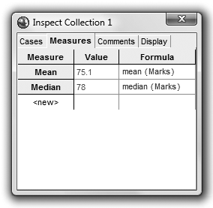
Median
• Click <new> under Mean, and type Median.
• Right-click under the formula heading, and click Edit Formula on the pop-up menu.
• Click the + next to Function, then the + next to Statistical, and finally the + next to One Attribute.
• Scroll down the list of functions, and double-click median.
The word median, followed by a pair of brackets, will appear in the display.
• Type the name of the attribute, Marks, inside the brackets. Click OK.
The mean and median of the attribute, Marks, will be displayed.
Note: Instead of selecting a function such as mean( ) from the
menu, you can type the name with the brackets.
Sorting to Find the Mode
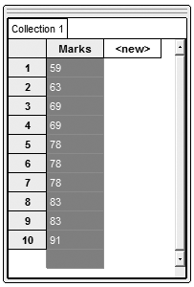
• Right-click the Marks attribute.
The data will be highlighted, and a menu will appear.
• Click either Sort Ascending or Sort Descending.
• To find the mode, scan the data list for repeated values.
The value that repeats the most often is the mode. In this example, the mode is 78.
Notes:
• If you make an error, you can use the Undo command on the Edit menu to undo as many steps as necessary to correct the error.
• You can move case tables, graphs, and other objects in the workspace by clicking on the object and dragging it.
• If you click a single set of an attribute in a histogram, the set will turn red. If you look in the Case Table, all the data items from that set will be highlighted blue.
