The TI-Nspire™ CAS Calculator
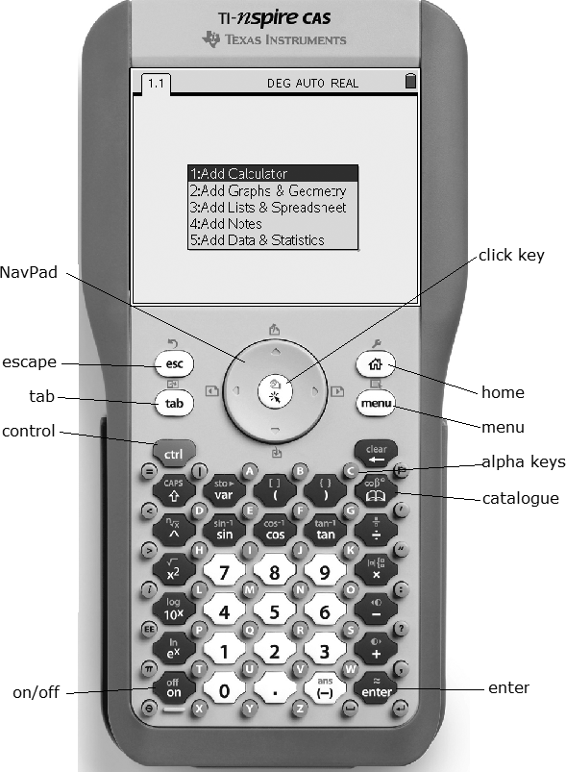

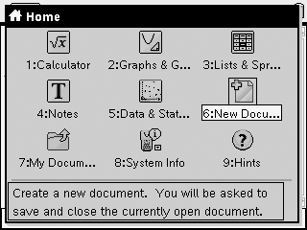
Opening a New Document
• Turn on the TI-Nspire™ CAS. Press c, and select New Document.
• Select the kind of page you want to open. You have several choices.
• Add Calculator lets you perform calculations.
• Add Graphs & Geometry lets you plot functions and other graphs, or draw sketches similar to dynamic geometry software.
• Add Lists & Spreadsheet allows you to work with lists in a spreadsheet environment.
• Add Notes lets you type notes.
• Add Data & Statistics lets you work with your lists.

Setting Auto/Approximate Mode
• Press c and select System Info.
• Select Document Settings… if you want the changes to apply only to the current document, or System Settings... if you want the changes to apply to all documents that you open.
• Scroll to the Auto or Approx. field and set to Approximate.
• Scroll to OK and click x to finish.
This will set the calculator to display approximate decimal answers.

Plotting a Function
• Open a new Graphs & Geometry page.
• In the entry line, you will see f1(x) =. Type
x² + 1 as a sample function, and press ·.
Note: The function is displayed with its equation as a label. The entry line has moved to function f2(x).
To change the window settings of the graph:
• Look at the axes. This is the standard window for the TI-Nspire™ CAS. To see, or change, the window settings, press b, select Window, and then Window Settings.
To hide or view the graph:
• Press e. Then, press up on the NavPad once. The function f1(x) will be displayed in the entry line.
• Press e until the eye symbol at the left of the entry line is selected. This allows you to hide or view the graph.
• Press · once. Note that the graph is hidden.
• Press · again. The graph reappears.
To change the attributes of the graph:
• Press e once to select the attributes symbol to the right of the eye symbol.
• Press · to display the attributes menu. You can use this menu to adjust the line weight, the line style, the label style, and the line continuity. Use up/down on the NavPad to select the attribute, and then left/right on the NavPad to change the attribute.
• When you are finished, press d to return to the
graph screen.

To change the view of the graph:
• You can change the appearance of the window. Press b and select View. There are several options. For example, if you choose Show Axes End Values, you can display the current range of each of the axes.
To move the function label:
• Press e once. The entry line will grey out, and the cursor will move to the graphing window.
• Move the cursor over the function label. When you are in the right place, the word “label” will appear, along with a hand symbol.
• Press /, then x. The hand will close to “grab” the label. Use the cursor to move the label around the screen. When you are finished, press d.
To move the graph around the screen:
• Move the cursor to a blank space in the second quadrant. Press /, then x. A hand will appear.
• Use the cursor to move the hand around. Notice that the hand has grabbed the entire graph and will move it around the screen. When you are finished, press d.
To see a function table:
• Press e once to return to the entry line. Press up on the NavPad once to return to the function f1(x).
• You can display a table of values for the function. Press b, and select View.
• Select Add Function Table. You can scroll up and down to inspect different values.
• Press b. Select Function Table, then Edit Function Table Settings. You can adjust the table start value and the table step value.

Tracing a Function
• Open a new Graphs & Geometry page.
• For f1(x) =, type x² as a sample function, and
press ·.
• Press b, select Trace, then Graph Trace.
• Use the cursor to trace along the graph.
The coordinates of the traced point will be displayed.
Finding a Zero/Maximum/Minimum Value
• Open a new Graphs & Geometry page.
• For f1(x) =, type x³ + x² – 2x as a sample function, and press ·.
• Press b, select Trace, then Graph Trace.
• Use the NavPad to drag the point to the right-most zero on the graph. A box with “zero” will appear, along with the coordinates of the zero.
• Continue dragging the point to the minimum on the graph. A box with “minimum” will appear, along with the coordinates of the minimum.
• Continue dragging the point to the maximum on the graph. A box with “maximum” will appear, along with the coordinates of the maximum.
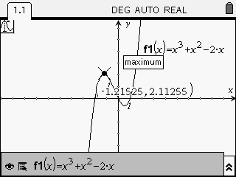
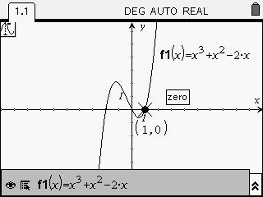
Drawing a Scatter Plot
The average mark on a standardized math test for several
years running is shown in the table. Create a scatter plot for the data.

Year | 1998 | 1999 | 2000 | 2001 | 2002 | 2003 | 2004 | 2005 | 2006
Mark | 71.2 | 72.3 | 73.1 | 73.9 | 74.5 | 74.8 | 75.2 | 75.9 | 76.4
• Open a Lists & Spreadsheet page.
• Enter the year title and data in column A. Call 1998 year 0.
• Enter the mark title and data in column B.

• Open a new Graphs & Geometry page.
• Press b, and select Graph Type. Change the graph type to Scatter Plot.
• Select year from the x-axis drop-down menu. Select mark from the y-axis drop-down menu.
• Press b. Select Window, then Window Settings. Change XMin to –0.5 and XMax to 10.0. Change YMin to 60 and YMax to 80. Select OK.
• Your scatter plot will appear as shown.
Linear Regression and Graphing
Refer to the time and mark data in Drawing a Scatter Plot.
• Return to the Lists and Spreadsheet page and press b.
• Select Statistics, then Stat Calculations.
• Select Linear Regression (mx + b).
• Select year for the X List, and mark for the Y List.
• Tab down and select OK. The linear equation of best fit will be displayed: y = 0.61x + 71.7.
• Press / and right on the NavPad to return to the Graphs & Geometry page. Set the graph type back to Function.
• Press e.
The line of best fit will be displayed.

Shortcut Key Sequences
Many of the shortcut key sequences that work in a Microsoft® Windows environment also work on the
TI-Nspire™ CAS. Here is a brief summary of some of the shortcuts:
/ C: copy
/ V: paste
/ X: cut
/ Z: undo
/ Y: redo
/ I: insert page
/ G: hide or show entry line

