Graphs of the Sine and Cosine Functions
f(x) = sin x

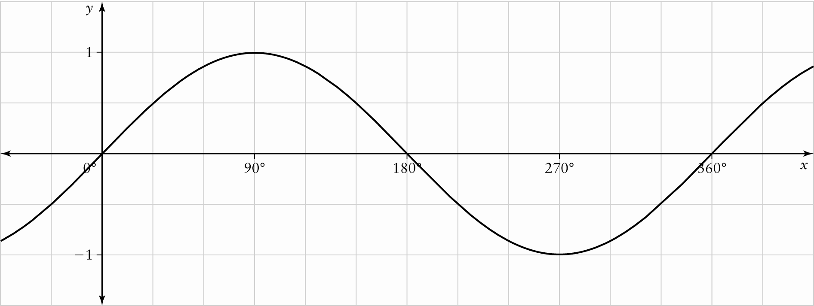

f(x) = cos x

