Chapter 1 Prerequisite Skills

Angles and Triangles
1. Determine the measure of the missing angles. Classify each triangle as acute, obtuse, right, scalene, isosceles, or equilateral.
a) 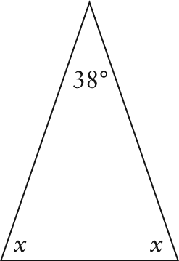
b) 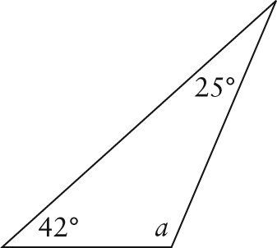
c) 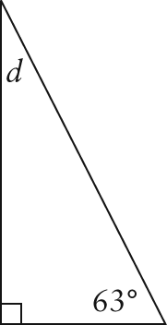
d) 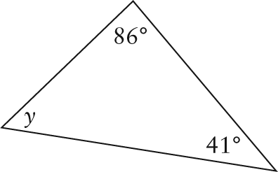
2. Determine the complement of each angle.
a) 30° b) 54°
c) 83° d) 6°
3. Determine the supplement of each angle.
a) 14° b) 109°
c) 47° d) 172°
Pythagorean Theorem
4. Determine the length of the indicated side, to the nearest tenth of a unit.
a) 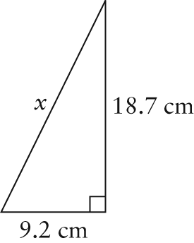
b) 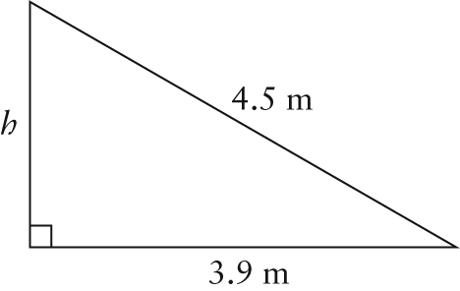
Equations and Proportions
5. Solve.
a) 600 = 100 + 75 – 5x
b)
c) a² + 200 = 425
d)
6. Solve each proportion. If necessary, round your answers to one decimal place.
a)
b)
c)
d)

Trigonometry
7. Determine the exact primary trigonometric ratios for θ.
a) 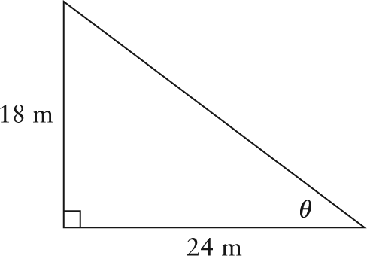
b) 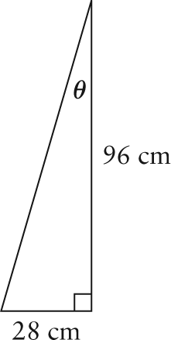
c) 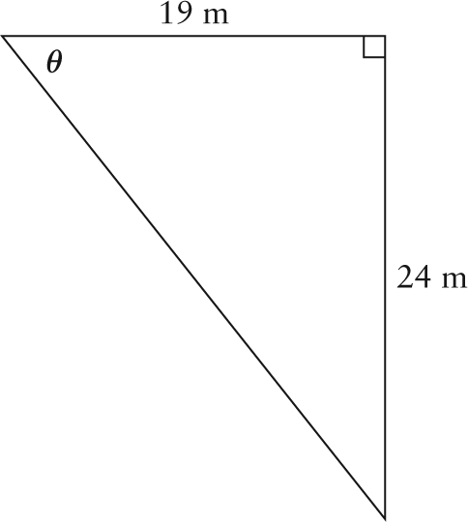
8. According to safety standards, the angle that the base of a ladder makes with the ground should be between 70° and 80°. Lorenzo is standing on an 11-m ladder. The base of the ladder is 1.5 m from the wall. Does this meet the safety standards?
9. Solve each triangle. Express all side lengths to the nearest tenth of a unit and all angle measures to the nearest degree.
a) 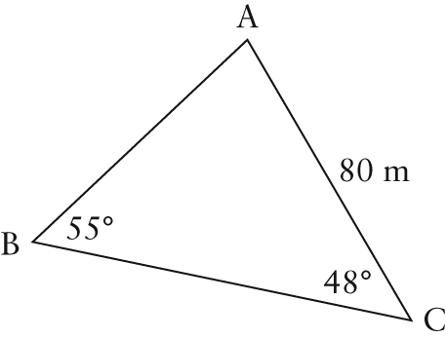
b) 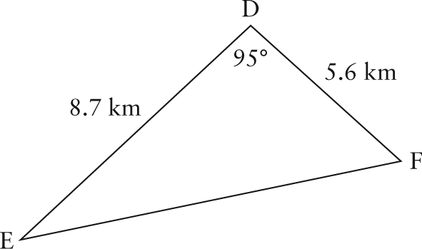
c) 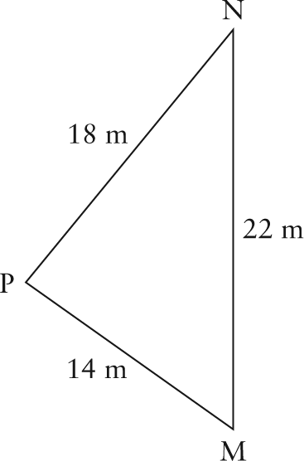
10. A skateboard ramp is to be built according to the specifications shown. Calculate the angle of inclination of the ramp to the nearest degree.
