Chapter 1 Review

1.1 Sine, Cosine, and Tangent of Special Angles
1. State the exact value for each ratio.
a) sin 60° b) tan 30° c) cos 45°
2. a) What reference angle should be used to find the primary trigonometric ratios of 210°?
b) Determine the primary trigonometric ratios of 210°.
3. a) Draw a 120° angle in standard position on a unit circle.
b) State two other angles that have the same reference angle.
c) State the exact values of the primary trigonometric ratios for 120°.
4. Amy is standing directly across the river from her friend Wei’s cottage. Jacob is sitting 2 km down shore from Amy and is
4 km from Wei’s cottage.
a) How far is Amy from Wei’s cottage? Express your answer as an exact value.
b) Describe an alternative method that can be used to solve the same problem. Check your answer to part a) using your alternative method.
1.2 Sine, Cosine, and Tangent of Angles
From 0° and 360°
5. Consider ∠Q in quadrant II, such that .
a) Draw a diagram.
b) Determine exact values for cos Q and
tan Q.
c) How would your answers to parts a)
and b) change if the quadrant in which ∠Q was located was not specified?
6. The coordinates of a point on the terminal arm of an angle θ in standard position are
(7, –2). Determine the exact primary trigonometric ratios for θ.
1.3 Trigonometry of Angles
7. Use a calculator to evaluate each ratio to four decimal places. Determine a second angle with the same ratio.
a) sin 74°
b) cos 221°
c) tan 289°
8. Given , determine the measure(s)
of θ, 0° ≤ θ ≤ 360°, to the nearest degree. Then, determine exact values for sin θ and cos θ.
9. Two angles between 0° and 360° have a cosine ratio of . Without using a calculator, determine the angles.
1.4 Solving Problems Using Primary Trigonometric Ratios
10. Determine the length of x, to the nearest tenth of a unit.
a) 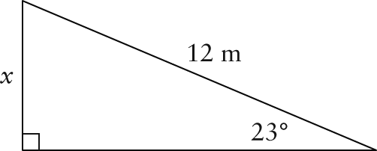
b) 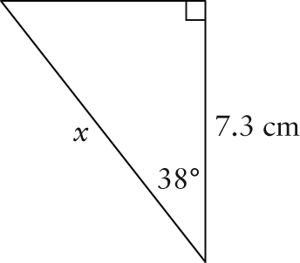
c) 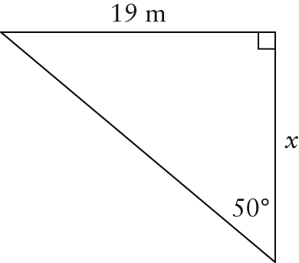
11. Sketch each triangle Then, solve the triangle.
a) ABC, ∠B = 90°, ∠C = 35°, c = 9.2 m
b) DEF, ∠D = 90°, ∠E = 64°, d = 18.6 cm
12. Tall structures are sometimes supported by guy wires. These are ropes or cables that are attached to the structure and the ground. A billboard is stabilized by pairs of guy wires attached to the top of the billboard. The wires at the front are 12 m long and make an angle of 60° with the ground. The wires at the rear are attached to the ground 8 m from the base of the billboard.
a) What angle, to the nearest degree, do the rear guy wires make with the ground?
b) How long are the rear wires?
1.5 Solving Problems Using the Sine Law
13. Find the length of the indicated side, to the nearest tenth of a unit.
a) 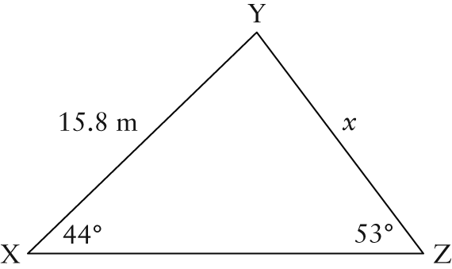
b) 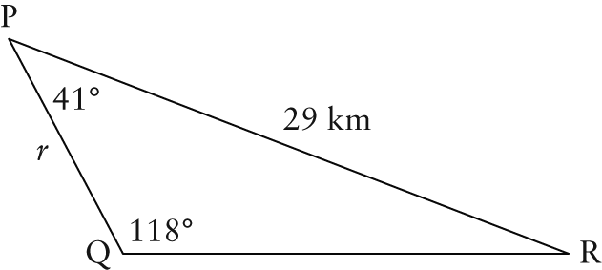
14. Find the measure of angle θ, to the nearest degree.
a) 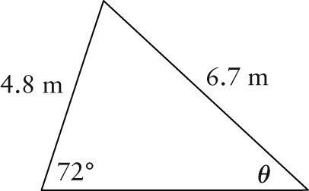
b) 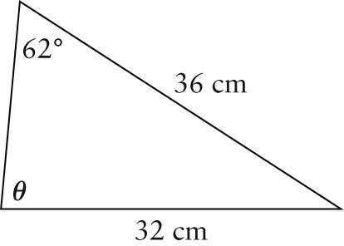
15. Solve each triangle, if possible. Round angle measures to the nearest degree and side lengths to the nearest tenth of a unit.
a) ABC, ∠A = 105°, a = 17.5 m, c = 15.2 m
b) DEF, ∠E = 40°, ∠F = 18°, d = 27.1 cm
16. In ABC, a = 4.7 cm, b = 6.4 cm,
and ∠A = 38°.
a) Determine the number of possible solutions for ABC.
b) Sketch and label all possible triangles.
c) Determine all possible lengths of side c, to the nearest tenth.
1.6 Solving Problems Using the Cosine Law
17. Find the length of the third side, to the nearest tenth.
a) 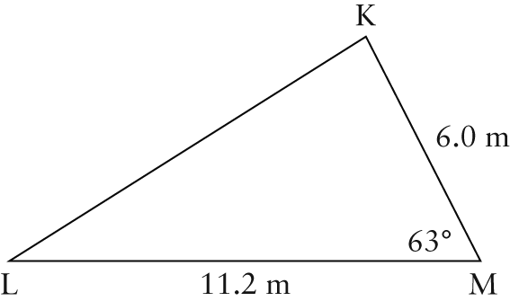
b) 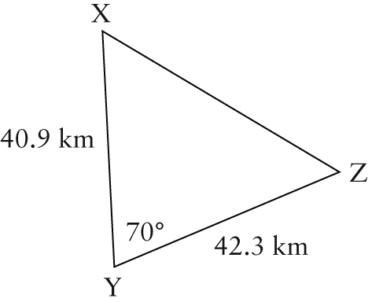
18. Sketch and then solve each triangle. Round angle measures to the nearest degree and side lengths to the nearest tenth of a unit.
a) ABC, a = 9.7 m, b = 20.9 m, c = 14.6 m
b) DEF, ∠F = 98°, d = 2.4 cm, e = 3.9 cm
19. The length of the pendulum on a grandfather clock is 1.4 m. If the bottom of the pendulum swings a horizontal distance of
20 cm, through what angle does the pendulum swing?

