Chapter 1 Case Study
Tools
• scientific calculator

Air Traffic Controller
• Edward Kendall was interested in becoming an air traffic controller. He needed a high school diploma and had to pass an aptitude examination and interview.
• Edward enrolled in the Aviation Management Program at Algonquin College. After one year, he received a certificate and his air traffic controller’s licence.
• The tuition fee was $3500, but he was paid $2500 per month for four months of on-the-job training.
• He is stationed in an area control centre in Toronto. He works 40 h per week, with rotating shifts, and is paid an annual salary of $80 000.
• For his training, Edward specialized in instrument flight rules (IFR) control. While pilots are in his airspace, he uses radar, tracking, communication, and information systems to provide clearance and directions to pilots during their flights. Then, he transfers control to adjacent centres and airport facilities. Essentially, he is responsible for ensuring the safety of every flight that moves into his airspace.
• In addition, Edward notifies airport emergency services when aircraft experience problems, and reports missing aircraft to search and rescue authorities.

Questions
1. What physical characteristics would be important for the performance of Edward’s job? Explain.
2. What personal characteristics and skills would be desirable for a person in this position?
3. The radar systems used by air traffic controllers contain software that uses trigonometry to calculate distances between aircraft in the sky. This information is interpreted by people like Edward to ensure the aircraft are a safe distance apart.
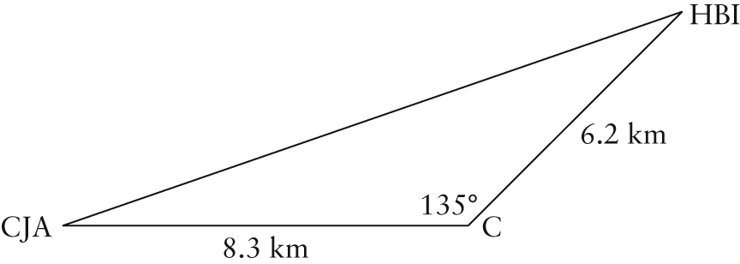
Two commercial airplanes, one identified as CJA and the other as HBI, are approaching the terminal control centre, C. CJA is heading east and HBI is heading southwest, such that the angle between the two planes and the control centre is 135°. The horizontal distances between the planes and the centre are shown. A safe distance between two aircraft is 9 km.
a) Show that these two airplanes are a safe distance apart.
b) If CJA is cruising at 880 km/h and HBI is flying at 600 km/h, will they be a safe distance apart
1 min later? Explain.

