Chapter 1 BLM Answers
BLM 1–1 Prerequisite Skills
1. a) x = 71°; acute isosceles
b) a = 113°; obtuse scalene
c) d = 27°; right scalene
d) y = 53°; acute scalene
2. a) 60° b) 36° c) 7° d) 82°
3. a) 166° b) 71° c) 133° d) 8°
4. a) 20.8 cm b) 2.2 m
5. a) x = –85 b) x = 4.5
c) a = 15 d) d = 8
6. a) x = 8 b) x = 6.3
c) x = 2.4 d) x = 6.9, y = 3
7. a) , ,
b) , ,
c) , ,
8. No. The angle is 82°.
9. a) ∠A = 77°, a = 95.2 m, c = 72.6 m
b) d = 10.7 km, ∠E = 31°, ∠F = 54°
c) ∠M = 55°, ∠N = 39°, ∠P = 86°
10. 28°
BLM 1–4 Chapter 1 Review
1. a) b) c)
2. a) 30°
b) , ,
3. a) 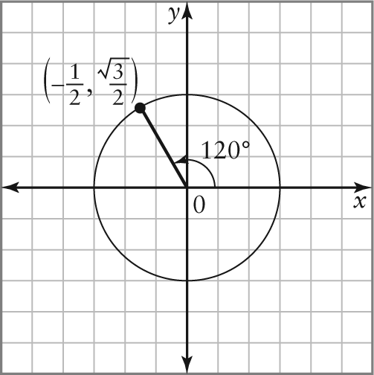
b) 240°, 300°
c) ,
4. a) km b) Pythagorean theorem
5 a) 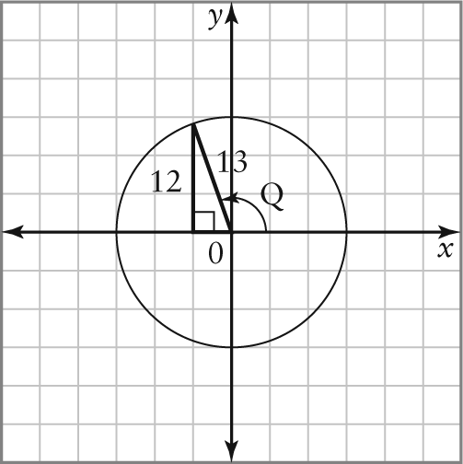
b) ,
c) signs could be positive or negative
6. a) , ,
7. a) 0.9613; 106°
b) –0.7547; 139°
c) –2.9042; 109°
8. 67°, 247°;
,;
,
9. 135°, 225°
10. a) 4.7 m b) 9.3 cm c) 15.9 m
11. a) 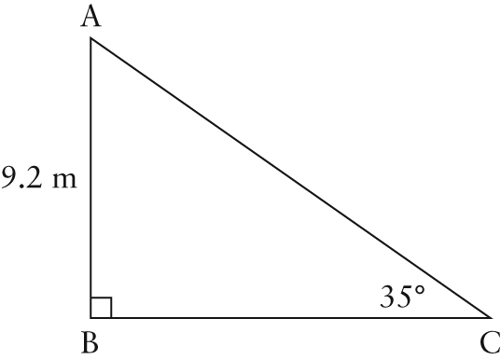
∠A = 55°, a = 13.1 m, b = 16.0 m
b) 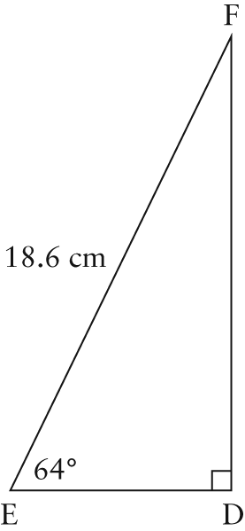
∠F = 26°, e = 16.7 cm, f = 8.2 cm
12. a) 52° b) 8.5 m
13. a) 13.7 m b) 11.8 km
14. a) 43° b) 83°
15. a) ∠B = 18°, ∠C = 57°, b = 5.6 m
b) ∠D = 122°, e = 20.5 cm, f = 9.9 cm
16. a) two
b)
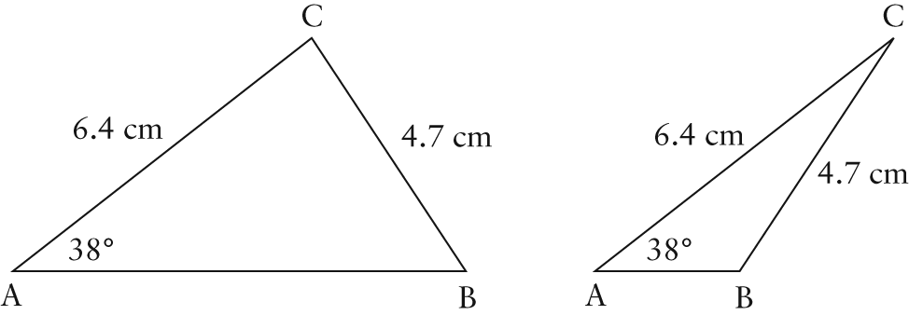
c) 7.6 cm, 2.5 cm
17. a) 10.0 m b) 47.7 km
18. a) 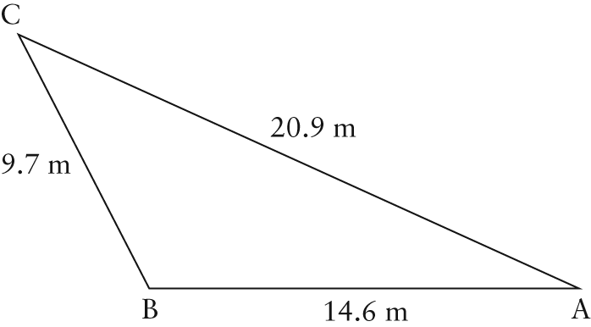
∠A = 24°, ∠B = 117°, ∠C = 39°
b) 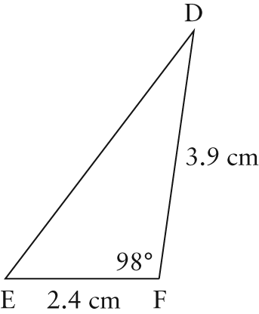
f = 4.9 cm, ∠D = 29°, ∠E = 53°
19. 8°
BLM 1–5 Chapter 1 Practice Test
1. a) 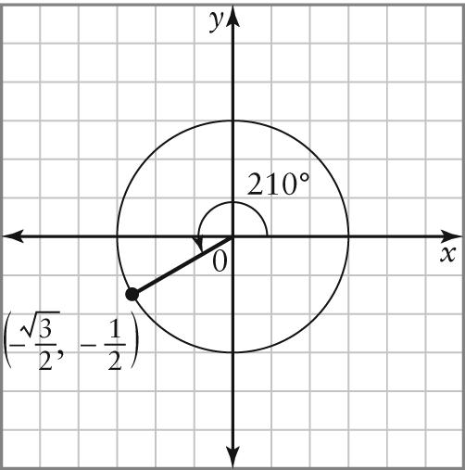
b) 150°, 330°
c) , ,
2. m, ,
3. a)
b) 249°
4. 135°, 315°
5. a) 0.6157 b) 38°
6.
7. a) –1,
b) same, except substitute cos θ for x
c) 60°, 180°, 300°
8. a) 6.2 m b) 10.7 cm
9. 311.1 ft
10. 7.2 m
11. a) ∠D = 135°, d = 46.8 m, e = 21.5 m
b) ∠A = 62°, ∠B = 60°, ∠C = 58°
12. a) no solution b) two; 7.1 m or 15.1 m
13. 267 m
14. a) Cori: 221 m; Jane: 230 m
b) Cori was closer by 1 m.
15. 7.4 cm
BLM 1–6 Chapter 1 Case Study
1. Example: good hearing, good vision, good speaking skills
2. Example: teamwork, calm under pressure, good short-term memory, quick with computational numeric skills, follows rules but is flexible
3. a) The distance is 13.4 km, which is greater than the 9-km minimum.
b) No. Within 1 min these planes will be less than 9 km apart.

