Chapter 2 Prerequisite Skills

Trigonometry
1. Write the exact values of the primary trigonometric ratios for angle θ.
a) 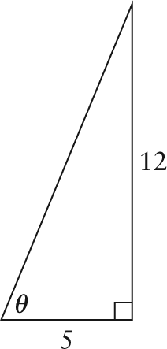 b) 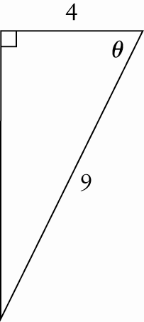
2. Given a point on the terminal arm of an angle θ in standard position, find the exact values for sin θ, cos θ, and tan θ.
a) (–3, 4) b) (5, –8) c) (–7, –6)
3. State the exact value of each ratio.
a) sin 45° b) tan 60° c) cos 30°
4. Which reference angle should be used to determine the primary trigonometric ratios?
a) 150° b) 240° c) 315°
5. Determine the primary trigonometric ratios for each angle in question 4.
Polynomials
6. Expand and simplify.
a) (x + 3)² b) (x – 6)²
c) 2(x – 5)² d) –3(x + 1)²
7. Factor fully.
a) x² + 5x b) x² – 3x – 10
c) 2x² – 10x + 12 d) –3x² – 3x + 36
Quadratic Functions
8. State the domain and range of each function.
a) y = –3x + 5 b) 2x + 5y = 7
c) y = 2(x – 1)² + 5 d) y = –4(x + 2)² + 3
9. Determine the x- and y-intercepts.
a) y = x² – 4x b) y = x² – 9
c) y = x² + x – 6 d) y = x² – 9x + 20
e) y = 3x² – 15x + 12 f) y = –x² + 2x + 15
10. Describe the shape and position of each parabola relative to the graph of y = x².
a) y = (x – 4)² b) y = 2(x + 7)² + 1
c) y = –3(x – 2)² + 5 d)
11. Graph each parabola in question 10.
12. A parabola opens up, is vertically stretched by a factor of 6, and has vertex
(2, –3). Write its equation in the form
y = a(x – h)² + k.
13. A parabola has vertex (7, 3) and passes through point (11, 9). Determine an equation in the form y = a(x – h)² + k.
14. State the maximum or minimum value, and determine the zeros and the y-intercepts, if they exist.
a) y = 3(x – 1)² + 4 b) y = (x – 2)² – 4
c) y = –2(x + 4)² + 8 d) y = (x – 3)² – 36
15. A gymnast jumps from a platform onto a trampoline below. Her path can be modelled by the relation h = –0.8d² + 0.8d + 4.8, where h is her height above the stage and d is her horizontal distance from the edge of the platform, both in metres.
a) What is the height of the platform?
b) How far from the edge of the platform did she land?
c) What was her maximum height above
the stage?

