Chapter 2 BLM Answers
BLM 2–1 Chapter 2 Prerequisite Skills
1. a) , ,
b) , ,
2. a) , ,
b) , ,
c) , ,
3. a) b) c)
4. a) 30° b) 60° c) 45°
5. a) , ,
b) , ,
c) , ,
tan 315° = –1
6. a) x² + 6x + 9 b) x² – 12x + 36
c) 2x² – 20x + 50 d) –3x² – 6x – 3
7. a) x(x + 5) b) (x – 5)(x + 2)
c) 2(x – 2)(x – 3) d) –3(x + 4)(x – 3)
8. a) domain range
b) domain range
c) domain range
d) domain range
9. a) x-intercepts: 0, 4; y-intercept: 0
b) x-intercepts: –3, 3; y-intercept: –9
c) x-intercepts: –3, 2; y-intercept: –6
d) x-intercepts: 4, 5; y-intercept: 20
e) x-intercepts: 1, 4; y-intercept: 12
f) x-intercepts: –3, 5; y-intercept: 15

10. a) same shape, shifted right 4 units
b) vertically stretched by a factor of 2, shifted left 7 units and up 1 unit
c) vertically stretched by a factor of 3, reflected in the x-axis, shifted right 2 units and up
5 units
d) vertically compressed by a factor of , shifted right 4 units and down 6 units
11. a)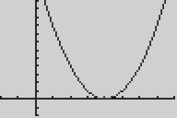 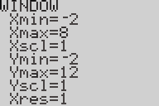
b)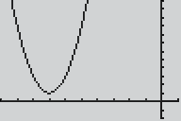 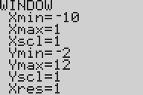
c) 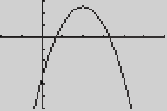 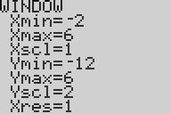
d)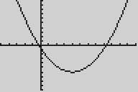 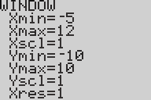
12. y = 6(x – 2)² – 3
13. a)
14. a) minimum: 4; zeros: none; y-intercept: 7
b) minimum: –4; zeros: 0, 4; y-intercept: 0
c) maximum: 8; zeros: –6, –2; y-intercept: –24
d) minimum: –36; zeros: –3, 9; y-intercept: –27
15. a) 4.8 m b) 3 m c) 5 m

BLM 2–3 Chapter 2 Review
1. a)
x | y =sin x
x | Exact Value | Approximate
0° | 0 | 0
30° |  | 0.5
45° |  | 0.7071
60° |  | 0.8660
90° | 1 | 1
120° |  | 0.8660
135° |  | 0.7071
150° |  | 0.5
180° | 0 | 0
210° |  | –0.5
225° |  | –0.7071
240° |  | –0.8660
270° | –1 | –1
300° |  | –0.8660
315° |  | –0.7071
330° |  | –0.5
360° | 0 | 0
b) 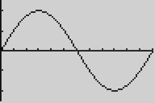 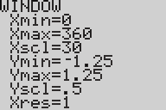
c) Each x-value corresponds to exactly one
y-value.
2. a) y = sin x: 1; y = cos x: 1
b) y = sin x: 360°; y = cos x: 360°
c) y = sin x:
domain range ;
y = cos x:
domain range
d) y = sin x:
x-intercepts 0°, 180°, 360°, y-intercept 0;
y = cos x:
x-intercepts 90°, 270°, y-intercept 1
e) y = sin x:
increase 0° ≤ x ≤ 90°, 270° ≤ x ≤ 360°,
decrease 90° ≤ x ≤ 270°
y = cos x:
increase 180° ≤ x ≤ 360°,
decrease 0° ≤ x ≤ 180°
3. a) 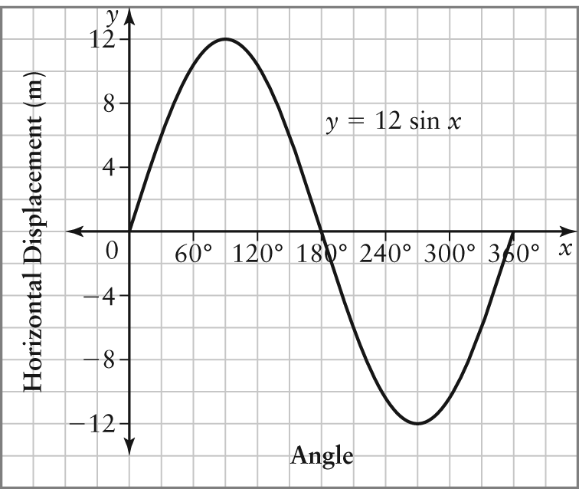
Sine, because the starting point is at the same vertical level, 0, as the centre
b) 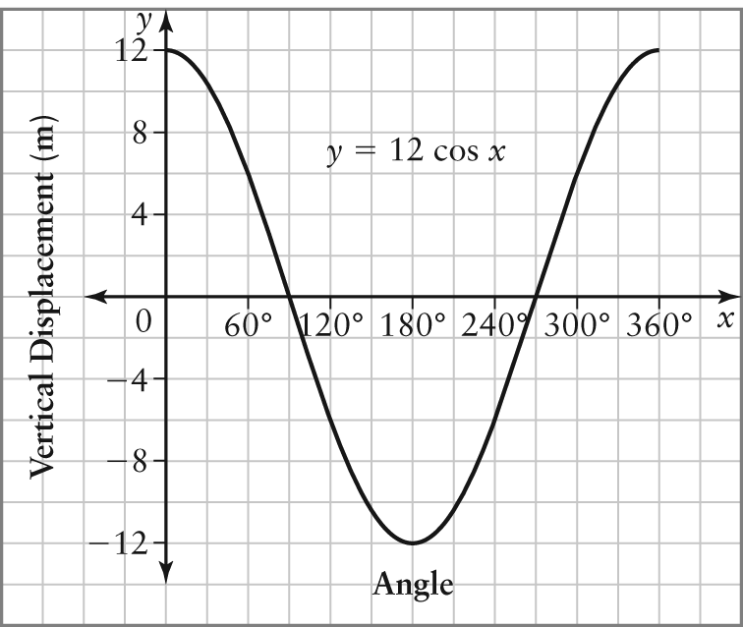
Cosine, because at the beginning, the point is 12 cm from the centre horizontally
4. a) phase shift: 14° left; vertical translation: 12 units down
b) phase shift: 5° right; vertical translation:
7 units up
c) phase shift: 36° right; vertical translation:
4 units down
d) phase shift: 85° left; vertical translation:
10 units up
5. a) phase shift: 30° right; vertical translation:
3 units up
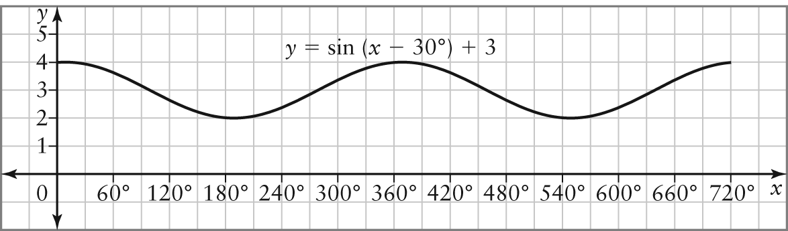
b) phase shift: 40° left; vertical translation:
1 unit down
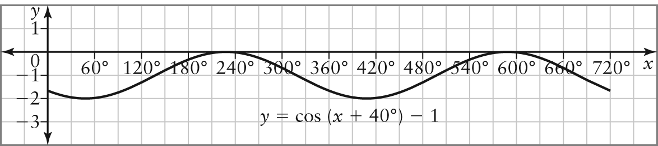
6. a) 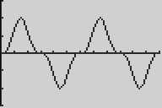 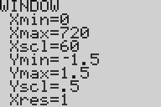
b) shifted 90° left and 2 units down
c) same, because the graph of y = cos x is the graph of y = sin x shifted left 90°
7. a) vertically stretched by a factor of 5, horizontally compressed by a factor of
b) vertically stretched by a factor of 3, horizontally compressed by a factor of
c) vertically compressed by a factor of , horizontally stretched by a factor of 3
d) vertically stretched by a factor of 6, horizontally stretched by a factor of 4
8. a) amplitude: 2; period: 120°
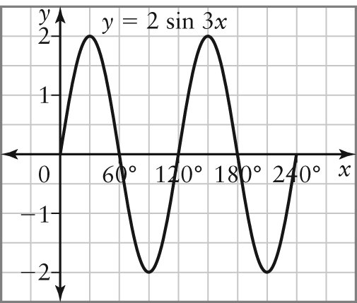
b) amplitude: 4; period: 720°
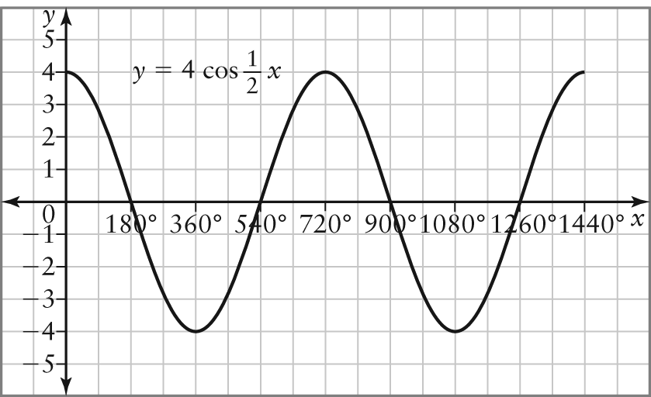
c) amplitude: ; period: 90°
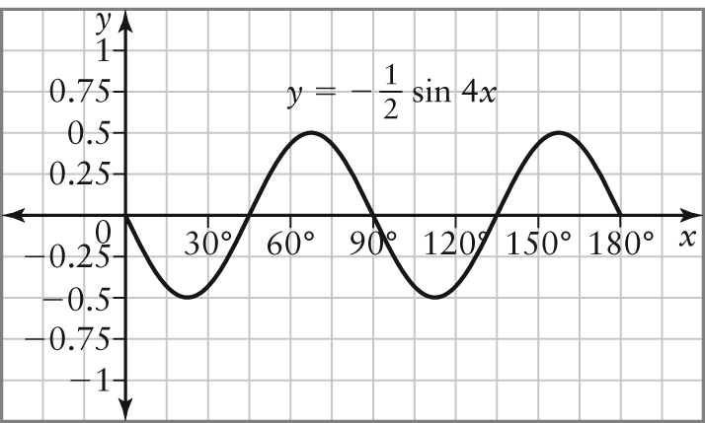
d) amplitude: 3; period: 180°
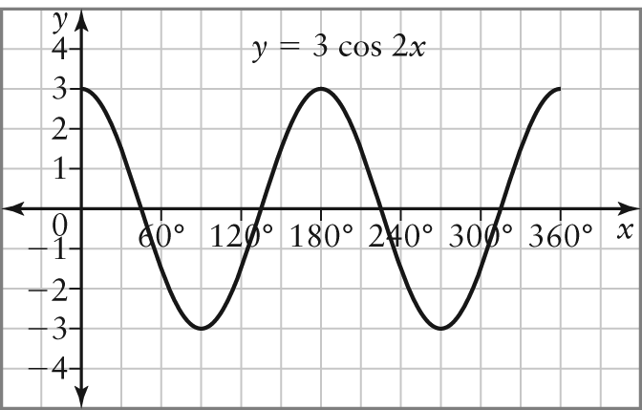
9.
10. a) amplitude: 2; period: 120°; phase shift:
18° left; vertical translation: 9 units up
b) amplitude: ; period: 72°; phase shift:
37° right; vertical translation: 4 units up
c) amplitude: 7; period: 30°; phase shift:
46° left; vertical translation: 3 units down
d) amplitude: 4; period: 900°; phase shift:
10° right; vertical translation: 8 units down

11. a) vertically stretched by a factor of 3, horizontally compressed by a factor of , vertically translated up 2 units
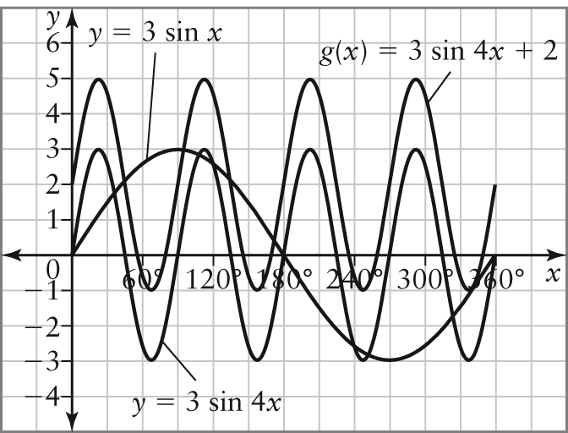
b) domain, range
c) h(x) = 3 sin [4(x – 30°)] + 2
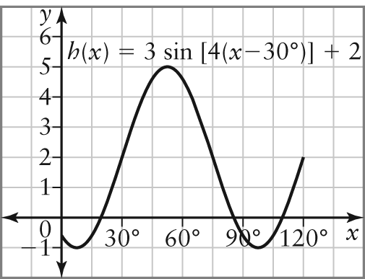
12. a) amplitude: 2; period: 120°; phase shift: 60° left; vertical translation: 1 unit down
b) 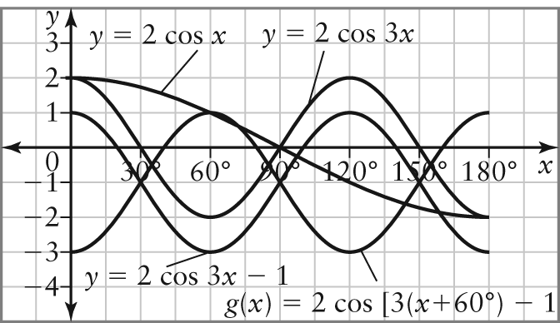
c) domain range
13. a) y = 4 sin 3x b)
14.
15.
16. a) h(n) = 4 cos 30n + 9
b) h(n) = 4 sin [30(n + 3°)] + 9
17. a) 2 m b) 20 s c) 30 m
BLM 2–4 Chapter 2 Practice Test
1. a)
x | y = cos x
x | Exact | Approximate
0° | 1 | 1
30° |  | 0.8660
45° |  | 0.7071
60° |  | 0.5
90° | 0 | 0
120° |  | –0.5
135° |  | –0.7071
150° |  | –0.8660
180° | –1 | –1
210° |  | –0.8660
225° |  | –0.7071
240° |  | –0.5
270° | 0 | 0
300° |  | 0.5
315° |  | 0.7071
330° |  | 0.8660
360° | 1 | 1
b) 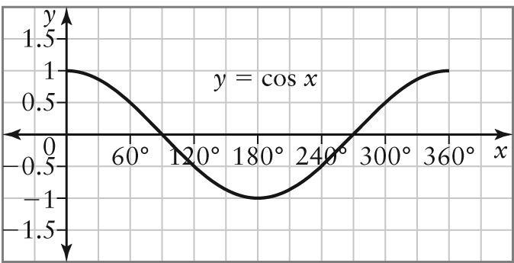
c) x-intercepts: 90°, 270°; y-intercept: 1; interval of increase: 180° ≤ x ≤ 360°; interval of decrease: 0° ≤ x ≤ 180°
2. a) 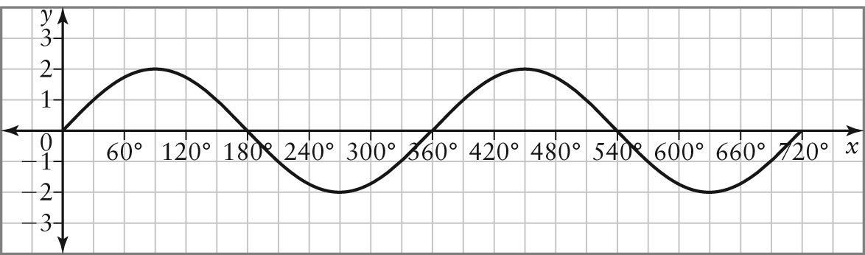
b) y = 2 sin x
3. a) phase shift: 25° right; vertical translation:
7 units down
b) phase shift: 67° left; vertical translation:
13 units up
c) phase shift: 10° left; vertical translation:
3 units up
4. g(x) = cos (x – 38°) – 20
5. a) amplitude: 4; period: 120°;
vertically stretched by a factor of 4, horizontally compressed by a factor
of
b) amplitude: 5; period: 1440°;
vertically stretched by a factor of 5, horizontally stretched by a factor of 4
6.
7. a) amplitude: 15; period: 180°; phase shift: 7° left; vertical translation: 6 units down
b) amplitude: ; period: 120°; phase shift: 40° right; vertical translation: 2 units up
8. a) vertical compression by a factor of , horizontal compression by a factor of , shift left 30°, translate down 4 units
b) 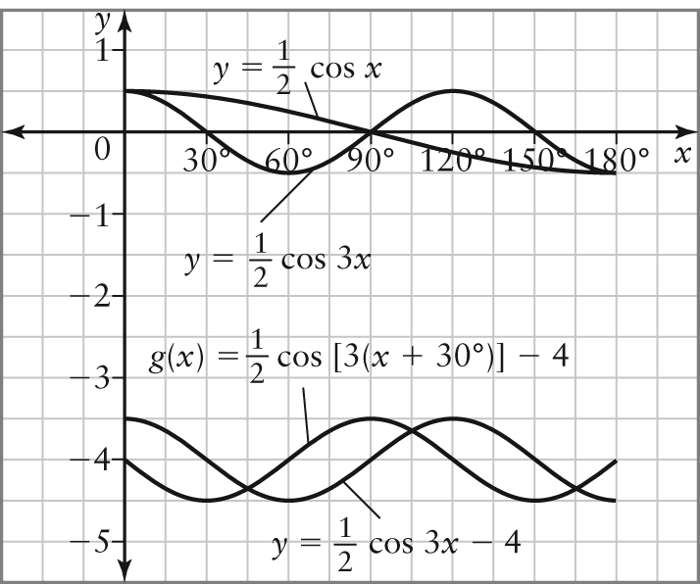
c) domain
range
9.
10. a) 13.9 m
b) minimum: 6 m; maximum: 18 m
c) 20 s
11. a)
b)
12. a) The heights decrease, then increase at regular intervals.
b) 50 m c) 12 s
d) h(t) = 50 sin [30(t + 3)] + 60
13. y = 4 sin 2x
14. A negative sign on x causes a reflection in the
y-axis. The graph of y = cos x is symmetrical about the y-axis. Therefore, a reflection in the
y-axis gives the same graph.
15. a) 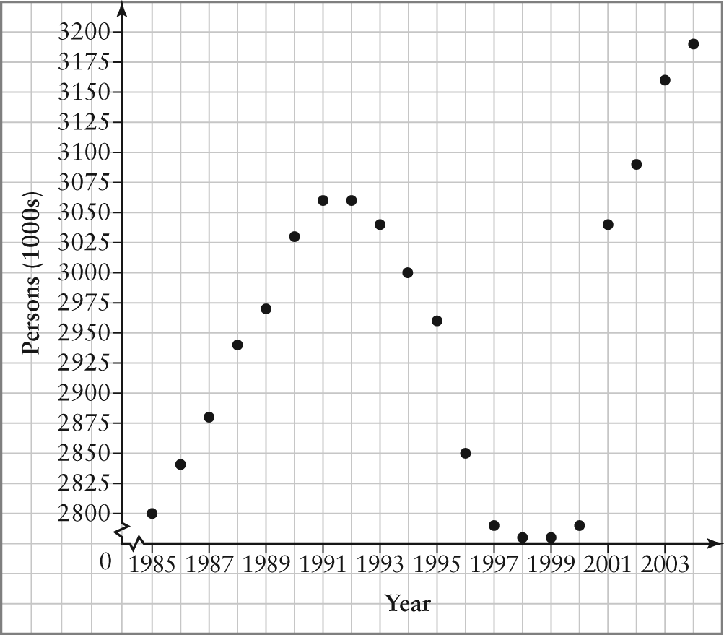
b) Example: Yes, but only for about 1.5 cycles. After 2001, the amplitude increases.
c) Example: amplitude: 140 000,
period: 15 years
d) Example:
P = 140 000 sin [24(x – 3.75)] + 2 920 000, where x is time, in years, after 1985 and P is the number of persons employed in the public sector

BLM 2–5 Chapter 2 Case Study
1. a) 50 b) s c) 65 Hz
2. 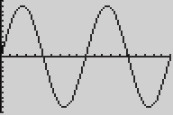 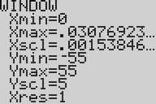
The graph looks like a regular sine graph with amplitude 50 and period .
3. a) 23 400x
b) 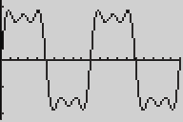 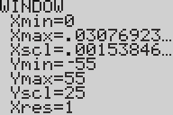
Example: The waves look flatter, with three little bumps instead of one big hump on the crests and troughs.
c) Example: The waves will become square-shaped.

