Chapter 3 Prerequisite Skills

Sketch Scale Figures
1. Measure each side and angle of the figure, and then draw the polygon using a scale
of 3:1.
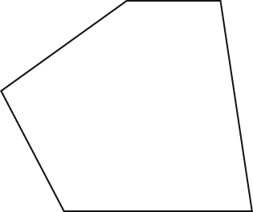
2. The rectangular foundation of a house measures 30 ft by 75 ft. Draw a scale diagram of the foundation, using a scale so that your drawing will fit on one quarter of an 8.5 in. by 11 in. sheet of paper.
Sketch and Determine Angles
3. For each angle described below, follow these steps:
i) Draw the given angle.
ii) Determine the measure of the angle clockwise between the positive y-axis and the terminal arm.
a) an angle in standard position, measuring 40°
b) an angle with its terminal arm 15° below the negative x-axis
c) an angle with its terminal arm 30° above the negative x-axis
d) an angle in standard position, measuring 280°
4. Determine the measure of the angle between the positive y-axis and the terminal arm of each angle after a reflection in the origin.
a) an angle in standard position measuring 60°
b) an angle in standard position measuring 220°
c) an angle with terminal arm 75° clockwise from the positive y-axis
d) an angle with terminal arm in the fourth quadrant and 18° from the negative y-axis
Solve Pythagorean Relationships
5. From his condominium building, Leon walks 250 m east. He then walks 400 m north. How far is he from his home, to the nearest metre?
6. A 12-foot ladder is leaning against the wall of a restaurant. The angle between the bottom of the ladder and the ground is 75°.
a) How far up the wall does the ladder reach, to the nearest tenth of a foot?
b) How far is the bottom of the ladder from the wall to, the nearest tenth of a foot?
Solve Non-Right Triangles
7. Determine the length of side c.
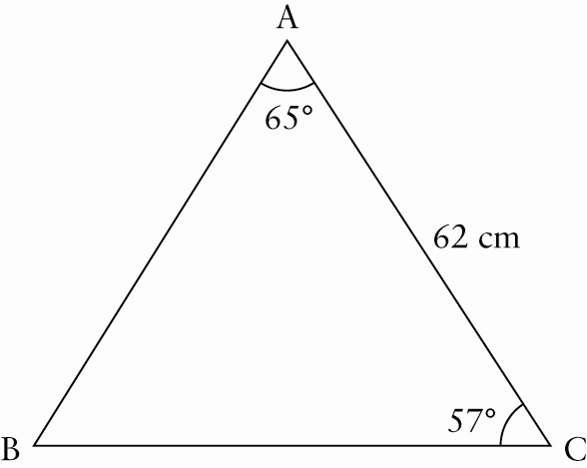
8. Determine the measure of ∠K, to the nearest degree.
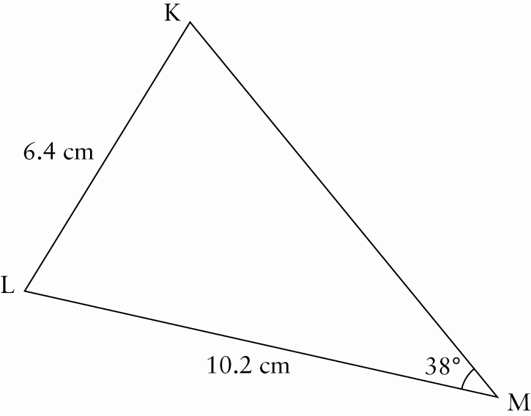

9. Calculate the measures indicated, to the nearest tenth.
a) 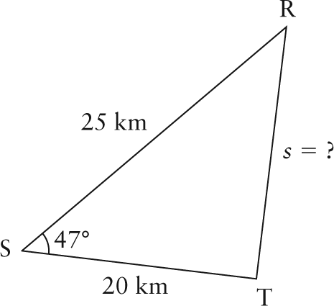
b) 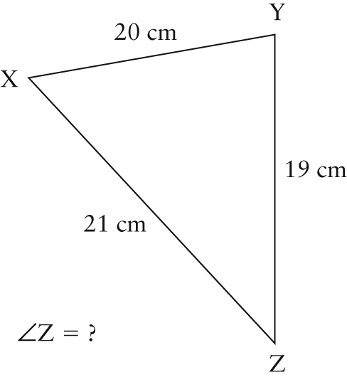
c) 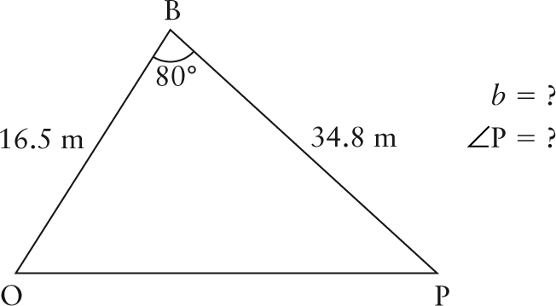
Understand Algebraic Properties
10. The properties in the table can be used to simplify expressions where a, b, and c represent real numbers. In your own words, explain each property. Give a numeric example for each property.

Property | Addition | Multiplication
Commutative | a + b = b + a | a × b = b × a
Associative | (a + b) + c = a + (b + c) | (a × b) × c =  a × (b × c)
Distributive | a(b + c) = ab + bc

