Chapter 3 Review

3.1 Vectors
1. Classify each quantity as a scalar or a vector.
a) A snowboarder is travelling at 30 km/h.
b) Sana drove 100 km southeast.
c) Luigi’s mass is 92 kg.
d) The golfer hit the ball 200 m.
e) A meteor collides with a planet with a force of 150 000 N.
f) The airplane flew 600 km/h in a NE direction.
2. State the opposite of each vector.
a) 40 m north
b) 570 km/h S35°W
c) 95 km on a bearing of N60°E
d) 80 mph on a true bearing of 103°
3. Describe the magnitude and direction of each vector in words and using symbols.
a) 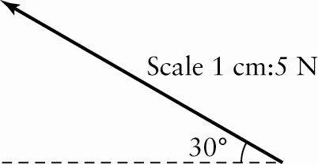
b) 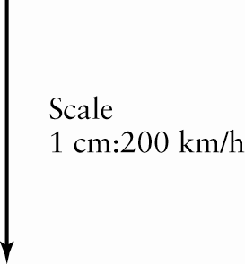
4. For each vector, choose an appropriate scale and draw a diagram. Label the magnitude, direction, and scale.
a) 600 m/s on a bearing of 070°
b) 1800 km heading S30°E
c) a force of 60 N at an inclination of 60° to the horizontal
3.2 Components of Vectors
5. Determine the horizontal and vertical components of each vector to the nearest tenth of a degree and nearest tenth of a unit.
a) 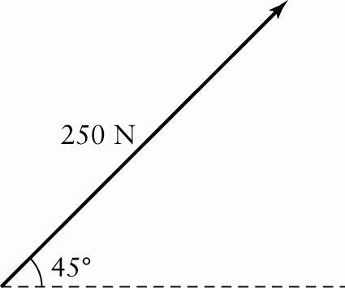
b) 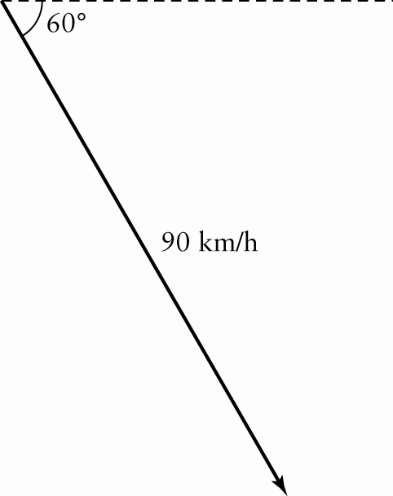
c) a force of 200 N applied at a bearing of 026°
d) a jet travelling N40°E at 900 km/h
6. A crate is pushed up a ramp with a net force of 150 N at an angle of 30° to the ground. Determine the magnitudes of the horizontal and vertical components to the nearest tenth of a newton.
7. A soccer ball is kicked with a velocity of
18 m/s at an angle of 15° with the ground. What is the magnitude of the velocity of the ball’s forward motion, to the nearest metre per second?

3.3 Adding Vectors
8. Consider the following vectors, all of which have the same magnitude.
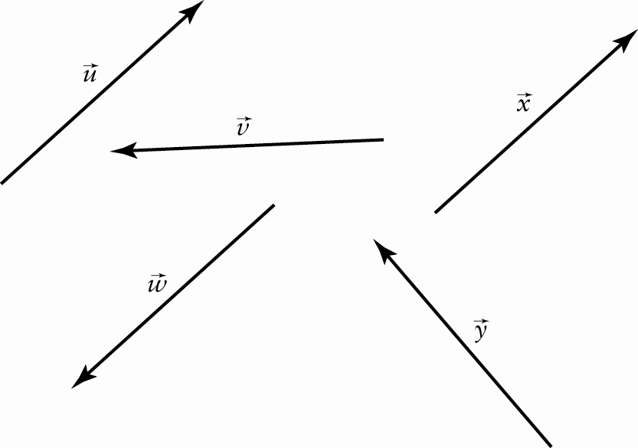
a) Which vectors are equivalent?
b) Which vectors are opposite?
c) Which vectors have a sum of 2?
d) Which vectors have a sum of ?
9. Determine the sum of each pair of vectors.
a) 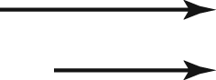 b) 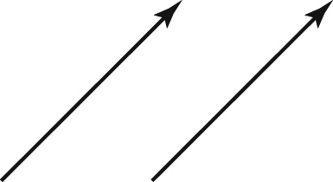
c) 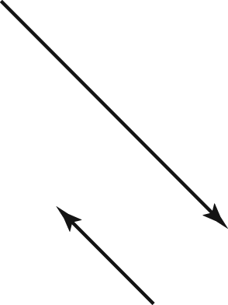
d) 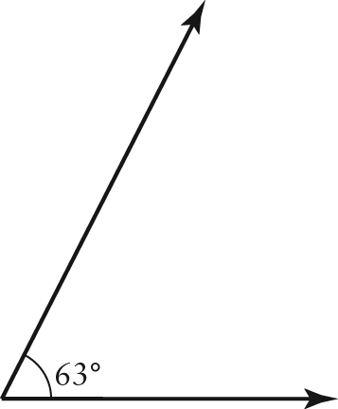
10. a) Explain the difference between distance and displacement.
b) Natasha went for a walk along the path shown. What distance did she travel?
c) What was Natasha’s displacement?
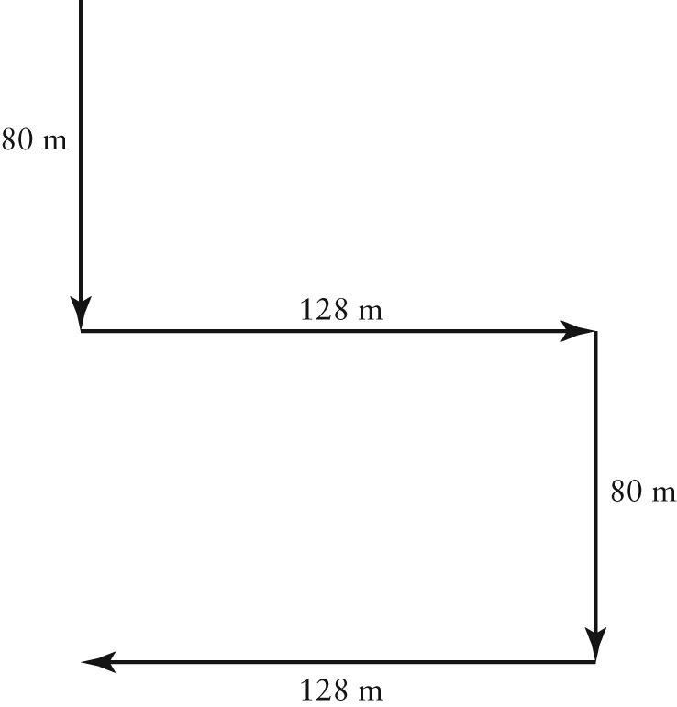
11. ABCD is a parallelogram with E the intersection point of the two diagonals,
as shown.
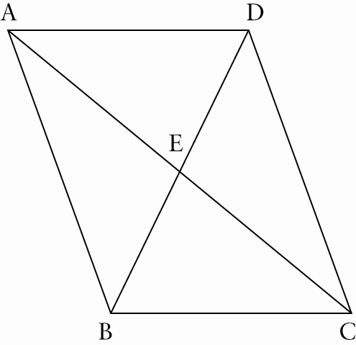
Name a vector equivalent to each of the following.
a)
b)
c)
d) +
e) +
f) +
12. Two vectors, and , are drawn head-to-tail. Use the triangle method to find the magnitude and direction of their sum.
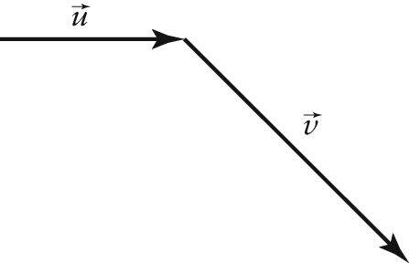
13. Use the parallelogram method to find the magnitude and direction of the sum of
and .
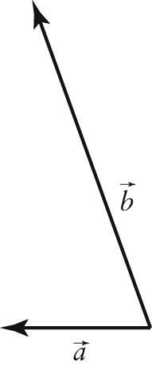
3.4 Subtracting Vectors
14. Draw a diagram to represent each difference.
a)
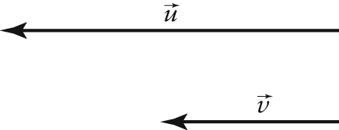
b)
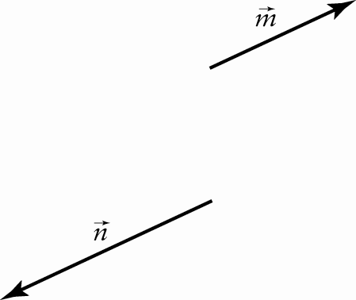
15. ABCDEF is a regular hexagon and O is
its centre. Let and . Write each of the following as an expression of
and .
a)
b)
c)
d)
16. Use this diagram to answer the questions.
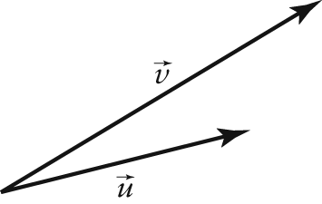
a) Find .
b) Find using the parallelogram method.
17. If and are given vectors and, describe how to find the magnitude and direction of .
3.5 Solving Problems Involving Vectors
18. A car travels north at 100 km/h for 2 h. Then, the car travels 60 km/h west for 1 h.
a) Determine the magnitude of the resultant displacement, to the nearest tenth of a kilometre.
b) Determine the direction of the resultant displacement, to the nearest degree.
19. An airplane travelling at an airspeed of
500 km/h and a heading of 225° encounters a wind blowing at 40 km/h from 180°. Determine the airplane’s velocity with respect to the ground to the nearest degree and the nearest kilometre per hour.

