Chapter 3 Practice Test

1. Classify each of the following quantities as a scalar or a vector. Justify your reasoning.
a) The temperature of the room is 20° C.
b) The barometric pressure is 118 kPa.
c) A cyclist is travelling east at 15 km/h.
d) The force of gravity is 196 N.
2. State the opposite of each vector.
a) 20 m/s heading east
b) 3100 N on a bearing of 120°
c) 16 km S40°W
d) 12 cm/h at an angle of 24° below the right horizontal
3. For each vector, choose an appropriate scale and draw a diagram. Use symbols to label the magnitude, direction as a quadrant bearing, and scale.
a) , representing a force of 2400 N on a bearing of 270°
b) , representing a displacement of
870 mi at an angle of 60° in standard position
4. An object is accelerating at a rate of 4 m/s² in a N30°W direction. Calculate the perpendicular components of the object’s acceleration to the nearest tenth of a kilometre per hour.
5. The cable from a tow truck to a car applies
a tension of 15 000 N at an angle of 35° to
the ground. What is the force holding the
car up, to the nearest newton?
6. After being hit, a baseball is moving at 60° to the horizontal. The horizontal speed of the ball is 80 km/h. Determine the following, to the nearest tenth of a kilometre per hour.
a) What is the vertical speed of the ball?
b) What is the velocity of the ball after
it is hit?
7. Determine the sum of each set of vectors.
a) 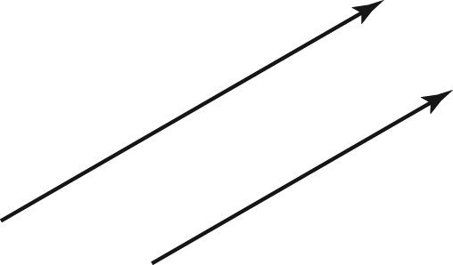
b) 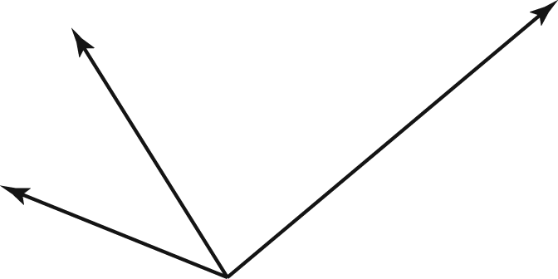
8. ABCD is a rhombus.
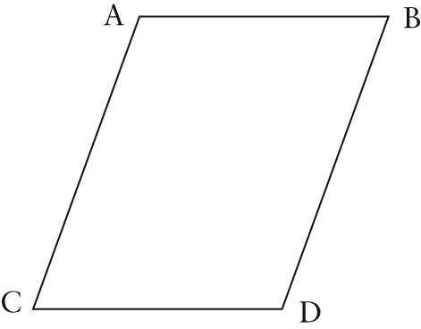
State whether each of the following statements is true or false. If the statement
is not true, rewrite it to make it true.
a)
b)
c)
d)
9. A plane flies 600 km in the direction N24°W, and then flies 350 km N40°W.
a) Draw a scale diagram to represent this situation. Label the scale on your diagram.
b) Use your diagram to determine the resultant displacement of the plane to the nearest kilometre.
c) Use another method to determine the resultant displacement of the plane to the nearest kilometre.
d) Compare your answers to parts b) and c). Which method is more accurate? Explain.
10. ABCDEFGH is a regular octagon. Name a single vector equivalent to each of the given expressions.
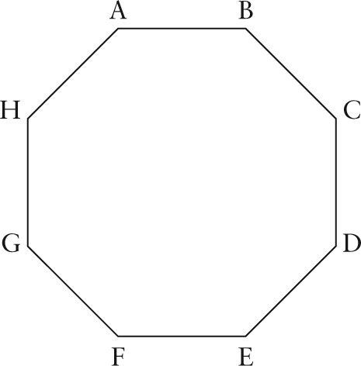
a)
b)
c)
d)
11. Given and , determine
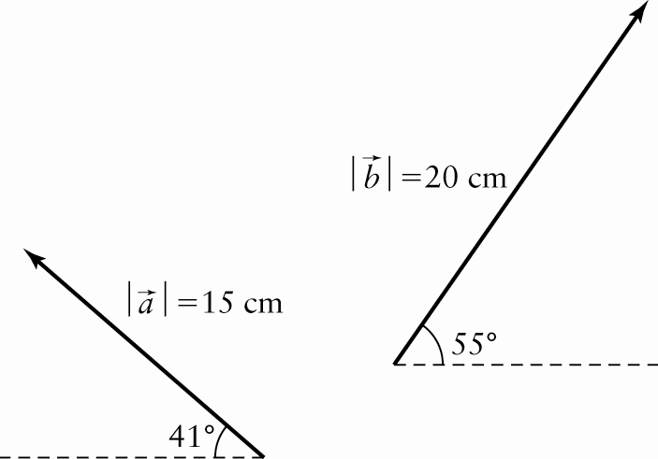
12. After a collision involving two vehicles,
the resulting momentum of the vehicles is 36 000 kg·m/s S45°E. Before the collision, the momentum of one vehicle was
15 000 kg·m/s E. What was the momentum of the other vehicle? Express your answer to the nearest whole numbers.
13. Two cranes are used to lift a heavy concrete pillar. One crane pulls straight up with a force of 7200 N. The other pulls with a force of 5300 N to the left, at an angle of 34° to the horizontal.
a) What is the magnitude of the combined force, to the nearest tenth of a newton?
b) At what angle does the pillar move, to the nearest tenth of a degree?
14. An airplane cruising with an airspeed of
550 km/h on a heading of 110° experiences a steady wind blowing 60 km/h from a heading of 300°. What is the velocity of the airplane with respect to the ground to the nearest degree and nearest kilometre per hour?
15. Jamie and Veronica Ant are dragging a bread crumb toward their colony for the queen. Jamie is pulling with a force of
0.3 g·cm/s² at an angle of 60° above the horizontal, while Veronica is pulling with
a force of 0.52 g·cm/s² at an angle of 30° below the horizontal. Buzz Bee tries to
steal the crumb by pulling along the horizontal in the opposite direction with a force of 0.60 g·cm/s². What is the net force on the crumb?
