Chapter 3 Case Study
Tools
• graphing calculator
Graphic Designer
• Jona Chris earned an associate degree of applied science from a Canadian college. In her spare time, she familiarized herself with computer graphic design applications. After college, Jona got a job as a graphic designer at an advertising company, earning $36 000 per year.
• Jona’s job requires more than an understanding of design software programs and printing processes. She must also provide creative solutions to clients’ visual communication challenges.
• Much of Jona’s work involves vector graphics that use mathematical formulas and algorithms to create the illusion of motion. These techniques include using translation, rotation, and/or scaling.
• On one of Jona’s projects, the client wants the company’s logo on its web site to appear to move toward the user. This effect can be created by using different sizes of the logo while simultaneously changing its horizontal and vertical position. To work through this problem, Jona begins by trying to create the effect using a simple vertical line. The line appears to move toward the user as it moves from the corner of the screen to the centre.
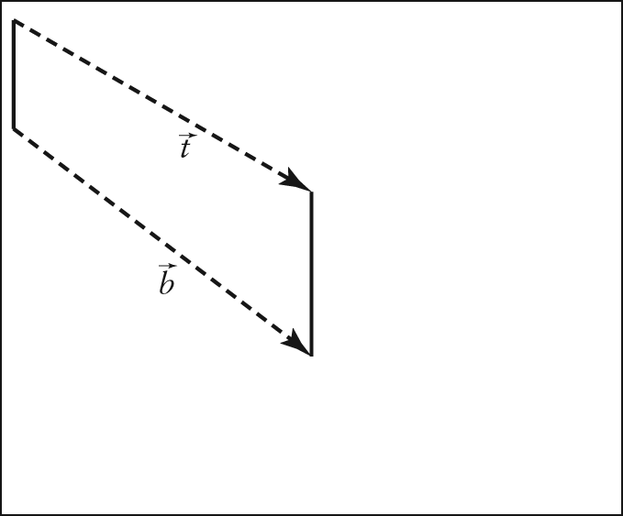
Questions
1. Explain why the two vertical lines in Jona’s sample need to be different lengths in order to achieve the desired effect.
2. Suppose the shorter vertical line was in the centre of the screen, gradually changing to the longer line. What would the user see? How would this effect be different from the one Jona hopes to create?
3. As shown in the drawing above, the changes in the top and bottom of the small vertical line can be represented using and Without measuring, determine whether these vectors are equivalent.
Explain your answer.
4. Suppose the video clip of the line moving is viewed on a screen that is 10 in. high and 16 in. wide. If the height of the vertical line in the corner is 3 in. and the height of the vertical line in the centre of the screen is 6 in., determine the magnitude to the nearest tenth of an inch and the direction of and to the nearest degree.

