Chapter 3 BLM Answers

BLM 3–1 Chapter 3 Prerequisite Skills
1. Answers may vary slightly.
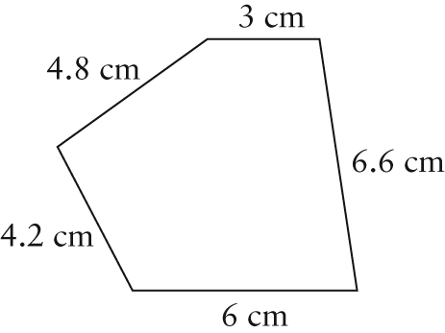
2. Example: At a scale of 1 cm:5 ft, the drawing of the rectangle is 15 cm by 6 cm.
3. a) i) 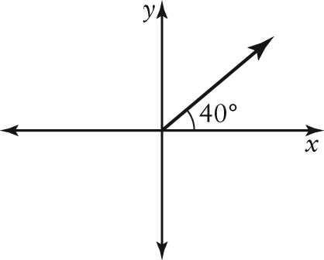
ii) 50°
b) i) 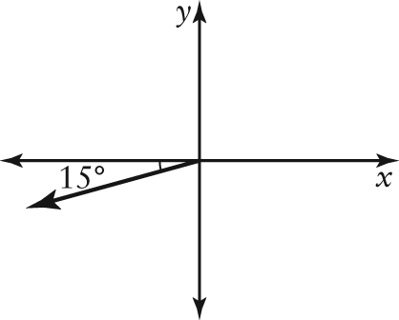
ii) 255°
c) i) 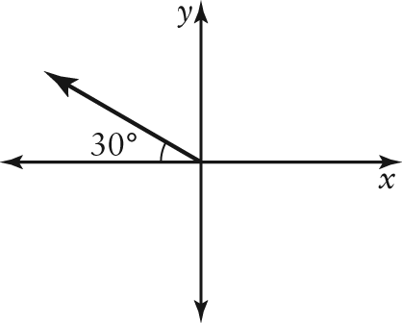
ii) 300°
d) 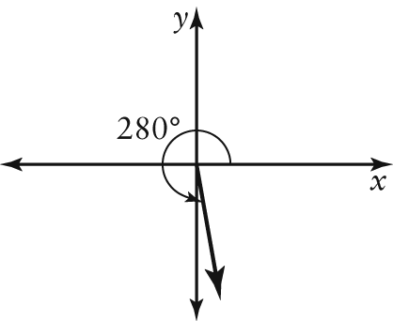
ii) 170°
4. a) 150° b) 50° c) 105° d) 18°
5. 472 m
6. a) 11.6 ft b) 3.1 ft
7. 61.3 cm
8. 79°
9. a) 18.5 km b) 59.8°
c) b = 35.8 m; ∠P = 27°
10. Example: The commutative property means that it does not matter in which order the numbers to be added or multiplied are written; e.g., 2 + 3 = 3 + 2. The associative property means that when adding or multiplying three numbers, it does not matter if you add/multiply the first pair or the second pair of numbers first; e.g., (2 + 3) + 4 = 2 + (3 + 4). The distributive property means that simplifying inside brackets before multiplying is equivalent to multiplying each number in the brackets by the number outside and adding the products;
e.g., 2(3 + 4) = 2(3) + 2(4).
BLM 3–3 Chapter 3 Review
1. a) scalar b) vector c) scalar
d) scalar e) scalar f) vector
2. a) 40 m south
b) 570 km/h N35°E
c) 95 km on a bearing of S60°W
d) 80 m/h on a true bearing of 283°
3. Magnitudes may vary slightly.
a) 18 N on a bearing of N60°E or a true bearing of 060°
b) 500 km/h S or a true bearing of 180°
4. a) Example: 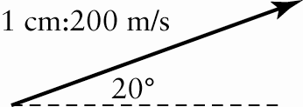
b) Example: 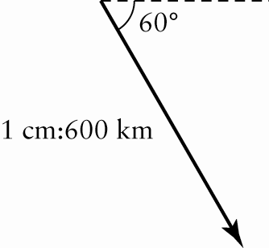
c) Example: 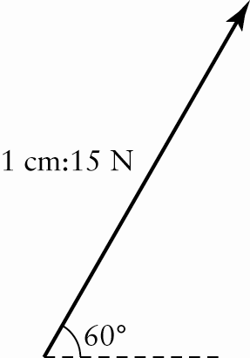

5. a) horizontal = 176.8 N, vertical = 176.8 N
b) horizontal = 45 km/h, vertical = 77.9 km/h
c) horizontal = 87.7 N, vertical = 179.8 N
d) horizontal = 578.5 km/h, vertical = 689.4 km/h
6. horizontal = 129.9 N, vertical = 75 N
7. 17.4 m/s
8. a) and
b) and are each opposite to
c) and
d) and or and
9. Drawn vector should be the same, in direction, as the vector shown, and drawn to the approximate length indicated:
a) 3.5 cm
b) 5 cm
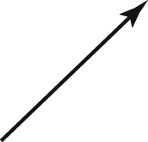
c) 2 cm
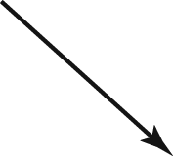
d) 6 cm
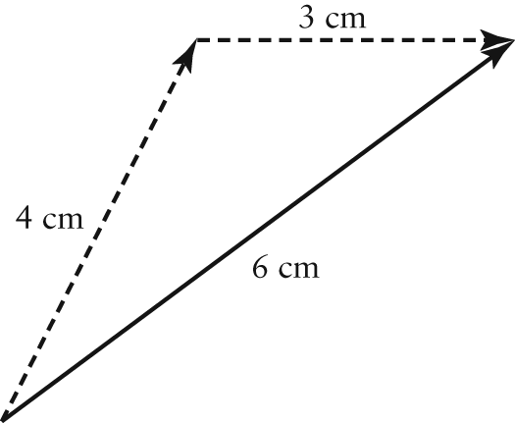
10. a) Distance represents the total length of movement, without direction. Displacement represents the difference between the starting and final positions, including direction.
b) 416 m c)160 m S
11. a) b)
c) none d)
e) f)
12. Answers may vary slightly. 4.1 cm at an angle of 315° in standard position

13. Answers may vary slightly. 4.5 cm at an angle of 130° in standard position
14. Vectors should be similar to the ones shown and drawn to the approximate given lengths.
a) 1.8 cm
b) 4.1 cm
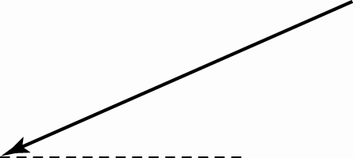
15. a) b)
c) d)
16. Answers may vary slightly.
a) 1.4 cm at an angle of 241° in standard position
b) 1.4 cm at an angle of 61° in standard position
17. Draw in the opposite direction and find the sum of .
18. a) 208.8 km b) N17°W
19. 473 km/h at a heading of 228°
BLM 3–4 Chapter 3 Practice Test
1. a) scalar; no direction
b) scalar; no direction
c) vector; magnitude and direction
d) vector; magnitude and a force, which always has direction
2. a) 20 m/s heading west
b) 3100 N on a bearing of 300°
c) 16 km N40°E
d) 12 cm/h at an angle of 156° in standard position
3. a) Example:
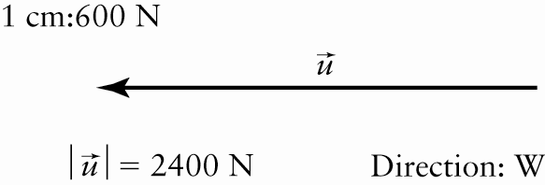
b) Example:
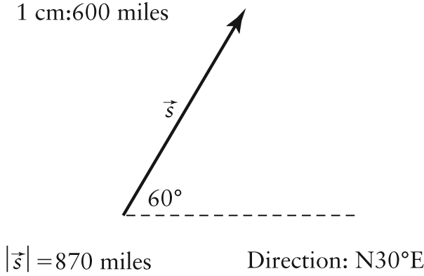
4. horizontal = 2 m/s² west, vertical = 3.5 m/s² north
5. 8604 N
6. a) 138.6 km/h b) 160.0 km/h
7. Answers may vary slightly.
a) 7.2 cm, at 16° to the horizontal
b) 6.3 cm at an angle of 95° in standard position
8. a) True
b) False; = 0 or = 0
c) False; or
d) True
9. a) 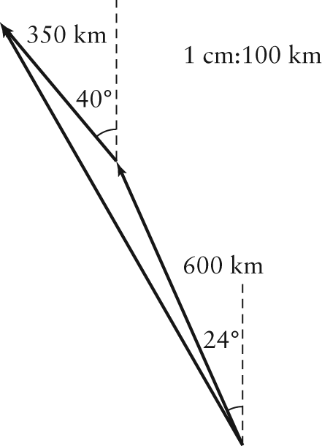
b) Example: 940 km at a heading of N30°W
c) 941 km at a heading of N30°W
d) Using trigonometry is more accurate because it is difficult to draw the triangle accurately using a ruler and protractor.

10. a) b) c) d)
11. 24.1 cm at an angle of 195° in standard position
12. 27 520 kg·m/s at S22°E
13. a) 11 072.8 N b) 66.6° from the horizontal
14. 609 km/h at a bearing of 111°
15. 0 g.cm/s²
BLM 3–5 Chapter 3 Case Study
1. The size difference is needed to create a sense of depth, because an object appears smaller when viewed from farther away. If the two lines were the same size, it would only appear as though the line was moving diagonally from the corner to the centre.
2. The line would appear to lengthen at both ends, but the apparent distance to the viewer would remain the same.
3. The two are not equivalent because the bottom of the line must move farther than the top. The angles are not equal.
4. = 8.2 in. at an angle of 14° below the horizontal; = 8.5 in. at an angle of 21° below the horizontal

