Chapter 4 BLM Answers

BLM 4–1 Prerequisite Skills
1. a) 5⁵, 3125 b) (–4)⁷, –16 384
c) , d) ,
2. a) 8², 64 b) 2⁵, 32
c) d)
3. a) 5⁶, 15 625 b) 2⁸, 256
c) (–3)⁶, 729 d)
4. a) 1 b) c)
d) e) f ) –1
5. a) x⁹ b) a³ c) b¹¹
d) e) f ) n⁹
6. a) –11 b) 2
7. a) b) c)
8. a) $5624.32 b) 8.0 cm c) 82.4 °F
9. a) 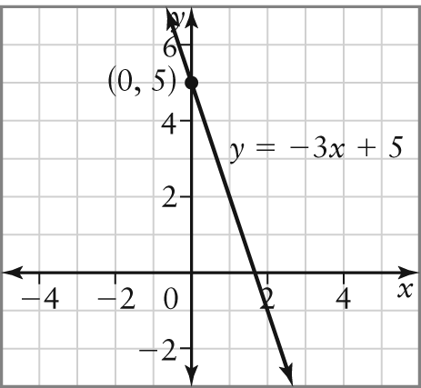
b) 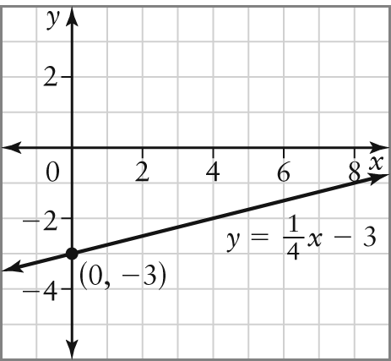
c) 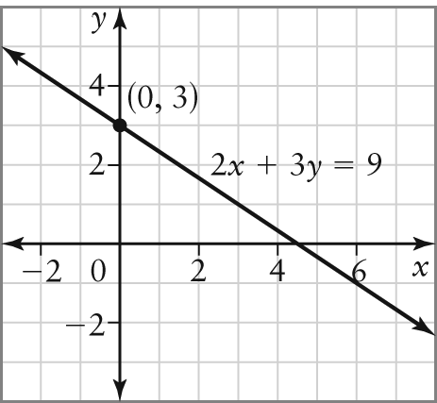
d) 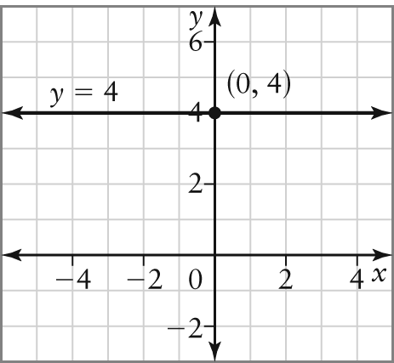
10. a) 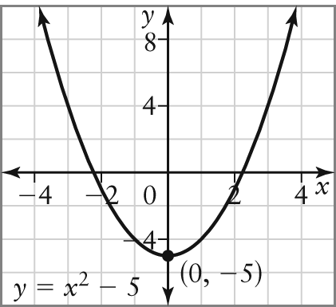
b) 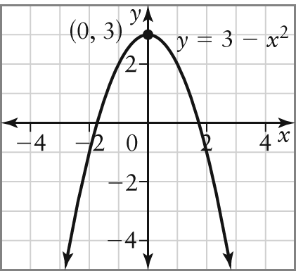
c) 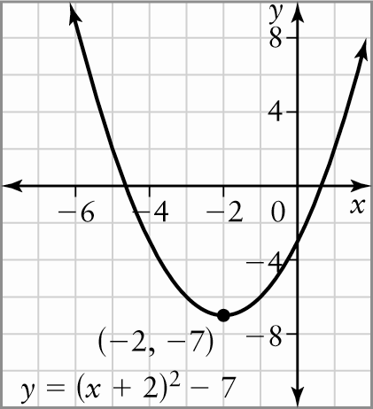

d) 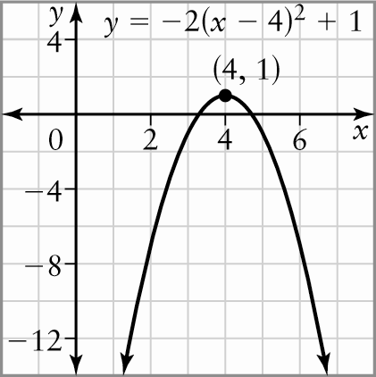
11. a) quadratic b) neither
BLM 4–3 Chapter 4 Review
1. a) 8⁸ b) 4¹⁵ c) 0.4⁵ d) 125a⁶b¹²
2. a) b) c)
d) e) f )
3. a) 0.0865 b) 0.7059 c) 10.4209
d) –0.0049 e) 13.8004 f ) –26.2279
4. a) b) c)
d) e) f )
5. equal;
6. a) 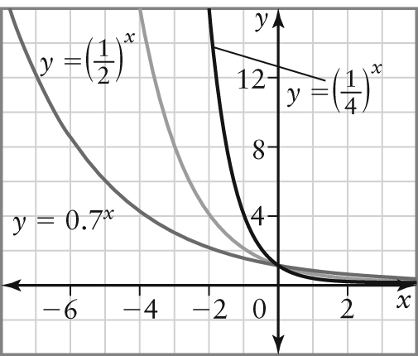

b) |  |  | y = 0.7^{x}
Domain | {x ∈} | {x ∈} | {x ∈}
Range | {y ∈  y > 0} | {y ∈  y > 0} | {y ∈  y > 0}
Asymptote | y = 0 | y = 0 | y = 0
y-intercept | 1 | 1 | 1
y-value when x = 1 | 2 | 5 | 10
Rate of decrease | decreases fastest | decreases faster | decreases fast
7. a) Example: 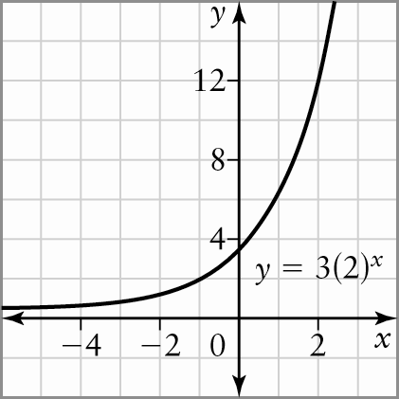
b) Yes. If the base is greater than 1 and the
y-intercept is 2, there are infinite possible curves.
8. –2
9. a) Example: x 2.8 because 4² = 16 and
4³ = 64, and 50 is much closer to 64 than 16
b) 2.8
10. a) 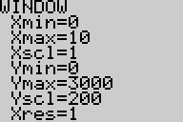 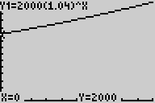
b) the y-intercept c) $2433.31
d) approximately 17.7 years
11. a) 4 b) 3 c) 3
d) 2 e) 2 f ) 1
12. a) 1.3 b) 3.4
c) 2.6 d) 1.5
13. a) b) –1 c)
d) e) –14
14. a) b) 7.9 mg
c) 12 days
15. a) (6, 512) b) (1, 27)
c) (–2, 1) d) no solution
16. a) 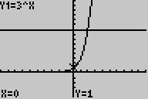
b) (2, 9) c) 2
d) by solving the equation 3^{x} = 9; because at the point of intersection the y-values are equal

17. a) A = 35 000(1.02)^{n} b) $40 204
c) 2018
18. a) 2⁵ = 32 b) 10^{–3} = 0.001
c)
19. a) 3 b) 5
c) –8 d) 0
20. a) Graph y = 3^{x} and estimate the x-value when
y = 18.
b) 2.6
21. a) 2.015 b) 1.295
22. a) 2.15 b) 46.90
23. a) A = 2500(1.018 75)^{2t}
b) approximately 37.3 years
BLM 4–4 Chapter 4 Practice Test
1. a) b) c) 8h⁶
d) e) f )
2. a) b) 1
c) 8 d)
3. a) b)
c) d)
4. 65 km
5. a) 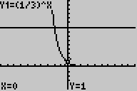
b) (–2, 9) c) –2
6. a) Example:
7. a) –3 b) –3
c) d)
8. a) n = 2^{d} b) March 8 c) March 11
9. a) V = 24 000(0.85)^{n}
b) approximately 14 years
c) $3600; $1879.22. As the value goes down, the amount of depreciation goes down because 15% of a smaller quantity is calculated each year.
10. 9.4
11. (2, 65 536)
12. x = 2. The graphs intersect at the point (2, 27).
13. a) Let n represent the number of months after January. Let E represent the monthly earnings, in dollars. E = 3100(1.01)^{n}
b) $3356.86
c) Example: No, because it is unlikely his monthly earnings will continue to rise.
14. a) log₃ 81 = 4
b)
c) log₇ 2401 = 4
d) log₅ 1 = 0
15. a) 3
b) 7
c) –4
d) 7
16.
17. Example: A negative base with a non-integer exponent is undefined, log₀ 0 has an infinite number of solutions, and log₁ x has meaning only for x = 1, in which case it has an infinite number of values.
18. a) Solve 2^{x} = 75 or evaluate .
b) 6.23
19. a) 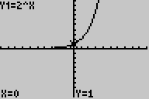
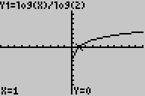

b) | y = 2^{x} | y = log₂ x
Domain | {x ∈} | {x ∈ x > 0}
Range | {y ∈ y > 0} | {y ∈}
x-intercepts | none | 1
y-intercepts | 1 | none
Vertical asymptote | none | x = 0
Horizontal asymptote | y = 0 | none
Intervals of increase | {x ∈} | {x ∈ x > 0}
Intervals of decrease | none | none
20. a)
b) $3568.33
c) approximately 20 years
21. a) 31 623 b) 5
22. a) 3.3 b) 10^{–7} mol/L
BLM 4–5 Chapter 4 Case Study
1. a) Example: 10, because there is a ten-fold increase in H⁺ ions for each single-point difference in the pH scale.
b) Yes; 7.4
c) 0.000 000 3 mol/L
2. a)
b) 20 480 000 organisms/mL
c) approximately 1.2 organisms/mL

