Chapter 5 Prerequisite Skills

Simplify Expressions
1. Expand and simplify.
a) 3(x – 4) + 7(x + 8)
b) 2(x – 5)(x + 3)
c) 4(x + 2)²
d) –3(2x – 1)(x + 5)
e) (3x + 2)² – (2x + 3)(2x – 3)
Convert Forms of Quadratic Equations
2. Write each relation in standard form.
a) y = (x – 15)² + 9 b) y = (x + 7)² – 3
c) y = 4(x – 1)² – 8 d) y = –3(x – 8)² + 14
Work With Factors
3. List the factors of each number.
a) 24 b) –12
c) 45 d) –110
4. Find two integers with each product and sum.
a) product 24, sum 11
b) product –15, sum 2
c) product –36, sum –16
d) product –60, sum –11
5. Factor fully.
a) x² + 3x b) x³ – 4x² + 2x
c) –2x³ + 10x² – 6x d) x² + 8x + 15
e) w² – 3w – 4 f ) 5t² – 20
g) 3k² + 12k – 36 h) –5m² + 25m – 30
Evaluate Equations
6. Evaluate y using the given value of x.
a) y = 3x + 2 when x = –2
b) 4x – 5y + 11= 0 when x = 1
c) y = 2x² – 5x + 9 when x = –3
d) y = (7 – x)(2 + x) when x = –5
7. Solve for x.
a) 5(x + 3) = 2x b) –8x + 22 = –50
c) x² – 9 = 0 d) (3x – 2)(x + 9) = 0
Solve Quadratic Equations
8. Find the zeros of each quadratic relation.
a) y = x² + 5x + 6 b) y = x² + x – 12
c) y = x² – 1 d) y = x² + 7x
e) y = x² + 6x + 9 f ) y = 2x² + 6x – 20
Interpret Graphs
9. Find the x-intercepts.
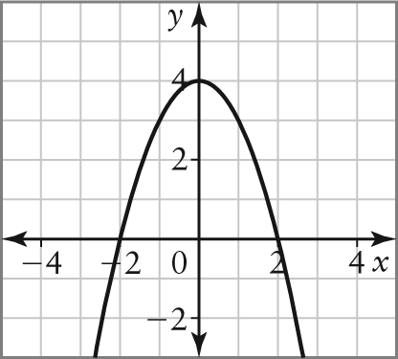
Recognize Types of Functions
10. Use finite differences to determine whether each relation is linear, quadratic, or neither.

a) b)
x | y
0 | –3
1 | –1
2 | 5
3 | 15
4 | 29

x | y
–2 | –26
–1 | –12
0 | –10
1 | –8
2 | 6

Solve Word Problems
11. A kicker is trying to kick a field goal. The path of the football can be modelled by the relation h = –0.03d² + 1.2d, where h is the ball’s height and d is the horizontal distance from the kicker, both in metres.
a) Find the zeros of the relation.
b) What do the zeros represent here?
12. A garden is to be surrounded by a paved walkway of uniform width.
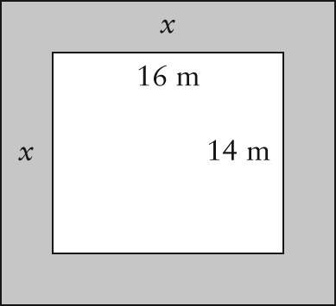
a) Write a simplified expression for the area of the walkway.
b) The walkway is to have an area of 216 m². Find the width of the walkway.

