Chapter 5 Review

5.1 Identifying Polynomial Functions
1. Determine whether each of the following is a function. Justify your answer.
a) y = cos x
b) y = x³ – x² + 7
c) x² + y² = 36
d) y =
e) y = ±
f ) {(–2, 1), (0, 3), (2, 4), (4, –3)}
2. Determine which of the following are polynomial functions. If it is not a polynomial function, state what type of function it is.
a) y = 3x + 8 b) y = 4^{x}
c) y = d) y = 5x³ – 13x⁵
e) y = f ) y = sin x + 2
3. State the degree of each function.
a) y = 4x³ – 10x
b) y = 20 + 37x
c) y = 3 + 5x² – 2x³ + 8x⁵
d) y = 36
5.2 Graphs of Polynomial Functions
4. Consider each of the following graphs.
i) State whether the graph represents an odd-degree or even-degree polynomial function.
ii) Determine the sign of the leading coefficient.
iii) State the domain and range.
iv) Describe the end behaviour.
a) 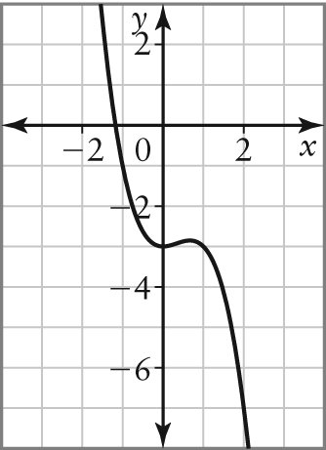
b) 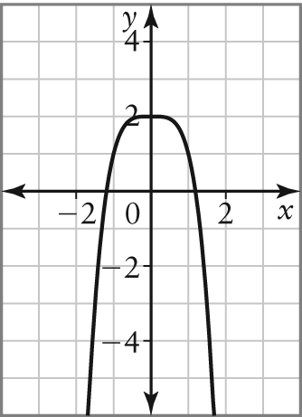
c) 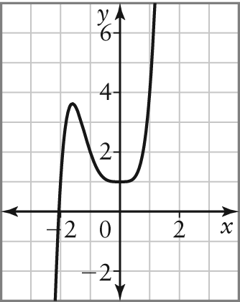
d) 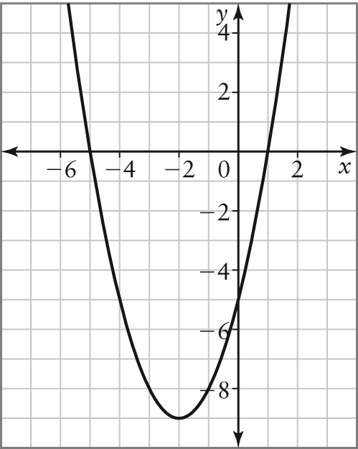

5. Consider the table of values below. Use finite differences to determine:
a) the degree of the polynomial function
b) the sign of the leading coefficient
c) the value of the leading coefficient
x | y
–2 | 7
–1 | –11
0 | –9
1 | –11
2 | 7
3 | 117
5.3 Comparing Polynomial Functions
6. Consider each of the following graphs.
i) Determine the x-intercepts and state whether they are of even or odd order.
ii) Determine the minimum degree of the polynomial function represented. Justify your answer.
a) 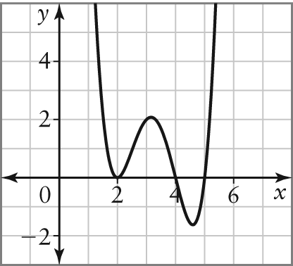
b) 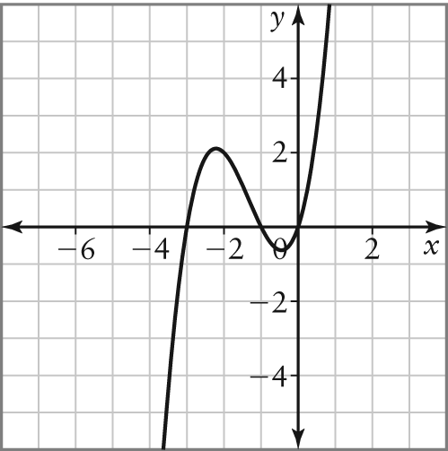
c) 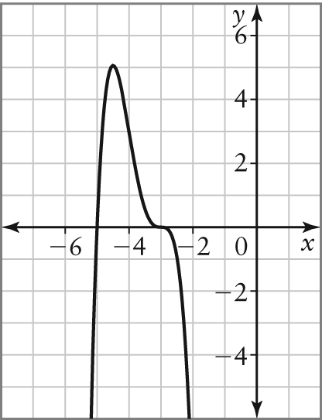
d) 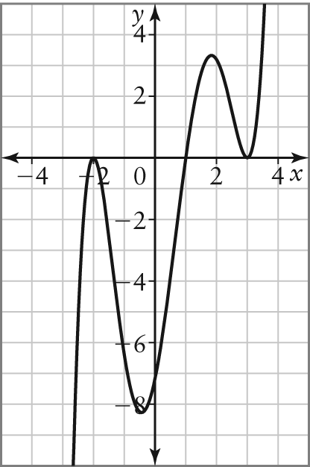
7. Determine algebraically whether the symmetry of each function is even, odd, or neither. Verify your answers using graphing technology.
a) y = 3x⁴ – 2x² + 1 b) y = 2x³ – 2x² – 4x
c) y = 2x⁴ + 8x³ – 5 d) y = –x⁵ + 7x³ + 3x
5.4 Evaluating Polynomial Functions
8. Evaluate each of the following functions for x = 3, with or without graphing technology.
a) y = 2x³ – 4x² + x – 10
b) y = –x⁴ + 6x² – 3
c) y = (x – 5)²(x + 1)²(x + 2)
9. Determine the y-intercept of each function.
a) y = x⁴ + 9x³ – 7x² + 4x – 8
b) y = –x⁷ + 5x³ – x² + 3
c) y = x(x + 2)(x – 4)²
d) y = (x – 3)(x – 2)(x + 1)³
5.5 Solving Problems Involving Polynomial Functions
10. A swimming pool is being drained according the function V = 1.1(82 – t)³, where t is the time, in minutes, and V is the volume, in litres, of water remaining in the pool.
a) How much water is in the pool initially?
b) How much water is in the pool after
20 min?
c) How long does it take to drain the pool?
d) State the domain and range of this function.
11. A town’s population can be modelled with the equation P = 6t⁴ – 5t³ – 12t² + 15 000, where t is time, in years from now, and P is the population.
a) What is the population of the town now?
b) Which finite differences are constant for this polynomial function?
5.6 Factoring Polynomial Expressions
12. Factor completely.
a) m² – 10m + 16 b) t² + 7t – 18
c) y² – 8y + 12 d) 3x² + 18x + 15
e) 4x² + 4x – 48 f ) –2x² + 14x – 12
13. Factor completely.
a) cx + cy + dx + dy b) au + av – bu – bv
c) 4a – 4b + ta – tb d) 2x² – 3x – 9
e) 5p² + 11p + 2 f ) 3t² – 31t + 36
g) 4x² + 4x – 3 h) 12h² – 4h – 5
14. Factor completely.
a) 4x² + 18x + 8 b) 14w² – 21w – 14
c) –12s³ – 51s² + 45s d) 12p² – 26p – 10
e) –32h² + 40h – 12 f ) 48x² + 6x – 9
g) 3x³ – 6x² + 5x – 10 h) x³ + 4x² – 8x – 32
5.7 Difference of Squares of Polynomial Expressions
15. Factor each polynomial expression.
a) x² – 100 b) 4w² – 9
c) 25x² – 1 d) 64r² – 81
16. Factor completely.
a) 32t² – 98 b) 2 – 50x²
c) x⁴ – 81 d) 3c⁴ – 48
5.8 Intercepts of Polynomial Functions
17. Do the following for each polynomial function below.
i) Graph the function.
ii) Use the graph to determine the
x-intercepts.
iii) Factor each polynomial function, and then use the factored form to determine the roots.
iv) State how the roots compare to the
x-intercepts.
a) y = x² + 2x – 3 b) y = x³ – 4x²
18. Consider the polynomial function
y = x³ + 2x² – 5x – 6.
a) Use graphing technology to determine the x-intercepts.
b) Use the x-intercepts from part a) to express the polynomial function in factored form.
c) Use the factored form from part b) to determine the roots algebraically.
d) Determine the y-intercept of the function.

