Chapter 5 Practice Test

1. Determine whether each of the following is a polynomial function. If it is not a polynomial function, state what type of function it is.
a) y = 4 – 3x + 5x²
b) y = 6^{x}
c) y = 4x⁵ + 3x³ – 1
d) y = –4 – x
2. State the degree of each function.
a) y = 9 – 4x² + 7x³ – x⁵
b) y = –4
c) y = 2x + 10
3. Explain how you can tell if a relation is a non-function given the following:
a) a graph of the relation
b) an equation of the relation
4. Describe the end behaviour of each of the following functions.
a) y = x⁴ – 2x² – 15x + 29
b) y = 6x + 40x² – 125x³
5. Consider the following table of values.
x | y
–3 | –40
–2 | –11
–1 | 2
0 | 5
1 | 4
2 | 5
Use finite differences to determine the following:
a) the degree of the polynomial function. Explain how you know.
b) the sign of the leading coefficient
c) the value of the leading coefficient
6. Answer the following for each of the graphs:
i) Is the polynomial function an odd-degree polynomial or an even-degree polynomial? Justify your answer.
ii) Is the leading coefficient positive or negative?
iii) Describe the end behaviour of the graph of the polynomial function.
iv) State the domain and range of the polynomial function.
a) 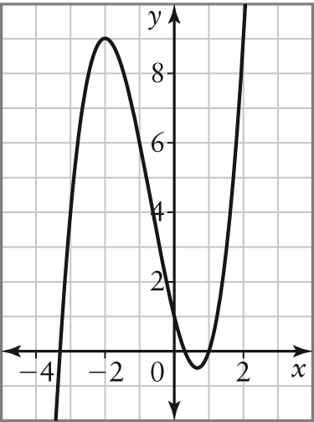
b) 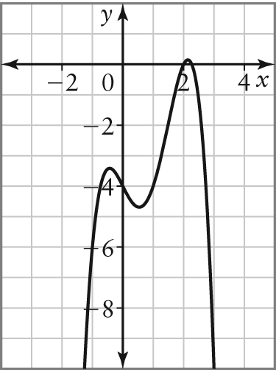
7. A designer wants to create a cylindrical glass vase with a radius to height ratio of 1:6. The height of the vase will not be greater than 36 cm, and it will have an
open top.
a) Write a polynomial function to represent the surface area, SA, of the vase in terms of the radius, r. State the domain and range, and describe the end behaviour of the function.
b) Write a polynomial function to represent the volume, V, of the vase in terms of the radius, r. State the domain and range, and describe the end behaviour of the function.

8. Explain why an even-degree polynomial function can have zero x-intercepts, but an odd-degree function cannot.
9. Consider each of the following graphs.
i) Determine the x-intercepts and state whether they are of even or odd order.
ii) Determine the minimum degree of the polynomial function represented. Justify your answer.
a) 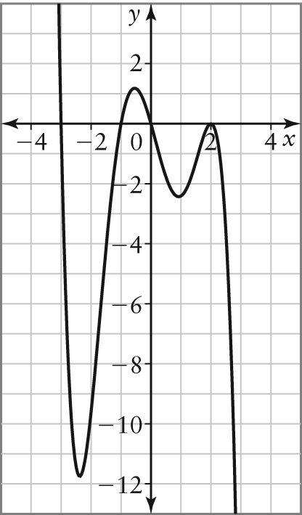
b) 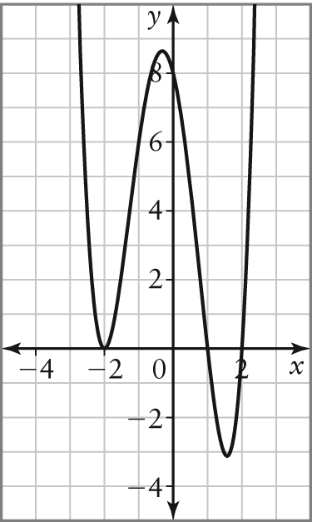
10. a) Describe how the graphs of an even function and an odd function are different.
b) Determine algebraically whether the symmetry of each function is odd, even, or neither.
i) f(x) = –5x³ – 2x²
ii) y = 3 – 2x² – x⁴
11. Evaluate each of the functions for the given value of x.
a) y = 2x³ – 3x² + 4x – 5, x = –3
b) y = –x⁶ + 4x⁵ – x³ + 3x² – 13, x = 2
12. The profit, P(x), in thousands of dollars, for the sale of a particular model of digital camera can be modelled by the function
P(x) = 0.00131x⁴ + x – 2, where x
represents the number, in hundreds,
of digital cameras sold.
a) What type of function is P(x)?
b) Which finite differences are constant for this polynomial function?
c) Describe the end behaviour of this function, assuming there are no restrictions on the domain.
d) What are the restrictions on the domain of this function? Explain why there are restrictions.
13. Factor each of the following completely.
a) 3w² – 17w – 28
b) ax + ay – 2x – 2y
c) 6t² + 7t – 3
14. The area of a rectangular yard is given by
A = 18x² + 45x + 7.
a) Determine expressions for the length and width of the yard.
b) For what value of x will the shape of the yard be a square?
15. Factor each of the following completely.
a) 2x² – 26x + 80
b) –24m³ + 6m² + 45m
c) 4w² – 49
d) 3a² – 108
e) h⁴ – 16
16. Two square sheets of metal have an area of 100a² and 64b². Express the difference in the areas in factored form.

17. Determine the x-intercepts of each function.
a) y = 2x² + x – 6
b) y = 3x² + 6x – 72
c) y = x³ – 5x²
18. Consider the function y = x³ + x² – 2x.
a) State the degree of the polynomial function.
b) State the value and the sign of the leading coefficient.
c) Determine the end behaviour of the function.
d) Determine the x-intercepts of the function algebraically.
e) Determine the y-intercept of the function algebraically.
f ) Sketch a graph of the function.
g) State the domain and the range of the function.
19. A rock breaks off of the side of a cliff.
Its height above the ground is given by the equation h(t) = –4.9t ² + 19.6t + 24.5, where h is the height of the rock, in metres, and t is the time, in seconds, after the rock break off.
a) How high above the ground is the rock when it breaks off?
b) What is the height of the rock after 2 s?
c) How long does it take to hit the ground?
d) What are the restrictions on the domain of this function? Explain.
20. The number of fish produced in a river depends on the temperature of the water,
and is modelled by the equation
y = –x³ + 5x² + 200x + 3000, where y is the number of fish produced and x is the temperature of the water, in degrees Celsius.
a) Name the type of polynomial function represented by this equation.
b) What is the y-intercept? What does it represent in this situation?
c) The x-intercept is approximately 21. What does it represent here?
d) The function has a local minimum at
(–6.7, 2185) and a local maximum at
(10, 4500). Sketch a graph of this function.
e) Explain what happens to the y-values when x is less than –6.7. Describe why this part of the function probably does not fit the situation represented.

