Chapter 5 BLM Answers

BLM 5–1 Chapter 5 Prerequisite Skills
1. a) 10x + 44 b) 2x² – 4x – 30
c) 4x² + 16x + 16 d) –6x² – 27x + 15
e) 5x² + 12x + 13
2. a) y = x² – 30x + 234
b) y = x² + 14x + 46
c) y = 4x² – 8x – 4
d) y = –3x² + 48x – 178
3. a) 1, 2, 3, 4, 6, 8, 12, 24
b) ±1, ±2, ±3, ±4, ±6, ±12
c) 1, 3, 5, 15, 45
d) ±1, ±2, ±5, ±10, ±11, ±22, ±55; ±110
4. a) 3 and 8 b) –3 and 5
c) –18 and 2 d) –15 and 4
5. a) x(x + 3) b) x(x² – 4x + 2)
c) –2x(x² – 5x + 3) d) (x + 3)(x + 5)
e) (w – 4)(w + l) f ) 5(t – 2)(t + 2)
g) 3(k – 2)(k + 6) h) –5(m – 2)(m – 3)
6. a) –4 b) 3 c) 42 d) –36
7. a) –5 b) 9 c) ±3 d) , –9
8. a) –2, –3 b) –3, 4 c) ±1
d) 0, 7 e) –3 f ) –5, 2
9. ±2
10. a) quadratic b) neither
11. a) 0, 40
b) the point where the ball is kicked and where it strikes the ground
12. a) 4x² + 60x b) 3 m
BLM 5–3 Chapter 5 Review
1. a) yes b) yes c) no
d) yes e) no f ) yes
Parts c) and e) are not functions because there are values of x that are associated with more than one value of y.
2. a) polynomial function
b) exponential function
c) rational function
d) polynomial function
e) square root function
f ) trigonometric function
3. a) 3 b) 1 c) 5 d) 0
4. a) i) odd-degree ii) negative
iii) domain {xrange { y
iv) as x → –∞, y → ∞; as x → ∞, y → –∞
b) i) even-degree ii) negative
iii) domain {xrange { y ≤ 2, y
iv) as x → ±∞, y → –∞
c) i) odd-degree ii) positive
iii) domain {xrange { y
iv) as x → –∞, y → –∞; as x → ∞, y → ∞
d) i) even-degree ii) positive
iii) domain {xrange { y ≥ –9, y
iv) as x → ±∞, y → ∞
5. a) 4 b) positive c) 2
6. a) i) 2: even; 4, 5: odd
ii) 4; has end behaviour of an even function with three intercepts
b) i) 0, –1, –3: odd
ii) 3; has end behaviour of an odd function with three intercepts
c) i) –5, –3: odd
ii) 4; has end behaviour of an even function with two intercepts, but no line of symmetry, which a quadratic function has
d) i) –2, 3: even; 1: odd
ii) 5; has end behaviour of an odd function with three intercepts, including two of
even order
7. a) even b) neither c) odd d) odd
8. a) 11 b) –30 c) 320
9. a) –8 b) 3 c) 0 d) 6
10. a) 606 504.8 L b) 262 160.8 L c) 82 min
d) domain {0 ≤ t ≤ 82, t
range {0 ≤ V ≤ 606 504.8, V
11. a) 15 000 b) 4
12. a) (m – 2)(m – 8) b) (t + 9)(t – 2)
c) (y – 2)(y – 6) d) 3(x + 1)(x + 5)
e) 4(x + 4)(x – 3) f ) –2(x – 1)(x – 6)
13. a) (x + y)(c + d) b) (a – b)(u + v)
c) (a – b)(4 + t) d) (2x + 3)(x – 3)
e) (5p + 1)(p + 2) f ) (3t – 4)(t – 9)
g) (2x – 1)(2x + 3) h) (2h + 1)(6h – 5)

14. a) 2(2x + 1)(x + 4) b) 7(2w + 1)(w – 2)
c) –3s(4s – 3)(s + 5) d) 2(2p – 5)(3p + 1)
e) –4(2h – 1)(4h – 3) f ) 3(2x + 1)(8x – 3)
g) (3x² +5)(x – 2) h) (x² – 8)(x + 4)
15. a) (x – 10)(x + 10) b) (2w – 3)(2w + 3)
c) (5x – 1)(5x + 1) d) (8r – 9)(8r + 9)
16. a) 2(4t – 7)(4t + 7) b) 2(1 – 5x)(1 + 5x)
c) (x – 3)(x + 3)(x² + 9) d) 3(x – 2)(x + 2)(x² + 4)
17. a) i) 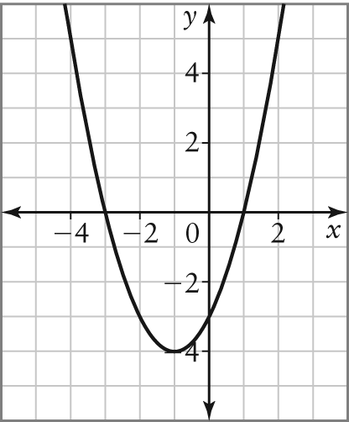
ii) –3, 1
iii) y = (x + 3) (x – 1); roots are –3 and 1
iv) They are the same.
b) 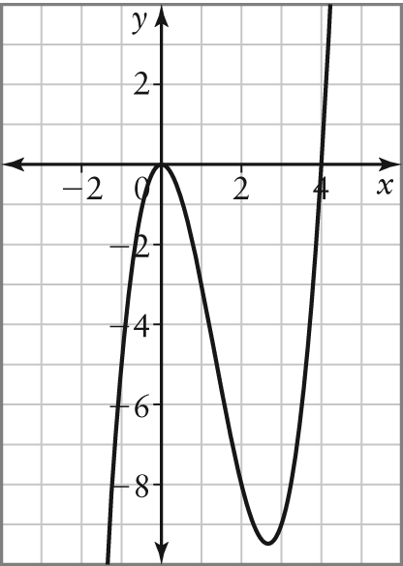
ii) 0, 4 iii) y = x²(x – 4); roots are 0 and 4
iv) They are the same.
18. a) –3, –1, 2 b) y = (x + 3)(x + 1)(x – 2)
c) –3, –1, 2 d) –6
BLM 5–4 Chapter 5 Practice Test
1. a) polynomial function
b) exponential function
c) polynomial function
d) rational function
2. a) 5 b) 0 c) 1
3. a) A vertical line passes through more than one point on the graph.
b) The equation yields more than one y-value for one or more x-values.
4. a) as x → ±∞, y → ∞
b) as x → –∞, y → ∞; as x → ∞, y → –∞
5. a) 3. The third differences are equal, so this is a third degree polynomial.
b) positive c) 1
6. a) i) odd-degree ii) positive
iii) as x → –∞, y → –∞; as x → ∞, y → ∞
iv) domain {xrange { y
b) i) even-degree ii) negative
iii) as x → ±∞, y → –∞
iv) domain {xrange { y ≤ –4, y
7. a) S = 13πr²; domain {r ≥ 0, rrange
{S ≥ 0, S as r → ∞, S → ∞
b) V = 6πr³; domain {r ≥ 0, rrange
{V ≥ 0, Vas r → ∞, V → ∞
8. In an even function, the behaviour of the
y-values on both ends is the same. Therefore, there can be a minimum or maximum value that is above or below the x-axis.
9. a) i) –3, odd; –1, odd; 0, odd; 2, even
ii) 5; has end behaviour of an odd function and four intercepts
b) i) –2, even; 1, odd; 2, odd
ii) 4; has end behaviour of an even function and three intercepts
10. a) Example: An even function has mirror images in the y-axis, but an odd function has mirror images in diagonal quadrants.
b) i) neither ii) even
11. a) –98 b) 55
12. a) even-degree polynomial
b) fourth differences
c) as x → ±∞, y → ∞
d) {x ≥ 0, x I}; the number of cameras sold cannot be less than zero and must be a whole number
13. a) (3w + 4)(w – 7) b) (x + y)(a – 2)
c) (3t – 1)(2t + 3)
14. a) (6x + 1)(3x + 7) b) 2
15. a) 2(x – 5)(x – 8) b) –3m(2m – 3)(4m + 5)
c) (2w – 7)(2w + 7) d) 3(a – 6)(a + 6)
e) (h – 2)(h + 2)(h² + 4)
16. 4(5a – 4b)(5a + 4b)
17. a) –2, b) –6, 4 c) 0, 5
18. a) 3 b) 1; positive
c) as x → –∞, y → –∞; as x → ∞, y → ∞
d) –2, 0, 1 e) 0
f ) 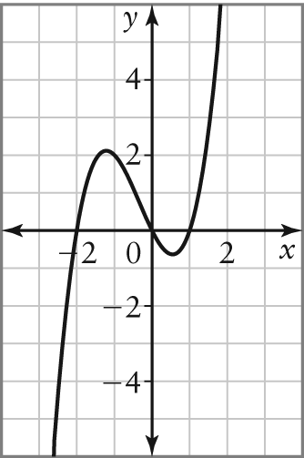
g) domain {xrange {y
19. a) 24.5 m b) 44.1 m c) 5 s
d) {0 ≤ t ≤ 5, tThe equation for the height is only valid from the time the rock breaks off until it hits the ground.
20. a) odd-degree polynomial
b) 3000; number of fish produced at 0°C
c) the temperature when no fish are produced
d) 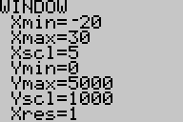

e) y-values increase. It is unlikely that more fish will be produced when the water gets colder than –6.7°C.
BLM 5–5 Chapter 5 Case Study
1. p(x) = –2x + 150
2. R(x) = –2x² + 150x
3. a) 2 b) C(x) = x² + 4x + 1000
4. a) P(x) = –3x² + 146x –1000
b) 24

