Chapter 6 Prerequisite Skills

Collect Like Terms
1. Simplify.
a) 4x + 9y + (4x – y)
b) –5s – t – (7s + 2t)
c) (7p – 2q + 4r) – (2p + 3q – r)
d) 3x² + 6x – 9 – (8x² – 7x + 12)
e) (9x² – 2x + 9) – (x² – 5x) + (x² – 11)
2. Expand and simplify.
a) 2(x – 3) + 5(x + 2)
b) –8(x² – 3x + 7)
c) 4(3r² + 2r) – 6(r – 2r²)
Simplify Expressions
3. Expand and simplify.
a) x(x + 3) b) p(2p – 7)
c) (2w – 3)(w + 2) d) k(4k + 3) + k(2k – 1)
e) (3s – 5)(s + 4) f) (5x – 1)(3x + 1)
g) (6t – 5)(t – 4) h) (4n – 3)(n² + 2n – 4)
Solve Area and Volume Problems
4. Write a simplified expression for the area of each of the following shapes.
a) 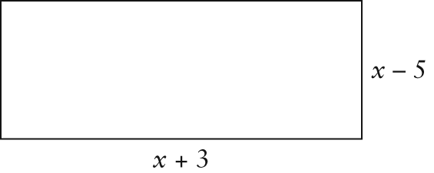
b) 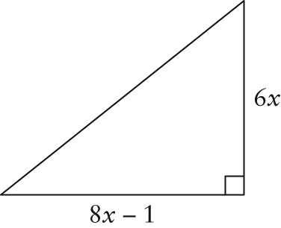
5. Consider the rectangular prism below.
Write a simplified expression for the
a) surface area
b) volume
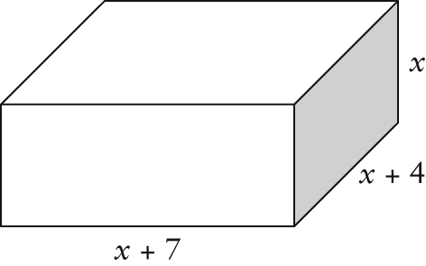
Factor Expressions
6. Factor by determining the greatest common factors.
a) t² + 4t b) 6q² – 3q
c) 4m³ – 2m² + 12m d) 9x³ + 6x² – 15x
e) 8w⁴ – 12w³ – 20w²
7. Factor fully.
a) x² + 5x + 4 b) x² + 7x – 18
c) k² – 12k + 36 d) t² – 8t + 15
e) 3a² + 21a + 18 f) 4x² – 28x + 48
g) –2y² + 26y – 60 h) 5h³ + 50h² + 120h
Solve Quadratic Equations
8. Solve.
a) x² – 5x + 6 = 0 b) n² + 9n + 20 = 0
c) p² + 3p – 10 = 0 d) s² – 12s + 35 = 0
e) 2w² + 6w – 56 = 0
Use Exponent Rules
9. Simplify using exponent rules. Then, evaluate. Express answers as integers or fractions.
a) (2²)(2⁴) b) (5⁷)(5^{–4})
c) d) (6³)(6^{–4})
e) (–2)⁵ ÷ (–2)² f) 9² ÷ 9⁴
g) (4³)^{–1} h)
10. Simplify using exponent rules.
a) x³(x²) b) p⁵ × p^{–2}
c) m⁶ ÷ m³ d) z⁴ ÷ z^{–5}
e) a³ × a^{–1} ÷ a² f) (b⁸)^{–4}
g)
Solve by Substitution
11. Solve each for the variable indicated.
a) P = 2l + 2w; w b) ; a
c) S = 2πr² + 2πrh; h d) ; r

