Chapter 6 Review

6.1 Simplifying Polynomial Expressions
1. Simplify.
a) 3p²(4p³) b) –4w³(9w⁵)
c) xy(3x)(–7y) d) 2b²(–4bc²)
e) (–5e⁴g³)(–3eg⁷)
2. Expand.
a) t²(3t – 2v²)
b) –4g⁵(6g²h + 5g³h²)
c) 3c²d ³(5c⁴d – 3c³d ²)
d) –7xy⁵(2x³y³ – 6x²y⁶)
e) 2a³b⁴(4a²b^{–1} – 3a⁴b)
3. Expand and simplify.
a) (3a + 2)(4a – 5) b) (2x – 7)(5x – 2)
c) 3(w + 1)(w + 6) d) –2(r – 3)(r + 5)
e) 4(y – 2)(y – 9)
4. Determine a simplified expression for the area of the triangle shown.
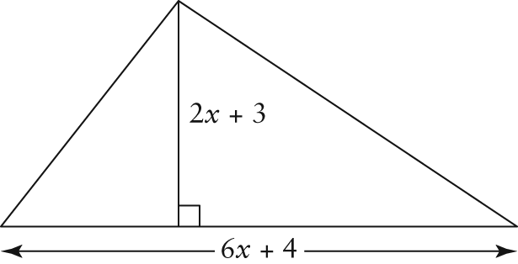
5. The base of a rectangular box has length
2x + 3y and width 3x – 4y.
a) Write a simplified expression for the area of the base.
b) If the height of the box is 2x – y, determine a simplified expression for the volume of the box.
c) If x = 3 cm and y = 1 cm, calculate the volume of the box.
6.2 Strategies for Solving Polynomial Equations
6. Solve each polynomial equation.
a) x² + 6x = 0 b) x² – 10x = 0
c) x² + 15x + 26 = 0 d) x² – 2x – 8 = 0
e) x² – 18x + 45 = 0
7. Describe how the roots of a polynomial equation are related to the graph of the corresponding function.
8. Use graphing technology to solve each equation.
a) x² – 3x + 2 = 0 b) x² + x – 6 = 0
c) x² + 4x = 0 d) x² – 8x + 16 = 0
e) x² – 9 = 0
9. Solve, expressing your answers as fractions in lowest terms, where necessary.
a) 3x² + 11x – 4 = 0
b) 4x² – 17x – 15 = 0
c) 6x² – 7x – 3 = 0
d) 5x² + 22x + 8 = 0
e) 16x² – 34x – 15 = 0
10. Find the roots of each polynomial equation.
a) 2x² + 8x – 42 = 0
b) x³ – 3x² – 4x = 0
c) 3x² + 12x = 135
d) 3x(x + 1) + 7 = 10 + x(x – 2)
e) 5x(x + 2) – 17 = x(x + 8) + 2(x – 4)
6.3 Solving Equations of the Form x^{n} = a
11. Evaluate.
a) b) c)
d) e)
12. Evaluate.
a) b) c)
d) e)
13. Solve.
a) x² = 36 b) x³ = 216 c) x⁵ = 243
d) x⁴ = 81 e) x³ = –343
14. Determine the real roots. Round your answers to two decimal places.
a) x² = 19 b) x³ = 100 c) x⁵ = 48
d) x⁴ = 79 e) x³ = 225
15. a) Use graphing technology to graph the polynomial functions y = (x – 2)³, y = x³, and y = (x + 2)³ on the same set of axes.
b) Describe how the graphs of the three functions are alike. Describe how they are different.
c) Use the graphs to solve the following polynomial equations.
i) (x – 2)³ = –8
ii) x³ = –8
iii) (x + 2)³ = –8
d) Use the results from part c) to predict the solutions for each of the following equations.
i) (x – 5)³ = –8
ii) (x + 5)³ = –8
Use an algebraic method to check your solutions.
6.4 Functions and Formulas
16. Through market research, an electronics company predicts that total revenue from the sales of its new line of computers for the next year can be modelled by the function
R = –3500t³ + 62 000t² + 20 000t, where t is time, in months, and R is revenue, in dollars.
a) Express the function in factored form.
b) Determine the expected revenue at the beginning of the first month.
c) Determine the total revenue expected at the end of the first year.
17. The formula is used to calculate the volume of a cone.
a) Determine the volume of a cone with radius 4 cm and height 11 cm. Round your answer to the nearest tenth of a cubic centimetre.
b) Rearrange the formula to solve for
the radius.
c) Determine the radius of a cone with height 40 cm and volume 7500 cm³, to the nearest tenth of a centimetre.
18. Mohammad invested $3000 in an account earning 4.5% interest, compounded quarterly. Calculate the amount of his investment after 5 years.
6.5 Solving Multi-Step Problems Using Polynomial Equations
19. A pyramidal tent is being designed for a chain of sporting goods stores. Its base length is twice its width. A net of the tent is shown below.
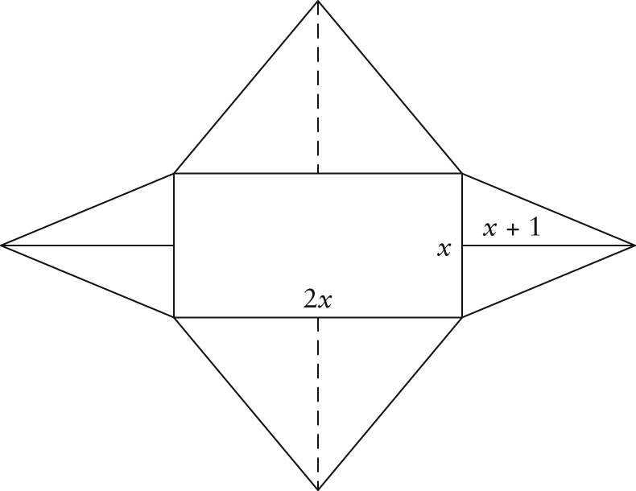
a) Determine a simplified polynomial equation for the total surface area of the tent, A, as a function of x.
b) Determine the minimum amount
of material needed to make the tent if
x = 1 m.
20. John has two cylindrical oil drums that he wants to use as markers at the front of his driveway. Each drum has a diameter of
30 cm and a height of 120 cm. John plans to cover the tops and sides of the drums with fluorescent paint so they are visible at night. He figures he will need to use two coats of paint for each drum. The paint is available in 1-L cans, each of which will cover approximately 10 m² of surface. John thinks he needs to buy only 1 can. Is he correct? Explain.

