Chapter 6 Practice Test

1. Simplify.
a) x²(3x³y²) b) –4st⁵(8st)
c) 8a³b⁶(–2b^{–3}) d) (–3x⁴y)(5xy²)(–4x³y⁵)
2. Expand.
a) 2p( p³ – q) b) 3x²y³(–5xy + 2x³y³)
c) de(4de² + 1) d) –6a²b⁵(–a⁴b + 8ab^{–2})
3. Expand and simplify.
a) (4p + 5)(2p – 1)
b) 3(s – 4)(s + 7)
c) –(3 – x)(5 – 2x)
4. Determine a simplified expression for the area of each shape.
a) 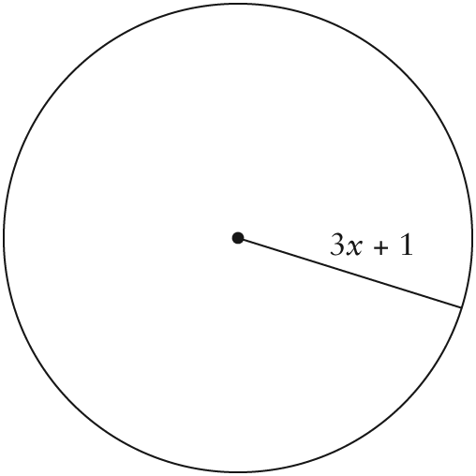
b) 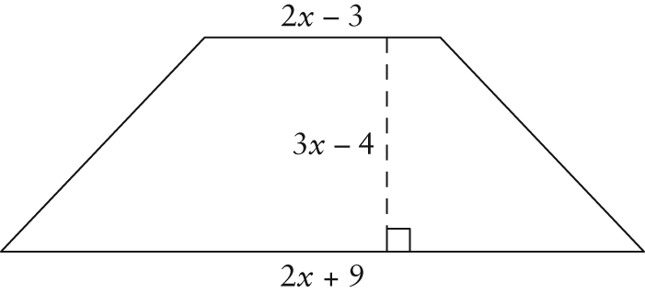
5. Consider the following prism.
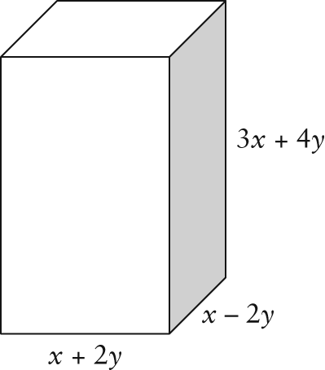
Find a simplified expression for the
a) surface area
b) volume
6. Solve.
a) x² + 5x = 0 b) x² + 5x – 36 = 0
c) x² – 12x + 27 = 0
7. The dimensions of a rectangular patio are
4 ft by 6 ft. If the length and width are both increased by the same amount, the patio’s area will be double its original area. Write an algebraic equation and solve it to determine the dimensions of the larger patio.
8. Solve the following equations. Express answers as fractions reduced to lowest terms, where necessary.
a) 3x² + 11x + 10 = 0 b) 4x² – 16x – 84 = 0
c) 6x² – 47x – 8 = 0 d) 12x² + 23x – 24 = 0
9. Juanita solved the following equation:
x² – x = 12
x(x – 1) = 12
x = 12 or x – 1 = 12
x = 12 + 1
x = 13
Explain why her solution is incorrect.
10. Solve the following equations.
a) 18w² – 28 = 55w
b) 4 + 3(x² – 1) + 5x = 3(x + 2)
11. Evaluate each of the following.
a) b) c)
d) e) f )
12. Evaluate . Explain your result.
13. Solve.
a) x³ = 216 b) w⁴ = 4096
c) 2t⁵ = –33 614
14. Determine the real roots for each of the following. Round your answers to two decimal places.
a) x² = 182 b) r³ = 1205
15. Describe in detail how you could estimate the solution for question 14b) using systematic trial and error.
16. Solve (x + 9)³ = –27 algebraically.
17. The formula relates the distance travelled by an object, d, in metres, to its initial velocity, v, in metres per second. Time, t, is in seconds, and acceleration, a, is in metres per second squared.
a) Create an equation to solve for a.
b) A car travels 300 m in 5 s, starting from an initial velocity of 6 m/s. Determine the acceleration during this time, to the nearest tenth of a metre per second squared.
18. The volume of a cylinder is given by the formula V = πr²h.
a) Rearrange the formula to solve for r.
b) A cylindrical tank for storing oil is being designed to hold as much as 6400 m³ of oil. For safety reasons, the height of the tank must be 20 m. What should the radius of the tank be? Round your answer to the nearest tenth of a metre.
19. Due to rent controls, a landlord can increase the rent on an apartment by only 3% each year.
a) What type of function could be used to model the rental price of an apartment?
b) Write an equation to model this situation. Use C to represent the current rental price of an apartment, in dollars, t to represent time, in years, and P to represent the new price, in dollars.
c) If a two-bedroom apartment currently rents for $1250.00, what will the rental price be in 5 years?
20. In January 2007, Ms. Kendall invested $2000 in a GIC, earning interest at 4.25%, compounded semi-annually. Calculate the GIC’s value in January 2012.
21. The dimensions of a kitchen floor are ft by ft. A moulding being installed around the base of the walls is sold in pieces that are 4 in. by in. by 3 ft.
a) How many 3-ft lengths of moulding need to be purchased?
b) If each length costs $3.80, before taxes, what will be the total pre-tax cost of the moulding?
22. Reagan wants to renovate his living room, which measures ft by ft. He plans to use laminate floor tiles that are 3 ft long by 6 in. wide.
a) How many tiles does Reagan need to cover the whole floor?
b) The tiles come in boxes of 6 and cost
$48 per box. How much will the tiles
cost before taxes?
23. Tyrone wants to paint the walls of his basement. The length of the basement is 9 m, the width is 6 m, and the height is 2.5 m.
a) Determine the total surface area that Tyrone will paint if he uses two coats
of paint.
b) How many 4-L cans of paint should Tyrone purchase if 1 L of paint will cover approximately 10 m²?
c) Tyrone has found a suitable paint that will cost $28 for a 4-L can before tax. Determine the total cost, before taxes, to paint Tyrone’s basement.

