Chapter 6 BLM Answers

BLM 6–1 Chapter 6 Prerequisite Skills
1. a) 8x + 8y b) –12s – 3t
c) 5p – 5q + 3r d) –5x² + 13x – 21
e) 9x² + 3x – 2
2. a) 7x + 4 b) –8x + 24x – 56
c) 24r² + 2r
3. a) x² + 3x b) 2p² – 7p
c) 2w² + w – 6 d) 6k² + 2k
e) 3s² + 7s – 20 f) 15x² + 2x – 1
g) 6t² –29t + 20 h) 4n³ + 5n² – 22n + 12
4. a) x² – 2x –15 b) 24x² – 3x
5. a) 6x² + 44x + 56 b) x³ + 11x² + 28x
6. a) t(t + 4) b) 3q(2q – 1)
c) 2m(2m² – m + 6) d) 3x(3x² + 2x – 5)
e) 4w²(2w² – 3w – 5)
7. a) (x + 1)(x + 4) b) (x + 9)(x – 2)
c) (k –6)² d) (t – 5)(t – 3)
e) 3(a + 1)(a + 6) f) 4(x – 3)(x – 4)
g) –2(x – 10)(x – 3) h) 5h(h + 6)(h + 4)
8. a) 2, 3 b) –5, –4 c) –5, 2
d) 5, 7 e) –7, 4
9. a) 2⁶ = 64 b) 5³ = 125
c) d)
e) (–2)³ = –8 f) 9^{–2} =
g) h)
10. a) x⁵ b) p³ c) m³ d) z⁹
e) 1 f) b^{–32} g) x^{–8}
11. a) b)
c) d)
BLM 6–3 Chapter 6 Review
1. a) 12p⁵ b) –36w⁸ c) –21x²y²
d) –8b³c² e) 15e⁵g¹⁰
2. a) 3t³ – 2t²v² b) –24g⁷h – 20g⁸h²
c) 15c⁶d ⁴ – 9c⁵d ⁵ d) –14x⁴y⁸ + 42x³y¹¹
e) 8a⁵b³ – 6a⁷b⁵
3. a) 12a² – 7a – 10 b) 10x² – 39x + 14
c) 3w² + 21w + 18 d) –2r² – 4r + 30
e) 4y² – 44y + 72
4. 6x² + 13x + 6
5. a) 6x² + xy – 12y²
b) 12x³ – 4x²y – 25xy² + 12y³
c) 225 cm³
6. a) –6, 0
b) 0, 10
c) –13, –2
d) –2, 4
e) 3, 15
7. The roots of a polynomial equation are equal to the x-intercepts of the corresponding polynomial function.
8. a) 1, 2 b) –3, 2 c) –4, 0
d) 4 e) –3, 3
9. a) , 4 b) , 5 c)
d) –4, – e) ,
10. a) –7, 3 b) –1, 0, 4 c) –9, 5
d) –3, e) ,
11. a) 8 b) 3 c) 2 d) 6 e) 16
12. a) 9 b) 4 c) –4 d) 125 e) 4
13. a) –6, 6 b) 6 c) 3 d) –3, 3 e) –7
14. a) ±4.36 b) 4.64 c) 2.17
d) ±2.98 e) 6.08
15. a) 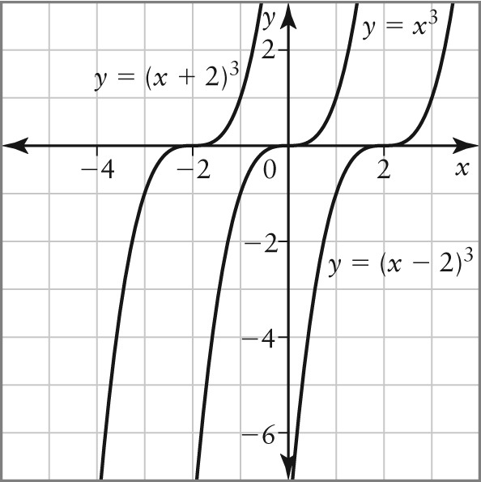
b) The shape and vertical orientation are all alike. The curve y = (x – 2)³ is shifted 2 units right of y = x³ and the curve y = (x + 2)³ is shifted 2 units left of y = x³.
c) i) 0 ii) –2 iii) –4
d) i) 3 ii) –7

16. a) R = –500t(7t² – 124t – 40)
b) 0 c) $3 120 000
17. a) 184.3 cm³ b) c) 13.4 cm
18. $3752.25
19. a) 5x² + 3x b) 8 m²
20. Yes, because the area to be painted is only 4.8 m².
BLM 6–4 Chapter 6 Practice Test
1. a) 3x⁵y² b) –32s²t⁶
c) –16a³b³ d) 60x⁸y⁸
2. a) 2p⁴ – 2pq b) –15x³y⁴ + 6x⁵y⁶
c) 4d²e³ + de d) 6a⁶b⁶ – 48a³b³
3. a) 8p² + 6p – 5 b) 3s² + 9s – 84
c) –2x² + 11x – 15
4. a) 9πx² + 6πx + π b) 6x² + x – 12
5. a) 14x² + 16xy + 8y²
b) 3x³ + 4x²y – 12xy² – 16y³
6. a) –5, 0 b) –9, 4 c) 3, 9
7. (x + 6)(x + 4) = 48; 6 ft by 8 ft
8. a) –2, b) –3, 7
c) , 8 d) ,
9. Example: Juanita must bring the constant to the left side of the equation and then factor. The factors are (x – 4)(x + 3). For the equation to equal zero, one of these factors must equal zero, which happens when x = 4 or x = –3.
10. a) , b) , 1
11. a) 12 b) 3 c) –8
d) 10 e) –4 f) 729
12. The calculator displays “error” because you cannot raise a negative base to an even exponent to get a negative product.
13. a) 6 b) ±8 c) –7
14. a) ±13.49 b) 10.64
15. Example: The cube root of 1000 is 10 and the cube root of 1331 is 11. Since 1205 is closer to 1331, try 10.6 as a base. 10.63 = 1191, which is too small, while 10.73 = 1225, which is too large. Since 1205 is closer to 1191, try a base in between the two, such as 10.64.
16. –12
17. a) b) 21.6 m/s²
18. a) b) 10.1 m
19. a) exponential b) P = C(1.03)^{t}
c) $1449.09
20. $3032.43
21. a) 13 b) $49.40
22. a) 73 b) $624
23. a) 150 m² b) 4 c) $112
BLM 6–5 Chapter 6 Case Study
1. $2250.54
2. The 5-Year Stepper Plan is better because it yields $42.38 more.
3. The competitor’s deal is better, because after
4 years the amount is only $12.61 less. If it was left for 5 years at the same rate, the total amount would be greater by $51.17.

