Chapter 7 Prerequisite Skills
Operations With Fractions
1. Simplify each of the following. Express your answers as fractions reduced to lowest terms.
a) b)
c) d)
2. Simplify each of the following. Express your answers as fractions reduced to lowest terms.
a) b)
c) d)
Angle Properties
3. Determine the values of the unknown angles.
a) 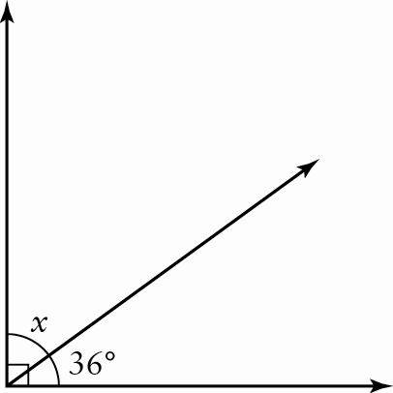
b) 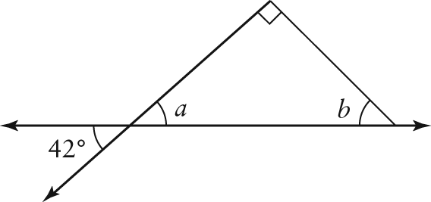
c) 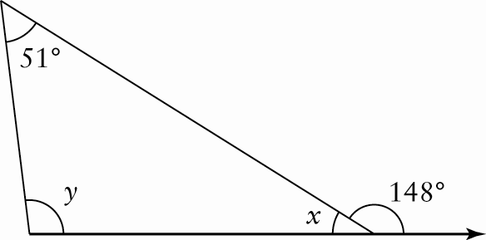
4. Classify each triangle according to angle properties.
a) 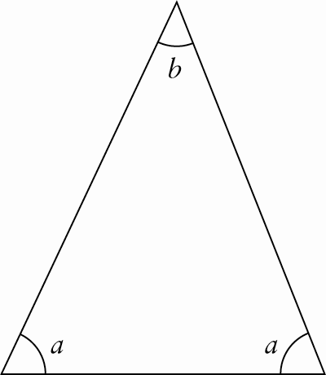
b) 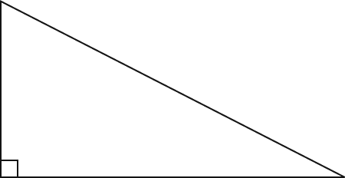
c) 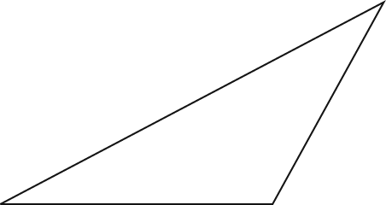
d) 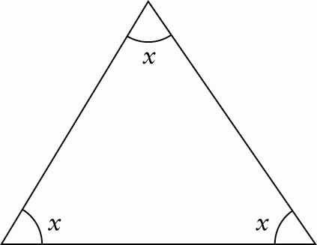
Polygons
5. The sum of the angles, in degrees, of a polygon with n sides is given by the formula S = 180(n – 2). If the polygon is regular, the measure of each angle is equal to the sum divided by n. Determine the sum of the angles and the measure of each angle in a regular hexagon.
6. Identify each polygon.
a) 
b) 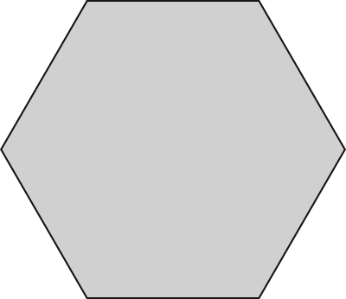
c) 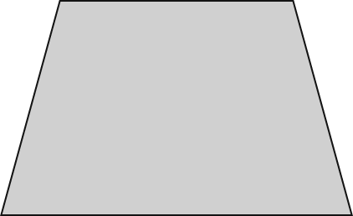
d) 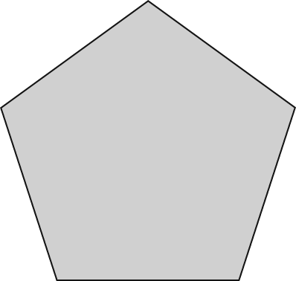
Perimeter, Circumference, Area, and Volume
7. For each figure, determine the perimeter (or circumference) and the area, to the nearest tenth of a unit.
a) 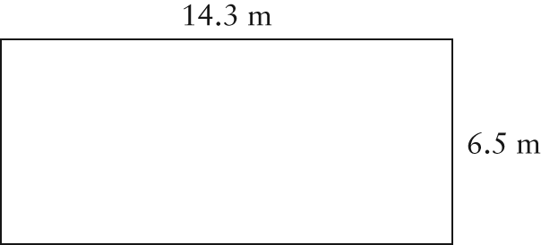
b) 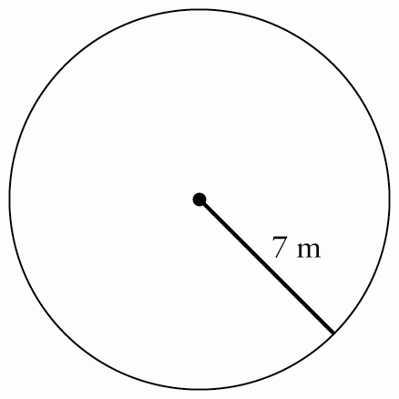
c) 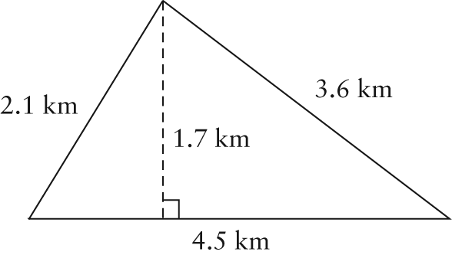
d) 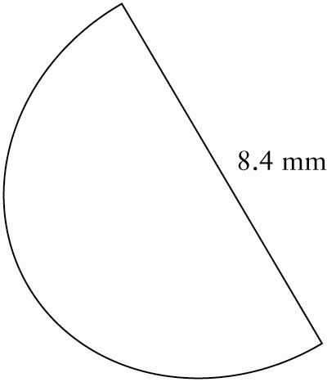
8. Determine the total surface area and volume of each shape, to the nearest tenth of a unit.
a) 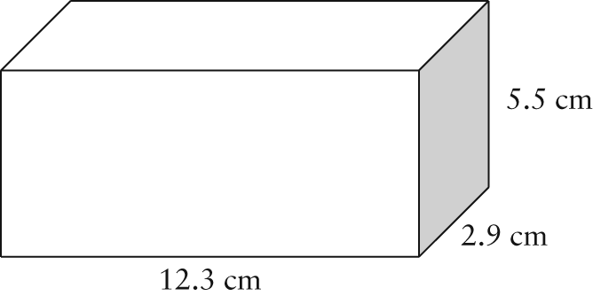
b) 