Chapter 7 Review

Unless otherwise specified, round all answers to the nearest tenth of a unit.
7.1 Area of Two-Dimensional Objects
1. Convert each measure from imperial units to the metric units indicated.
a) 14 in. ______ cm
b) ft ______ m
c) 7 yd ______ m
d) 60 mi ______ km
2. Convert each measure from metric units to the imperial units indicated.
a) 45 cm ______ in.
b) 8.6 m ______ ft
c) 567 km ______ mi
d) 74.8 m ______ yd
3. Convert each measure from imperial units to the metric units indicated.
a) 54 in.² ______ cm²
b) 90 ft² ______ m²
c) 250 yd² ______ m²
d) 442 mi² ______ km²
4. Convert each measure from metric units to the imperial units indicated.
a) 48 cm² ______ in.²
b) 56 m² ______ ft²
c) 328 m² ______ yd²
d) 3500 ha ______ mi²
5. Gina wants to tile the spare bedroom in her basement. The dimensions of the room are 2.9 m by 2.4 m. She wants to use tiles that are 12 in.² and cost $1.89 per square foot.
a) How many tiles should she buy, including 10% extra for wastage?
b) What will be the cost, before taxes?
7.2 Surface Area of Three-Dimensional Objects
6. Calculate the surface area of each shape.
a) 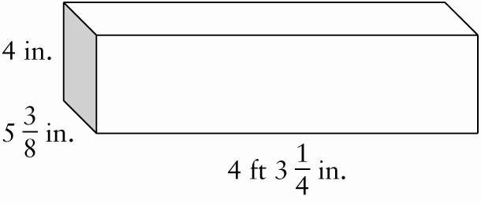
b) 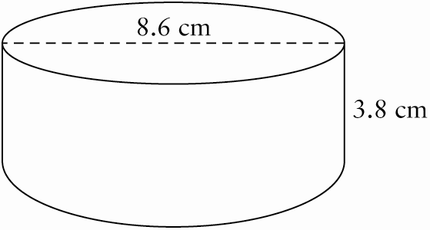
c) 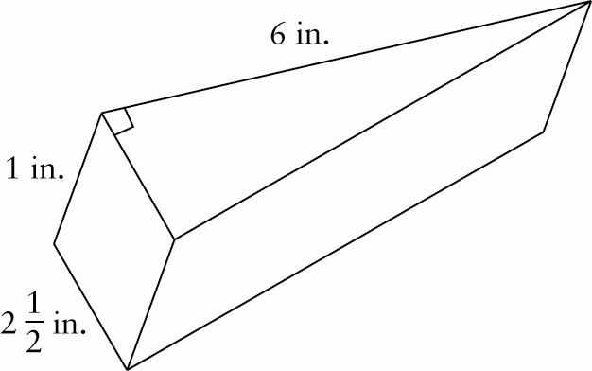
7. Randy is replacing the shingles on his roof. The top view of the roof is shown below.
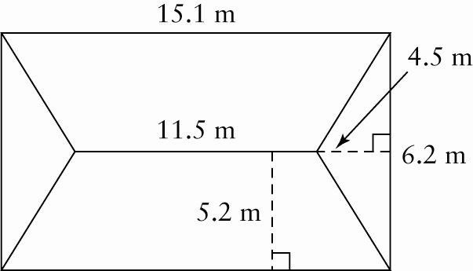
a) Calculate the surface area of the roof.
b) If the shingles cost $2.99/ft², what is the approximate cost, to the nearest dollar, before taxes?
8. A salad bowl is to be made in the shape of a hemisphere. If the diameter is 15 in., what is the minimum surface area of the outside of the bowl?

7.3 Volume of Three-Dimensional Objects
9. Convert the volumes as indicated.
a) 200 in.³ ______ cm³
b) 64 yd³ ______ m³
c) 36 ft³ ______ m³
d) 2.1 mi³ ______ km³
10. Convert the volumes as indicated.
a) 380 cm³ ______ in.³
b) 79 m³ ______ ft³
c) 2509 m³ ______ yd³
d) 36 025 cm³ ______ ft³
11. Calculate the volume of each shape to the nearest tenth of a unit.
a) 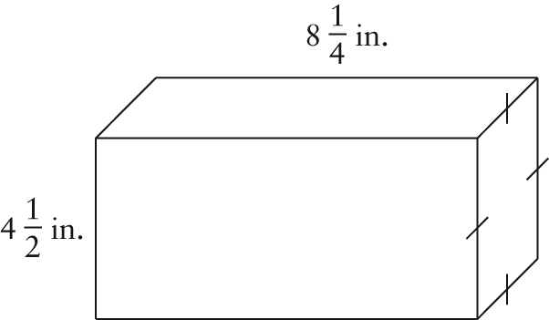
b) 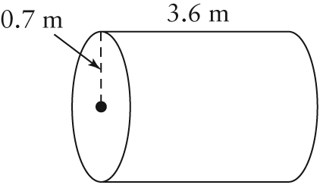
c) 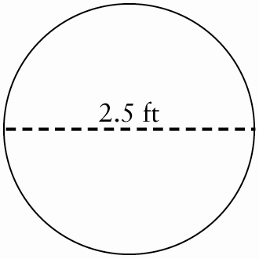
d) 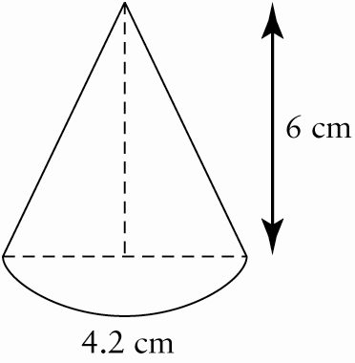
12. A candy box in the shape of a square-based prism has a height of 15 cm and a volume of 614 cm³. What is the side length of the base?
7.4 Properties of Circles
13. Match each term with the appropriate diagram.
A arc B chord
C secant D sector
E segment F tangent
a) ______ b) ______
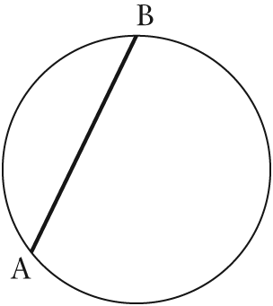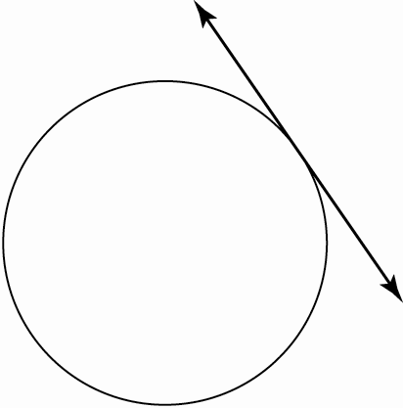
c) ______ d) ______
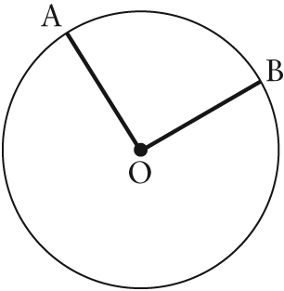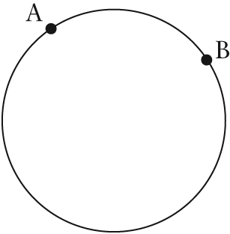
e) ______ f) ______
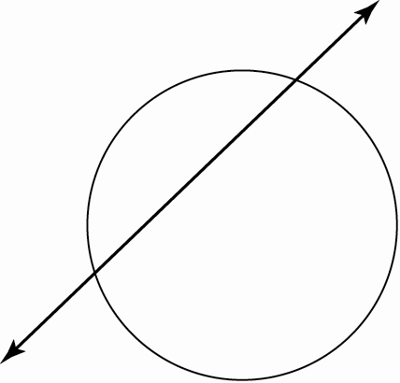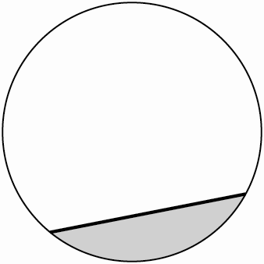
14. Determine the length of the arc, a.
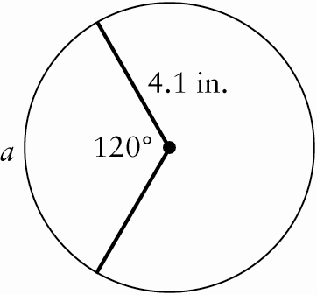

15. In the diagram, if the arc, a, is 3.4 m, determine the length of the radius.
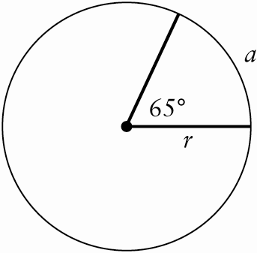
16. Point O is at the centre of the circle. Determine the area of the shaded sector.
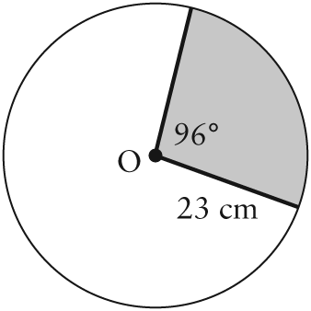
17. Point O is at the centre of a circle that has a radius of ft. Determine the area of the shaded segment.
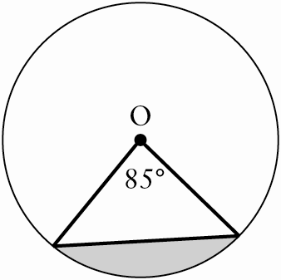
7.5 Investigating Properties of Circles
18. Determine the measures of the unknown angles.
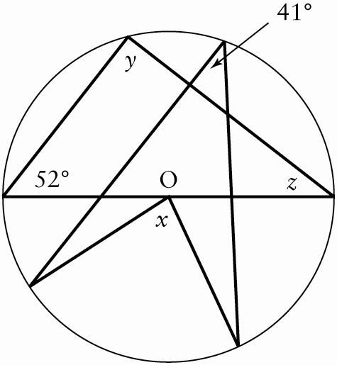
19. Determine the lengths of c, t, and x.
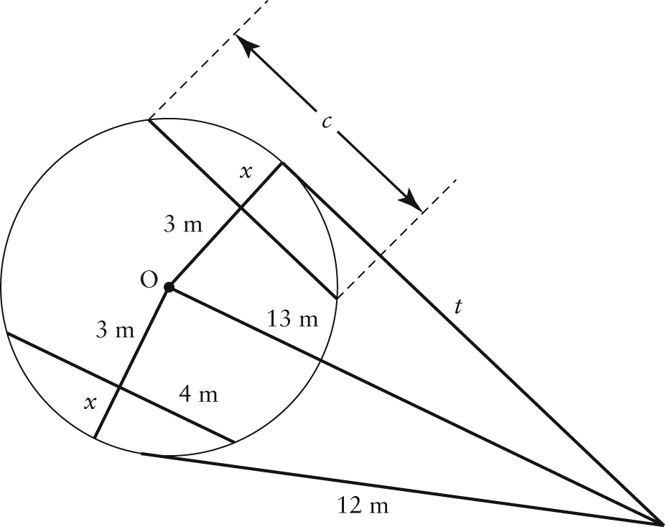
7.6 Solving Problems Involving Properties of Circles
20. Wayne is standing at a point 25 m from the centre of an old battle tower. He walks toward the tower on a tangent line that is
20 m long. When he reaches the tower, he walks around the building in an arc that is subtended by a 60° angle from the centre of the tower, and then stops to read a historic plaque posted on the tower.
a) What is the radius of the tower?
b) What is the total distance that Wayne walked?
21. Elda designed a circular crest with an arrow design, as shown below. Point C is the centre of the crest. The diameter of the crest is 5 in. and the line segment between A and B is 4 in. What is the area of the arrow?
