Chapter 7 Practice Test

Unless otherwise specified, round all answers to the nearest tenth of a unit.
1. Convert each measure from imperial units to metric units as indicated.
a) 34 in. ______ cm
b) 13 ft ______ m
c) 300 yd ______ m
d) 2100 mi ______ km
2. Convert each measure from metric units to imperial units as indicated.
a) 288 m ______ ft
b) 525 km ______ mi
c) 89 cm ______ in.
d) 1080 m ______ yd
3. Convert each measure from imperial units to metric units as indicated.
a) 58 ft² ______ m²
b) 432 in.² ______ cm²
c) 8900 yd² ______ m²
d) 75 000 mi² ______ km²
4. Convert each measure from metric units to imperial units as indicated.
a) 589 cm² ______ in.²
b) 12 km² ______ mi²
c) 9260 m² ______ yd²
d) 850 m² ______ ft²
5. A rectangular field measures 230 m by 68 m.
a) What is the area of the field in square feet?
b) Is it easier to convert the linear measurements first and then determine the area, or to calculate the area and then convert the answer? Explain.
6. A propane tank is in the shape of a cylinder, with hemispherical ends. The cylindrical is 14 in. long and the inner diameter of the tank is in. What is the tank’s capacity?
7. A Norman window consists of a rectangular section with a semicircular part on top.
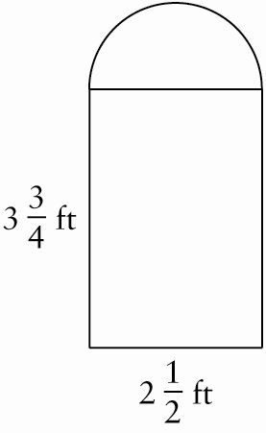
Calculate the total area of the glass needed for the window.
8. Calculate the surface area and volume for each of the following shapes.
a) 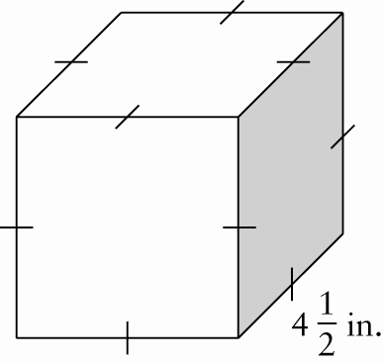
b) 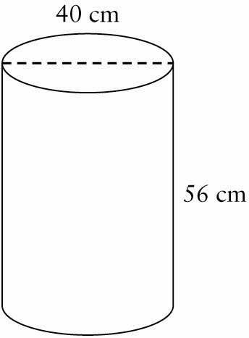
9. A wooden trough for feeding pigs has regular trapezoidal ends and dimensions as shown below. Find the minimum amount of wood required to make the trough.
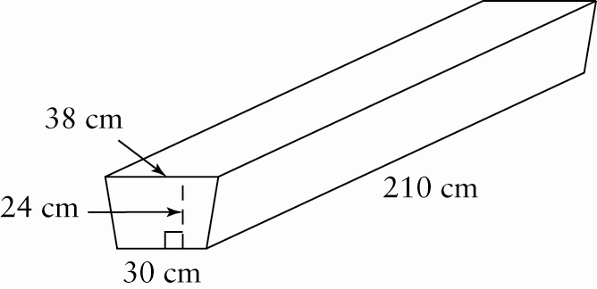

10. Mohanna wants to put a new vinyl floor in her kitchen. The dimensions are shown.
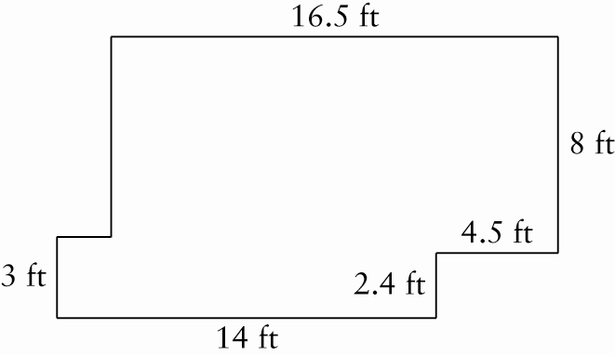
a) Calculate the area that will be covered.
b) The vinyl flooring costs $2.69/ft². What will be the total cost before taxes, including 10% extra for wastage?
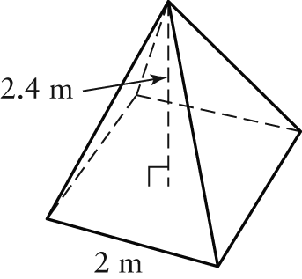
11. A tent is in the shape of a square-based pyramid.
a) Calculate the surface area of the tent.
b) How much space is inside the tent?
12. A rubber garden hose is 15 m long. Each end is covered by a metal disk. The hose has an inner diameter of 2.6 cm and an outer diameter of 3 cm. Determine the area of exposed rubber, including both the inside and the outside of the hose.
13. An in-ground swimming pool has the following dimensions:
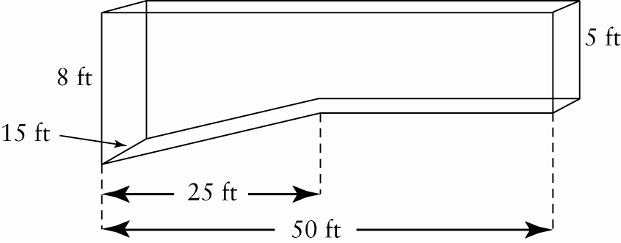
How much water is needed to fill it to a level that is 15 in. from the top?
14. The volume of a spherical balloon is
7240 cm³. What is the radius of the balloon?

15. Match each term with the diagram that best illustrates it.
A chord B inscribed angle
C sector D segment
a) ______ b) ______
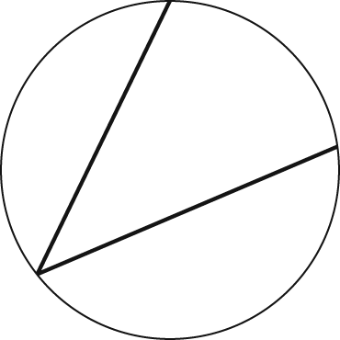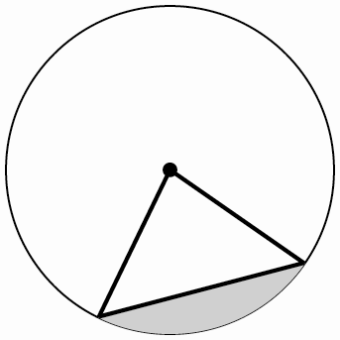
c) ______ d) ______
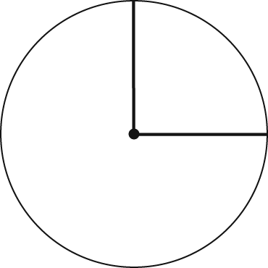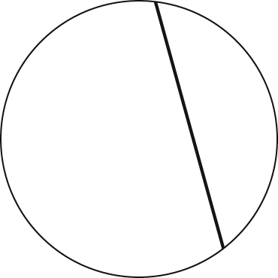
16. Determine the length of the arc, a.
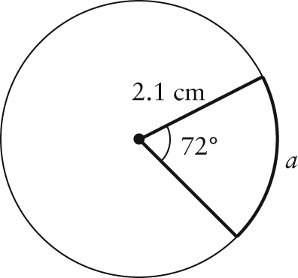
17. Determine the measure of θ to the nearest degree.
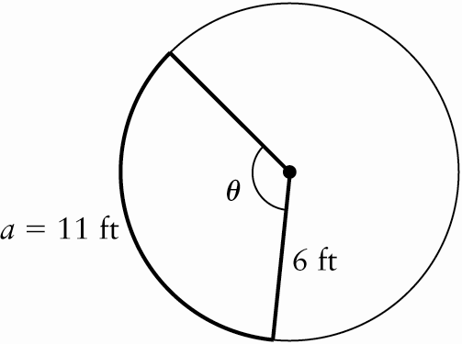

18. Calculate the area of AOB.
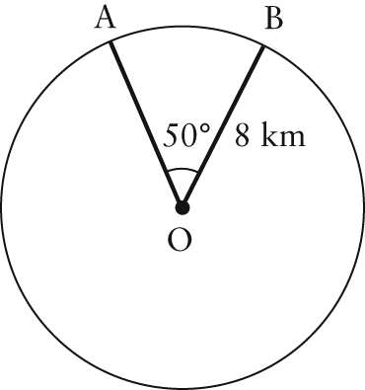
19. Determine the area of the shaded region.
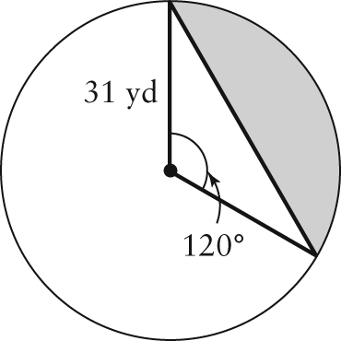
20. The sector of a circle has an area of 214 cm² and a central angle of 30°. What is the radius of the circle?
21. Given O is the centre of the circle,
OA = 12 in., and AB = 16 in., determine the length of OC.
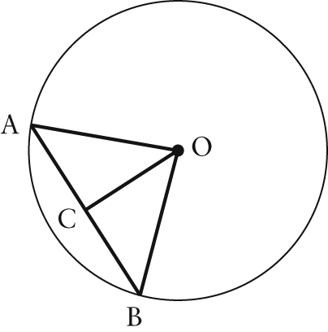
22. Determine the value of each variable in the diagram.
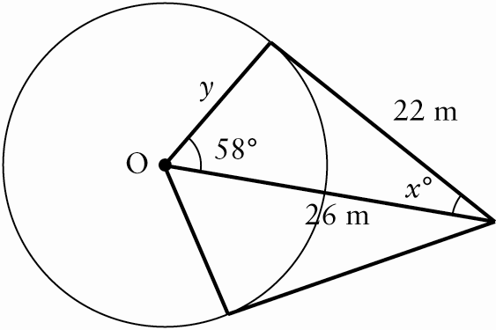

23. Determine the value of each unknown angle.
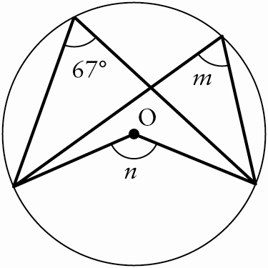
24. With a height of 331 m, the second tallest
concrete tower in Germany is the Telecommunications Tower of Frankfurt, completed in 1977. The diameter at the foundation is 20.0 m. Marie walked around the tower along an arc subtending a central angle of 80° before walking along a tangent line from the building for 30 m. Then, she stopped to take a photo.
a) What distance did Marie walk?
b) How far was Marie from the centre of the building?
25. A circular garden in a park is enclosed by a paved path. Part of the path has been painted. Calculate the painted area.
