Practice: Focus on Communicating

1. Describe the pattern in each sequence. Then, write the next three terms.
a) 99, 88, 77, 66, 55
b) $\frac{2}{3}, \frac{4}{3}, 2, \frac{8}{3}, \frac{\text{10}}{3}$
c) 4096, 2048, 1024, 512, 256
d) V, X, XV, XX, XXV

2. Explain why this graph shows how your height off the ground changes when you ride on a Ferris wheel.

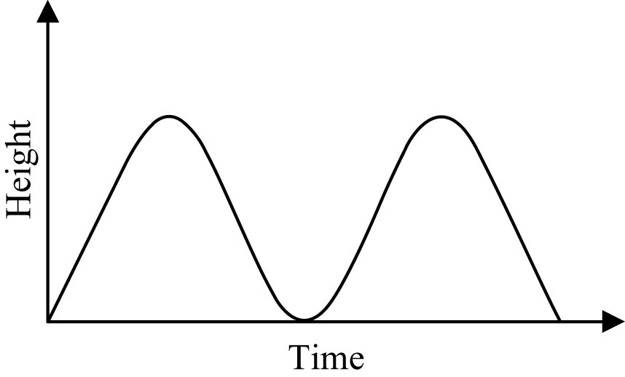

3. Explain how you can use this grid to model the product $\frac{2}{5} × \frac{5}{8}$.
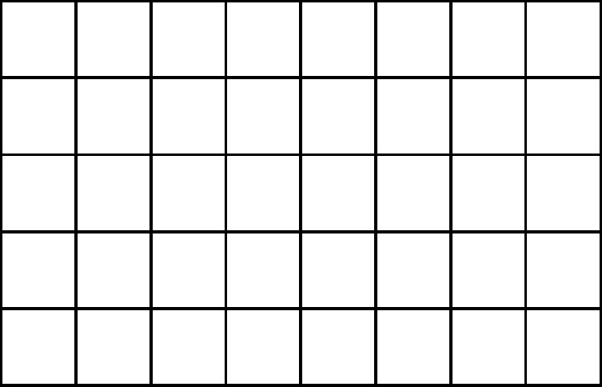
4. These are triangular numbers.

a) Write the next three triangular numbers.
b) Find the sum of consecutive triangular numbers. Describe the pattern in the sums.

