Sudoku

Solve for the missing digits.

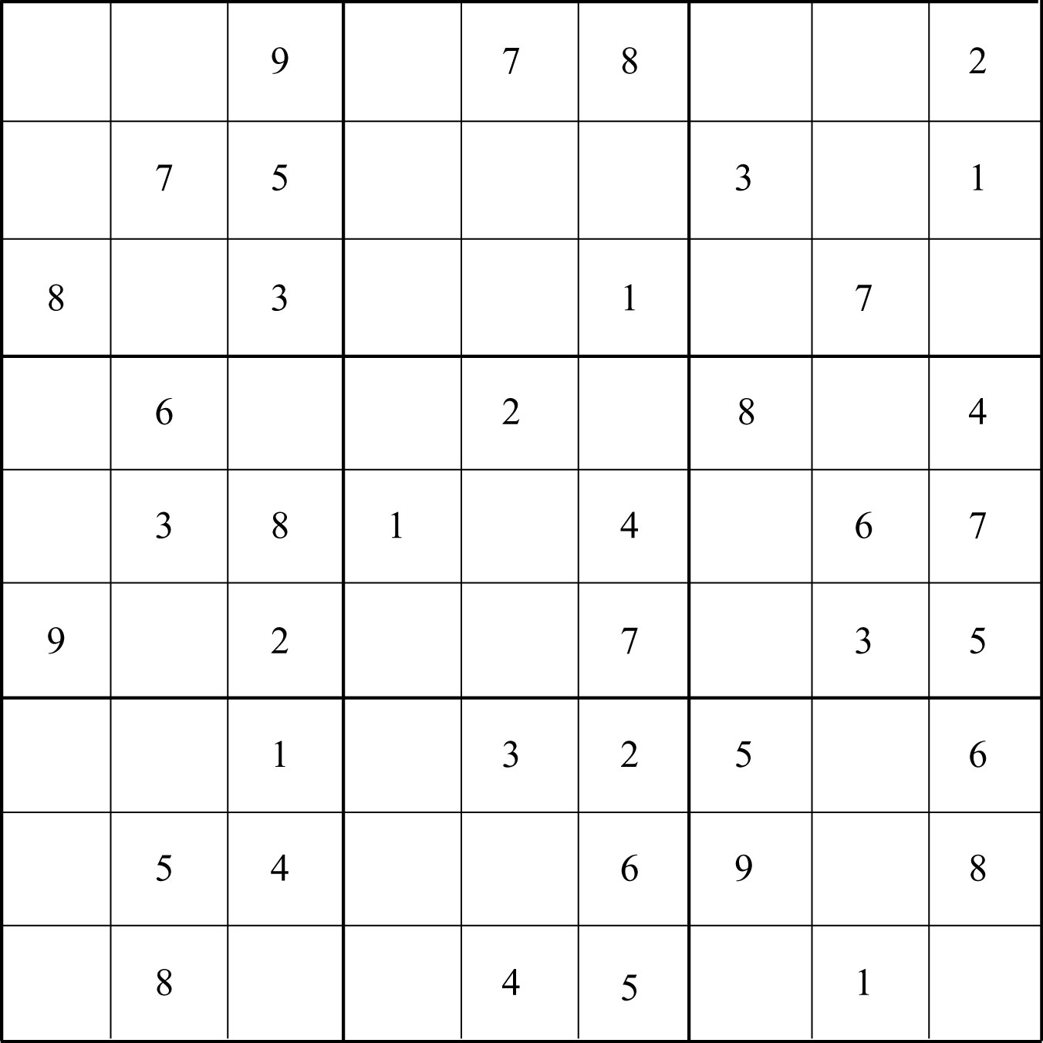

Describe your problem solving process:
_________________________________________________________________________
_________________________________________________________________________
_________________________________________________________________________
_________________________________________________________________________

