Practice: Focus on Representing

1. Kendra got lost. She drove 3 km west, then 5 km north, 6 km east, 4 km south, and 3 km west. Where is Kendra relative to where she started?

2. How many different paths are there from A to F, without going back?

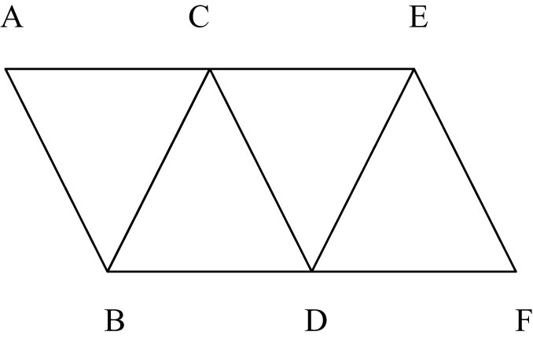
3. A palindrome is a word, number, or phrase that reads the same forwards and backwards. These are palindromes: label, 3663, not a ton.
a) How many times each day will the time displayed on a digital clock be
a palindrome?
b) The years 1991 and 2002 are palindromes. When are the next three palindrome years? When were the last three before 1991?

4. Liam made this pattern with right isosceles triangles.

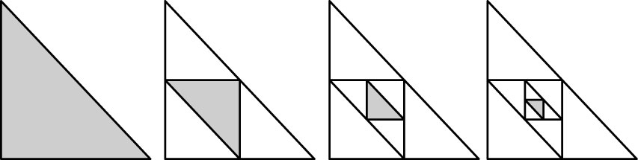

a) The legs of the largest shaded triangle are 8 cm long. What is the area of the largest triangle?
b) What are the side lengths of each of the smaller shaded triangles?
c) Find the area of each of the shaded triangles. Describe the patterns in the side lengths and in the areas.

