Practice: Focus on Selecting Tools and Computational Strategies

1. Draw a diagram to model 5 × $\left(−\frac{3}{5}\right)$.
2. The faces on a number cube are labelled so the sum of the numbers on opposite faces is 7. Each of these diagrams represents the net of a cube. Copy each of the diagrams and complete the labelling.

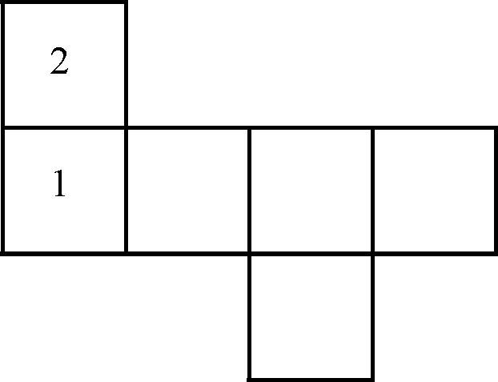
a)

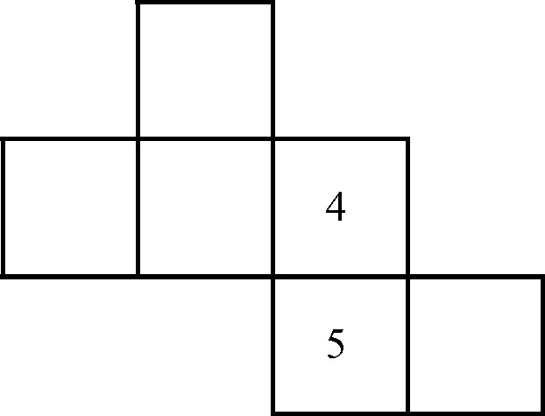
b)
3. A number raised to the power 6 is
262 144. What is the number? Which tool did you use?

4. Find each sum or difference.
a) $−\frac{2}{3} + \left(−\frac{4}{3}\right)$ b) $\frac{1}{3} + \left(−\frac{2}{5}\right)$
c) $\frac{3}{8} − \left(−\frac{1}{4}\right)$ d) $−\frac{1}{4} − \frac{3}{5}$

5. Evaluate.
a) $−\frac{2}{5} × \left(−\frac{1}{6}\right)$ b) $−\frac{5}{8} × \frac{4}{5}$
c) $−\frac{7}{\text{10}} ÷ \left(−\frac{1}{5}\right)$ d) $\left(−3\frac{2}{9}\right) ÷ 1\frac{2}{3}$

