Tangram

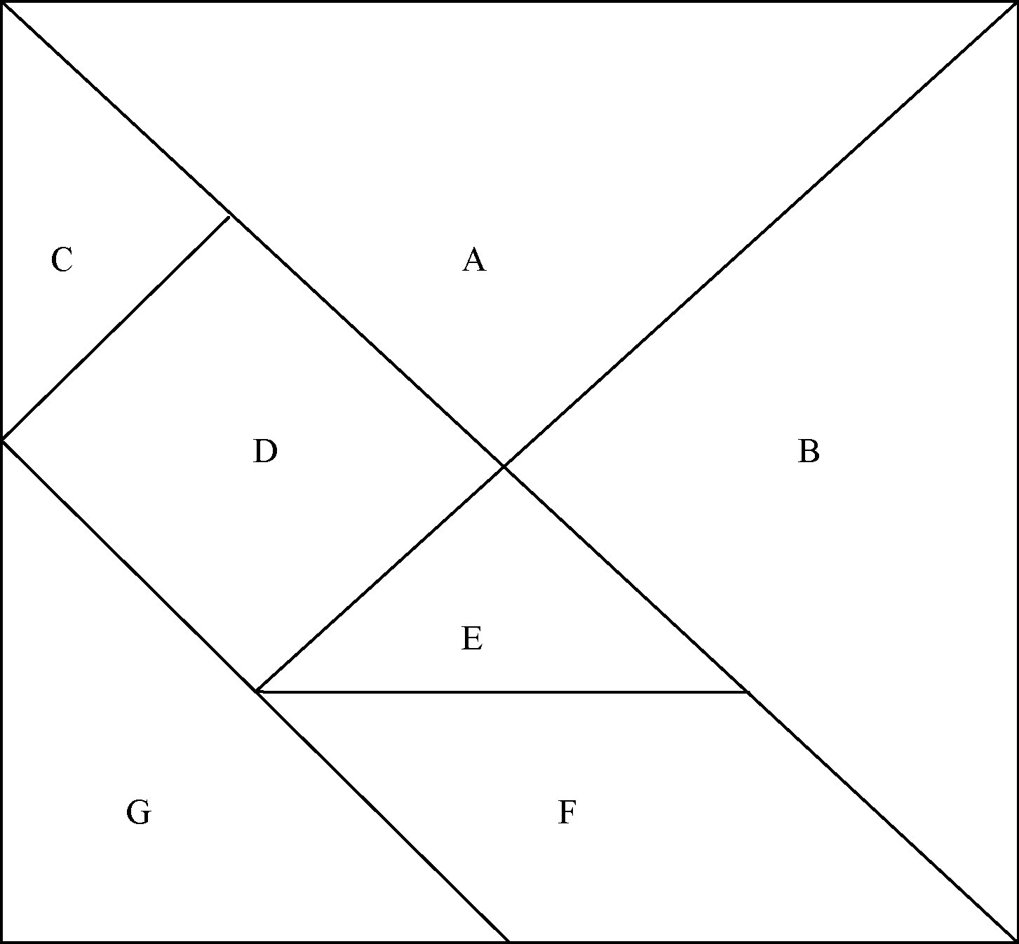

16. a) ________________________________

b) i) _____________________________ ii) ___________________________________

iii) _____________________________ iv) ___________________________________

v) _____________________________ vi) ___________________________________

17. a) _________________________________

b) _________________________________

