Chess Board

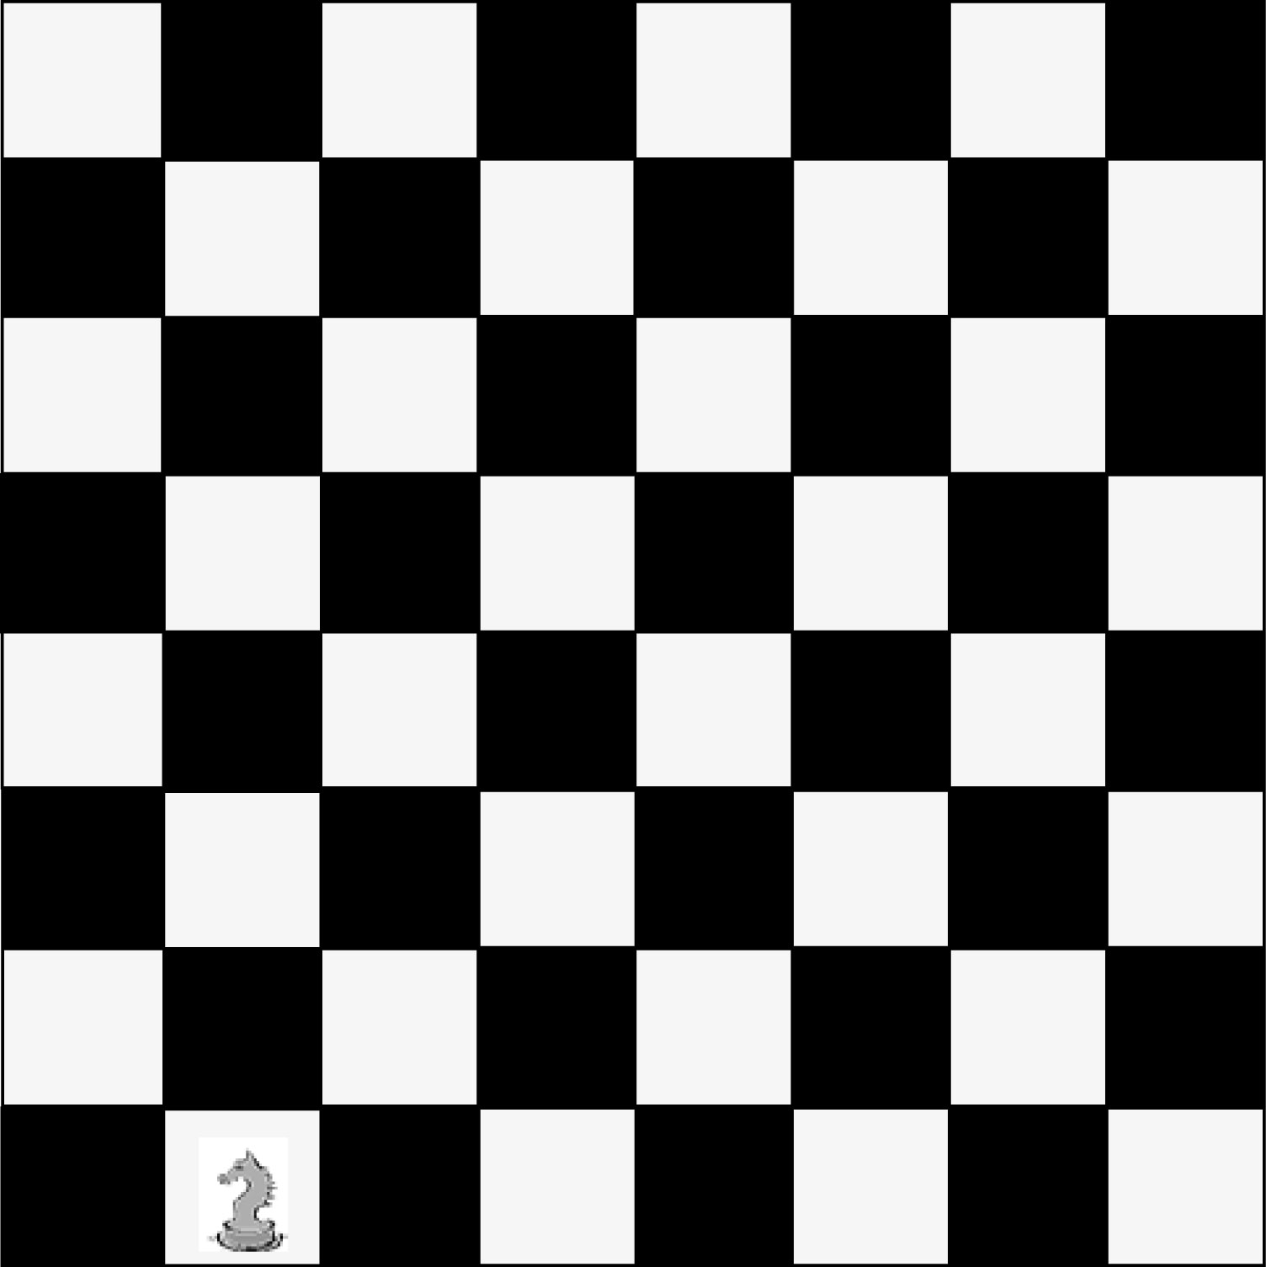

In the game of chess, a knight can move two spaces forward or backward and one space left or right, or two spaces left or right and one space forward or backward.

Can a knight eventually land on any square on the board?
_________________________________________________________________________
_________________________________________________________________________

