BLM 1.GR.1 Practice: Get Ready
1. a) b) c) d)
2. a) b) c) d)
3.
4. a) −5 b) −2 c) −7 d) 10
e) −21 f) 3 g) −75 h) −44
i) 200 j) −9 k) 5 l) −6
5. a) −24 b) −16 c) 4 d) 15
6. $8
7. a) −28 b) 10 c) 72 d) 47
e) 4 f) −20 g) 9 h) −7
8. $18
9. a) A = 20² −5(2²)
b) 380 cm²
BLM 1.1.1 Investigate A Table
Diagram Number | Number of Pennies
1 | 3
2 | 6
3 | 10
4 | 15
5 | 21
6 | 28
7 | 36
8 | 45
9 | 55
BLM 1.1.2 Investigate B Table
There are two possible answers. A = 7, B = 1, D = 9,
E = 6, F = 2, H = 4, and J = 8 are confirmed by the clues. C and G can be either 3 or 5, so two answers are possible.
BLM 1.1.3 Practice: Focus on Problem Solving
1. a) 20, 23, 26; each term is 3 more than the previous term
b) 66, 78, 90; each term is 12 more than the previous term
c) 16, 26, 42; after the first two terms, each term is the sum of the previous two terms
d) 96, 192, 384; each term is double the previous term
2. 9; 1 loonie, 3 quarters, 1 nickel, and 4 pennies

3. a) 891, 9801, 98 901, 989 901, 9 899 901
b) The number of digits in each product equals the sum of the digits in the factors; after the second product, each product begins with 98 and ends with 901; the middle digits are 9s.
c) 98 999 901
4. a) = 0.0909…
= 0.1818…
= 0.2727…
= 0.3636…
= 0.4545…
= 0.5454…
= 0.6363…
= 0.7272…
= 0.8181…
= 0.9090…
= 1
b) Each decimal is a repeating decimal. The digits that repeat are the same as the digits in the product of 9 and the numerator.
c) When the denominator is 111, a 0 appears in the digits that repeat.
For example, = 0.027027…
BLM 1.1.4 Sudoku
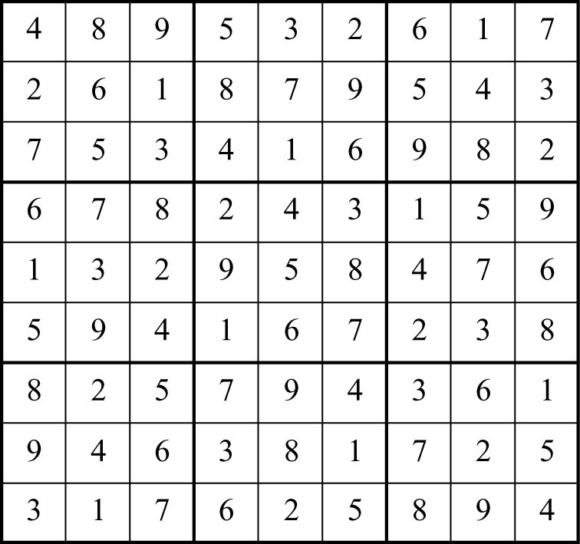

BLM 1.2.1 Practice: Focus on Communicating
1. a) Each term is 11 less than the previous term;
44, 33, 22
b) Each term is more than the previous term;
c) Each term is half the previous term;
128, 64, 32
d) Each term is V (5) more than the previous term;
XXV, XXX, XXXV
2. When you ride on a Ferris wheel, you start at the bottom. When the ride begins, you gradually climb up until you are at the top of the wheel, then you go down. This continues until the ride ends.
3. The grid has 5 rows. I can shade 2 rows to show
. There are 8 columns. I shade 5 columns.
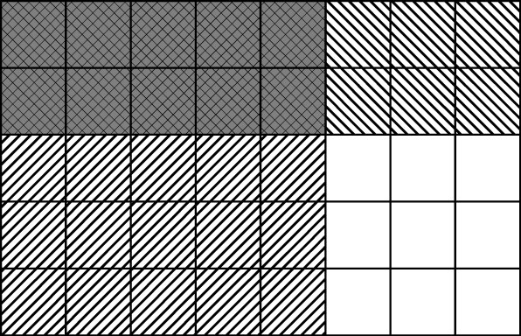
The area where the shaded regions overlap is the product of . The product is .
4. a)
b) 1 + 3 = 4
3 + 6 = 9
6 + 10 = 16
10 + 15 = 25
15 + 21 = 36
21 + 28 = 49
The sums of consecutive triangular numbers are equal to the squares of the natural numbers.

BLM 1.2.2 Sudoku
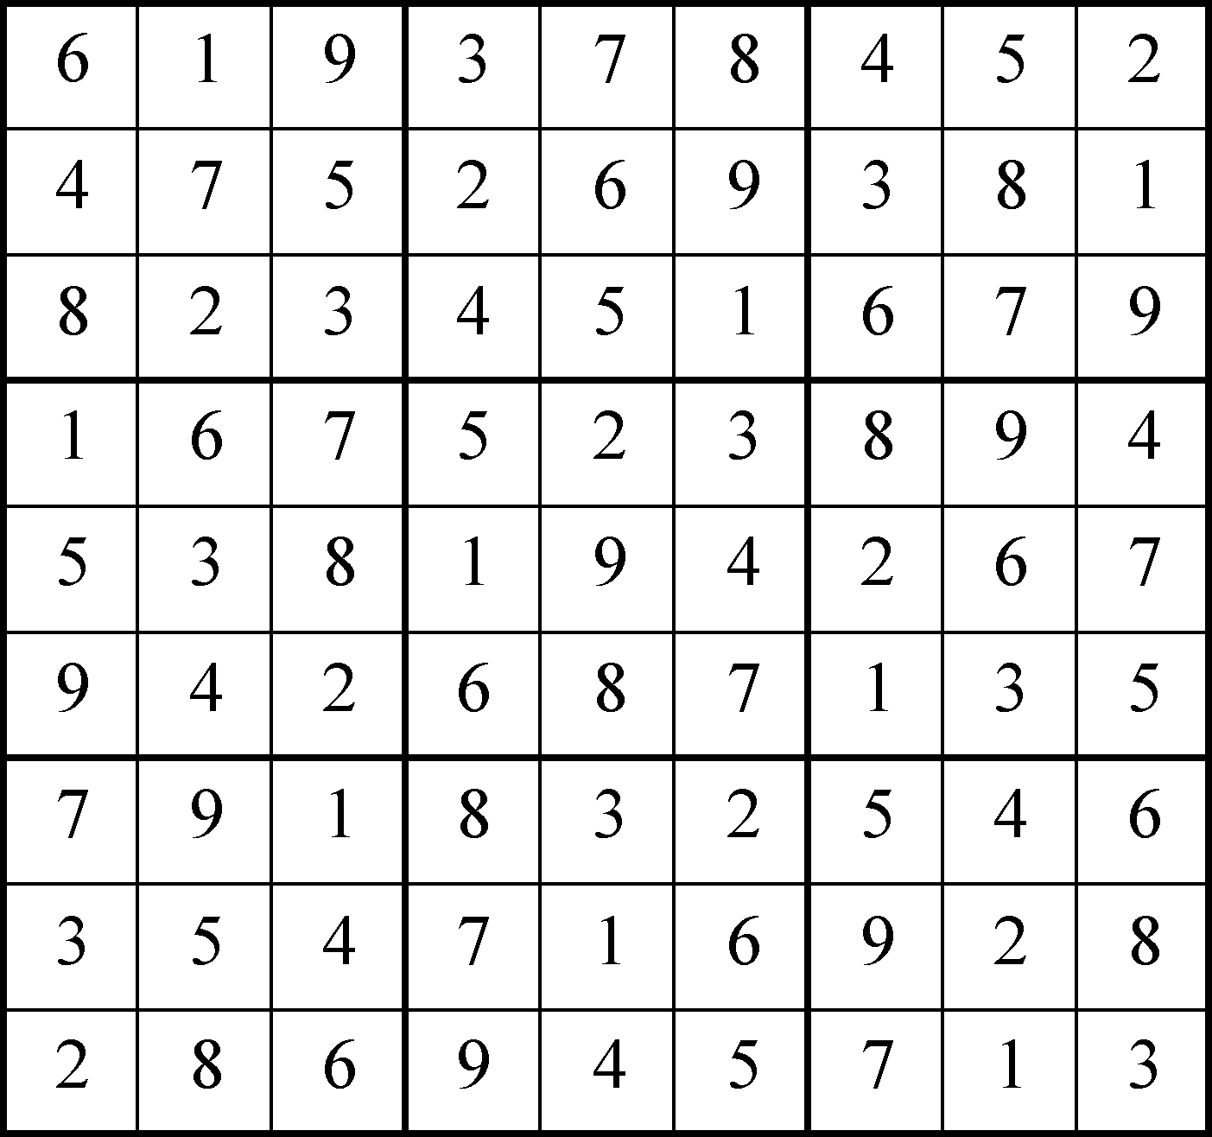
BLM 1.3.1 Practice: Focus on Connecting
1. Week 13
2. Possible answers are:
1 toonie, 1 loonie, 1 quarter, 1 dime, 1 nickel,
2 pennies
3 loonies, 1 quarter, 1 dime, 1 nickel, 2 pennies
3 loonies, 4 dime, 2 pennies
3. a)
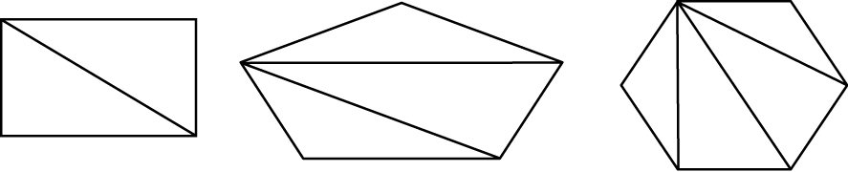

b) Rectangle – 2; Pentagon – 3; Hexagon – 4.
The number of triangles formed by the diagonals from one vertex is 2 less than the number of sides.
c) There will be 13 triangles.
4. The train pass will allow Ayesha to make 400 trips. She makes two trips each workday, so she can
use it for 200 workdays. There are 5 workdays in
a week, so Ayesha won’t have to purchase tickets for 40 weeks.
BLM 1.3.2 Sudoku
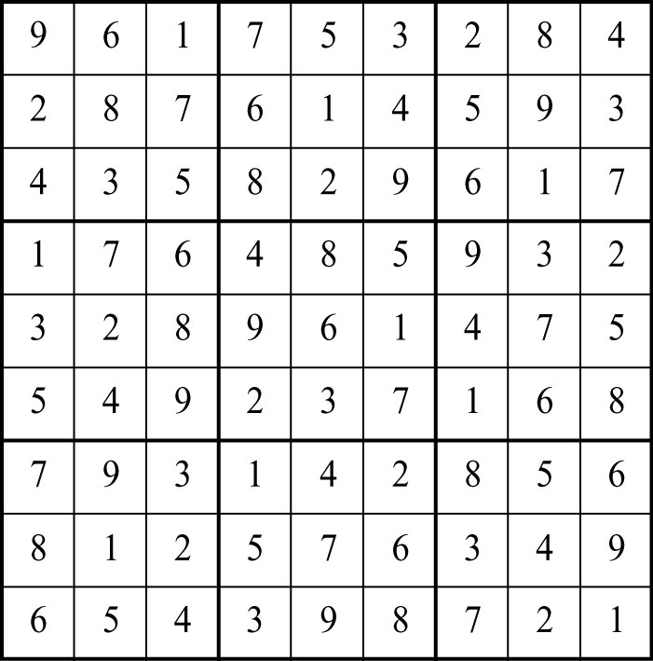
BLM 1.4.1 Practice: Focus on Representing
1. Kendra is 1 km north of where she started.
2. There are 8 different paths between A and F.
3. a) 6 (10:01 a.m. and p.m., 11:11 a.m. and p.m.,
and 12:21 a.m. and p.m.)
b) 2112, 2222, 2332
1661, 1771, 1881
4. a) 32 cm²
b) 4 cm; 2 cm; 1 cm
c) 8 cm²; 2 cm²; cm²
The side length of each triangle is one half the side length of the triangle that surrounds it.
The area of each triangle is one quarter the area of the triangle that surrounds it.
BLM 1.5.1 Practice: Focus on Selecting Tools and Computational Strategies
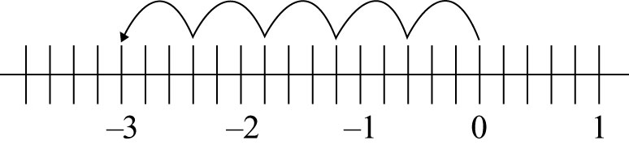
1.

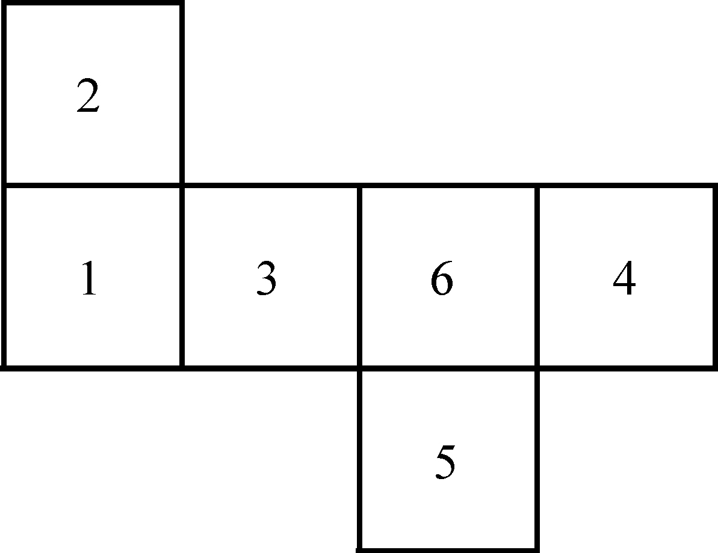
2. a)

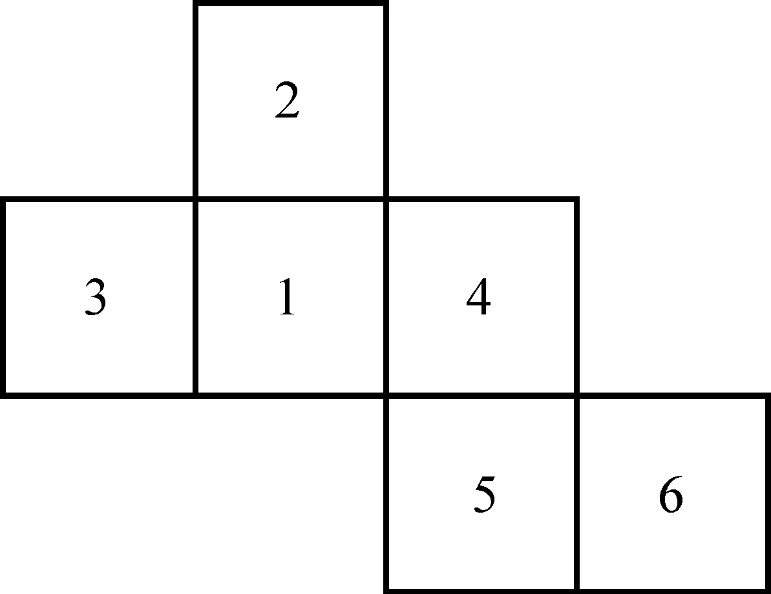
b)

3. 8; I used my calculator.
4. a) −2 b) c) d)
5. a) b) c) d)

BLM 1.5.2 Tangram
16. a) A, B = ; C, E = ; D, F, G =
b) i) ii)
iii) iv)
v) vi)
17. a) F = C + E
b) B = C + E + F
BLM 1.6.1 Practice: Focus on Reasoning and Proving
1. $63.20
2. a) The exponent must be odd
b) (−3)⁵; I know the exponent must be odd because the result is negative. I tried (−3)⁷ and got −2187, which is too low. I tried (−3)⁵ and got −243.
3. Possible answer
a) −3 + 7 = 4
b) A right triangle has one angle equal to 90°
c) = 4
4. Possible answer
a) 5 × 2 + 8 ÷ 4 = 12
b) 33 = 81 ÷ 3 + 42 ÷ 7
c) 2 = + × 6
BLM 1.6.2 Chess Board
Yes, the knight can eventually land on every space on the board.
BLM 1.6.3 Sudoku
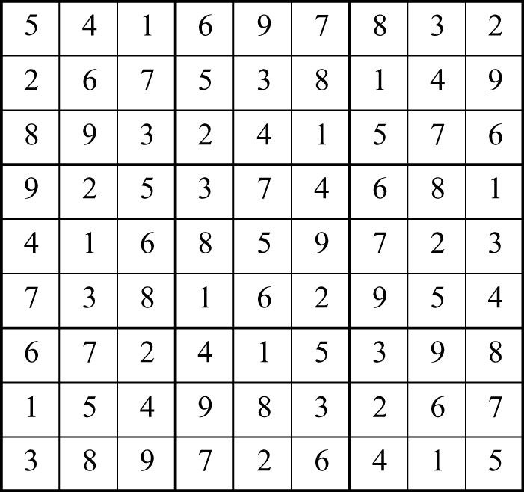

BLM 1.7.1 Practice: Focus on Reflecting
1. 17
2. −2401
3.
4. 16
5. a) 10 b) 10
c) 14 d) 14
e) 18 f) 18
g) 22 h) 22
i) 26 j) 26
6. The sum of four consecutive natural numbers, beginning with n, is equal to 2 times the sum of double n and 3.
Suppose n = 8
8 + 9 + 10 + 11 = 38
(8 × 2 + 3) × 2 = 38
BLM 1.CR.1 Chapter 1 Review
1. a) Each term is 0.25 more than the previous term; 1.5, 1.75, 2
b) Each term is triple the previous term;
243, 729, 2187
c) Each term is 4 less than the previous term;
−14, −18, −22
d) The difference between consecutive terms increases by 2 each time;
36, 48, 62
2. a) = 0.0666…
= 0.1333…
= 0.2
= 0.2666…
= 0.3333…
= 0.4
= 0.4666…
= 0.5333…
= 0.6
= 0.6666…

b) The digit in the tenths place follows this pattern: 0, 1, 2, 2, 3, 4, 4, 5, 6, 6, 7,
The digits in the remaining decimal places are starting with repeating 6s, then repeating 3s, then nothing (repeating 0s), going in a loop.
= 0.7333…
= 0.8
= 0.8666…
3. 8
4. a) A square with perimeter 36 cm has sides 9 cm long. Its area is 81 cm². A rectangle with perimeter 36 cm could have dimensions 16 cm by 2 cm. The area of this rectangle is 32 cm².
b) A square has all sides equal. The rectangle in 4a) has length 16 cm and width 2 cm. This rectangle cannot be a square.
c) 7 and 3 are both prime numbers. Their sum
is 21, which is not a prime number.
5. −16, −17, −18

