Corel® Quattro Pro® 10
Open
Click the Start button and point to Programs. Point to Corel® WordPerfect ® Suite 10. Then, click Corel® Quattro Pro ® 10.
The Basics
The Quattro Pro ® screen is called a notebook.
• Each cell has a cell address. For example, the address of the active cell shown is D3 (column D, row 3).
• The toolbar contains the most commonly used functions from the menus, such as Save, Print, Copy, and Paste.
• The application bar displays the address and the contents of the cell in which you
are working.
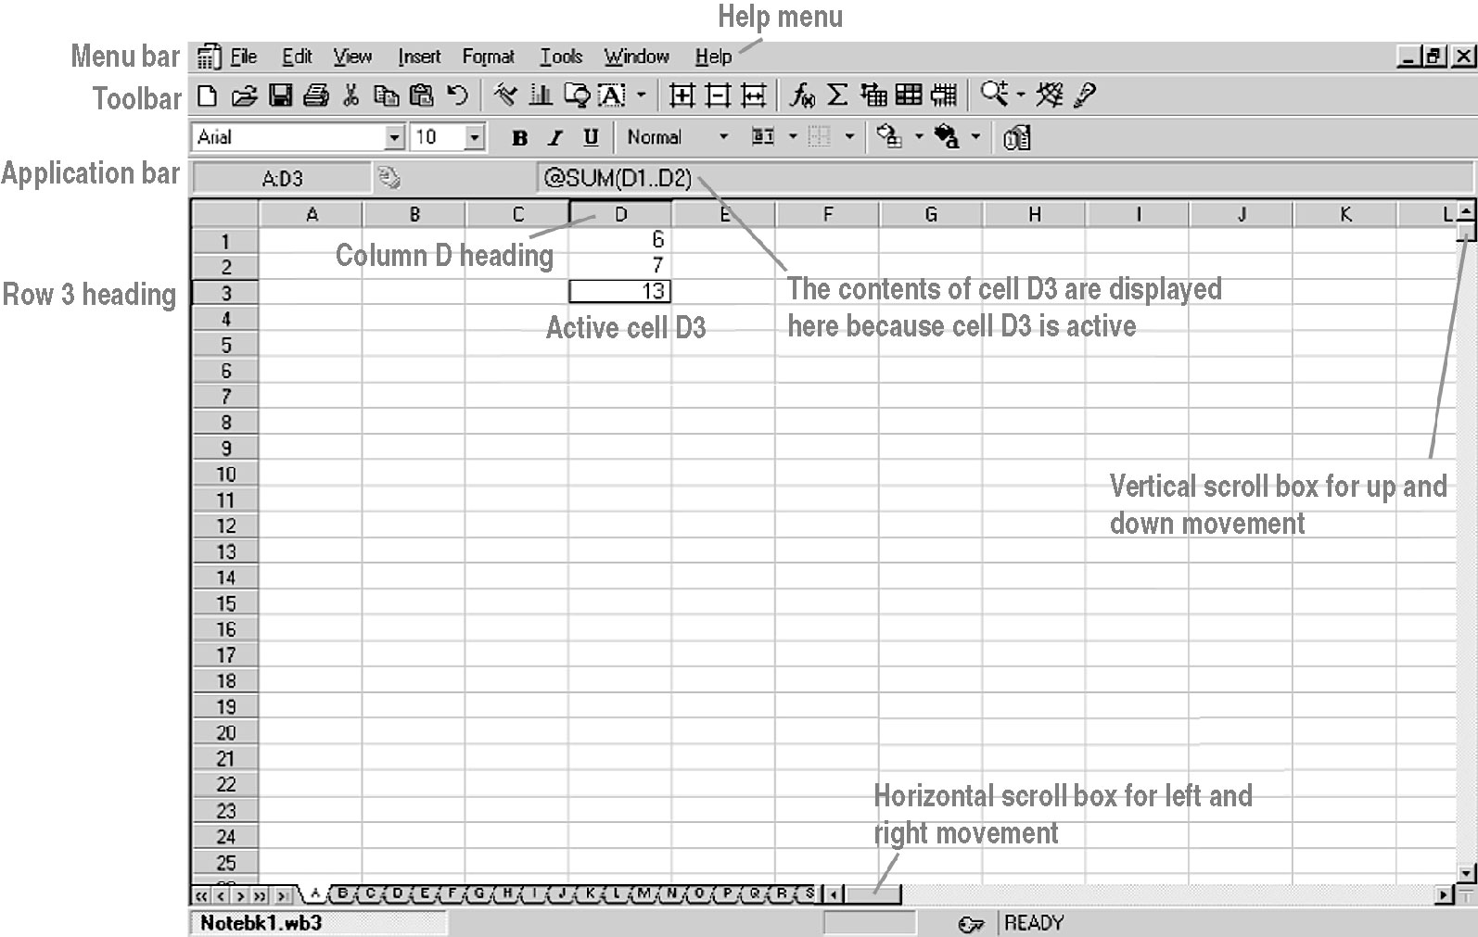
Corel® Quattro Pro® 10
To highlight an entire column,  click the column letter. | To highlight an entire row, click  the row number. | To select the cell into which you wish to enter data, simply click the cell.
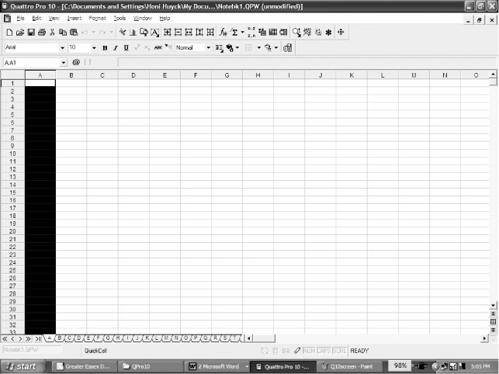 | 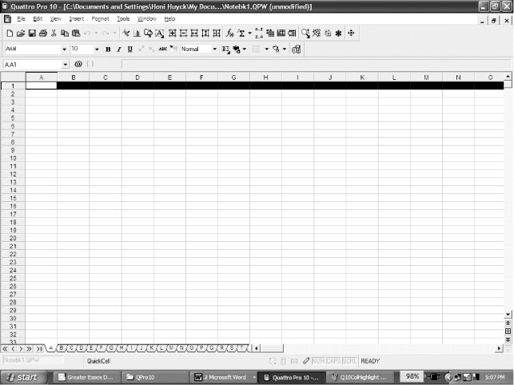 | 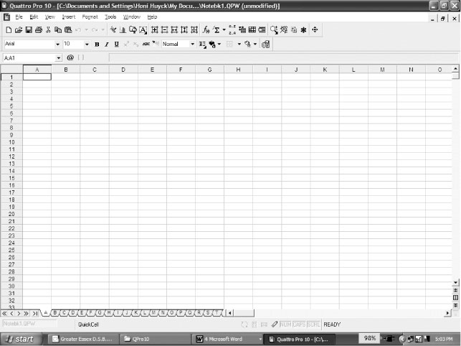
Menus
To display a menu, click the menu name in the menu bar.
File | Edit | Options
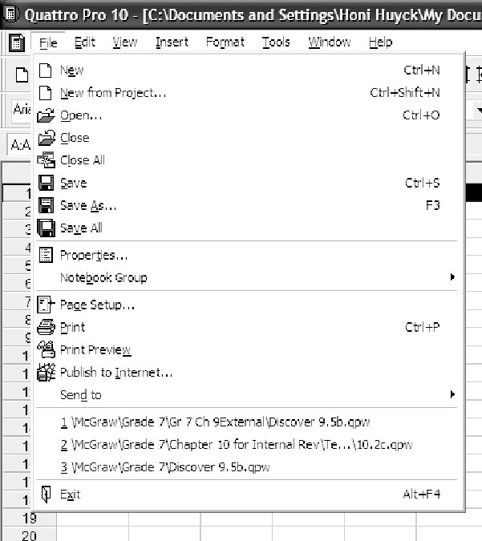 | 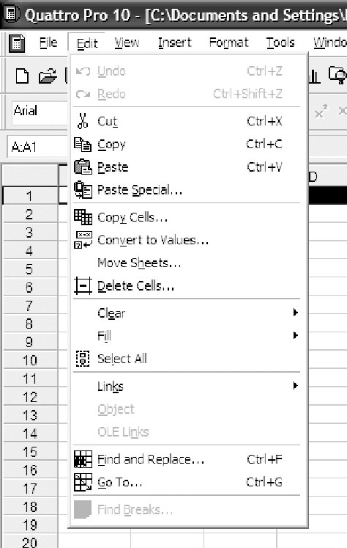 | 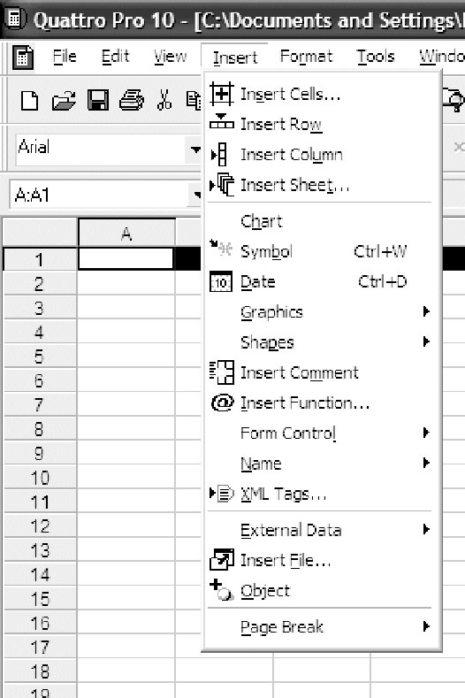
Use this menu to Save your file,  to Print your file, or to Open an existing file. | Use this menu to Copy or Cut highlighted data, to Paste data previously copied, or to Fill  a selected row or column. | Use this menu to create a graph  by clicking the Chart… menu command.

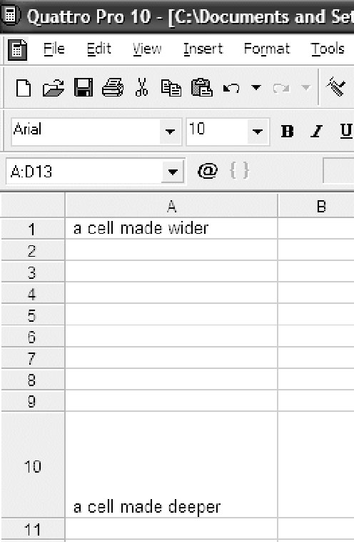
Corel® Quattro Pro® 10
Cell Sizing
To adjust cell size, click the edge of the cell column
heading (A, B, …) and drag it to widen, or click the bottom
of the cell row heading (1, 2, …) and drag to deepen.
Entering Data
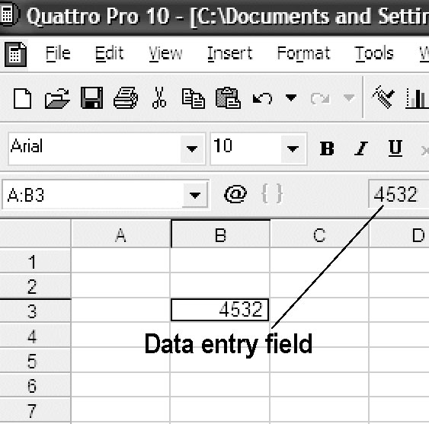
Click the cell into which you wish to enter
data (here, B3), and type in your data.
The data can be numeric, alphabetic,
or alphanumeric. You may widen or
deepen the row/column as necessary to
hold the data. To edit existing data,
click the cell, then click the data entry
field.
Creating a Graph
Select the cells containing the data you wish to graph. On the Insert menu, click Chart….  Click the Next button. | Select the category of graph  you wish to create. Here Pie (or Circle) graph has been chosen. Click the Next button. | Select the type of graph.  Here, Regular has been chosen. Click the Next button.  Label your graph as needed,  and click the Next button.
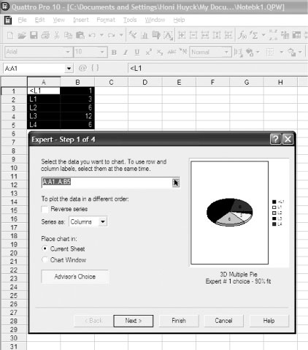 | 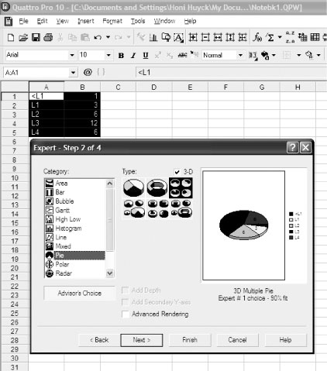 | 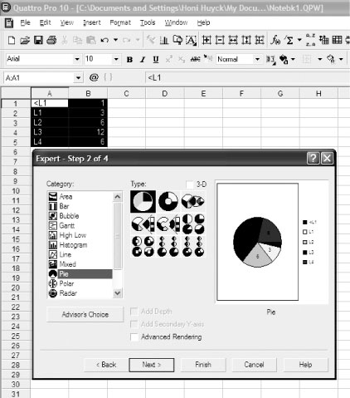

Corel® Quattro Pro® 10
Choose a colour scheme. Click  the Finish button. | A small bar graph icon will appear  in your notebook. Position it where you would like your graph to appear on the spreadsheet, and click. | Your graph will appear.
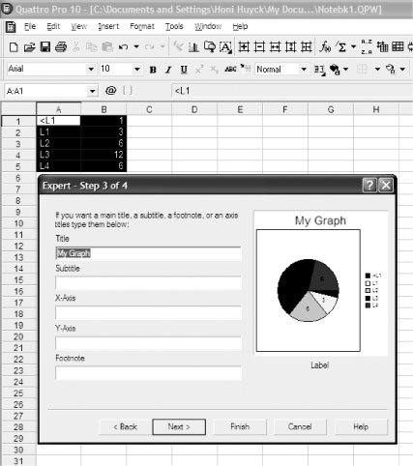 | 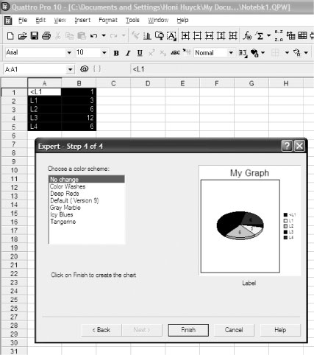 | 