The Geometer’s Sketchpad® 3
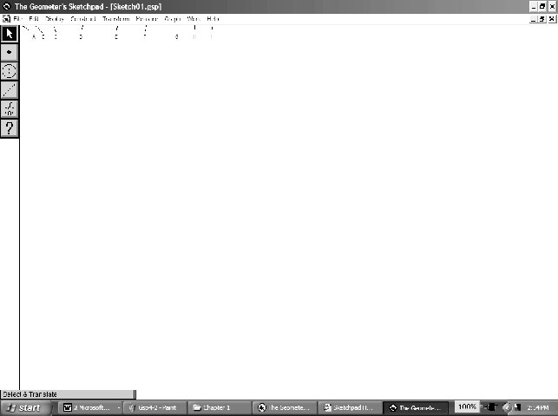
The Menus
File: Used to open, save, close, and print documents.
Edit: Used to undo and redo actions.
Display: Used to control an object’s appearance, to label/hide/animate objects, and to set preferences.
Construct: Used to construct new geometric objects based on selected objects in your sketch.
Transform: Used to apply geometric transformations to selected objects.
Measure: Used to give various measures based on selected objects in a sketch.
Graph: Used to create grids and axes for plotting points.
Window: Used to manipulate windows within The Geometer’s Sketchpad ® to create a script.
Help: Used to access the available help files.
The Toolbox
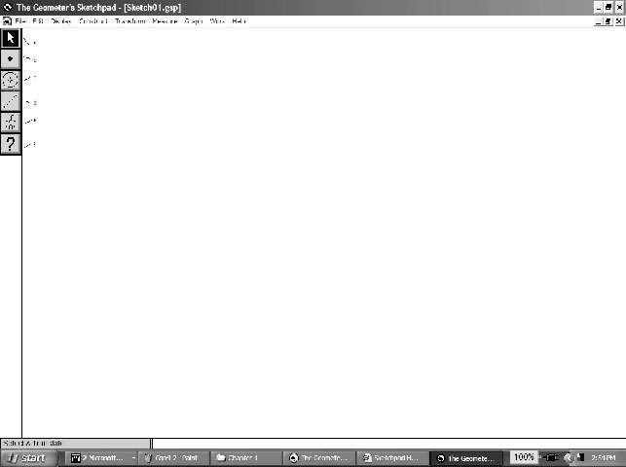
Selection Arrow Tool: Used to select, move, and transform objects in a sketch.
Point Tool: Used to draw and plot points.
Compass Tool: Used to draw circles.
Straightedge Tool: Used to draw line segments, lines,
and rays.
Text Tool: Used to label/unlabel points and lines, and to
write text within a sketch.
Object Information Tool: Provides information about selected objects.
Creating a New Sketch
• To create a new sketch window, on the File menu, click New Sketch.
The Geometer’s Sketchpad® 3
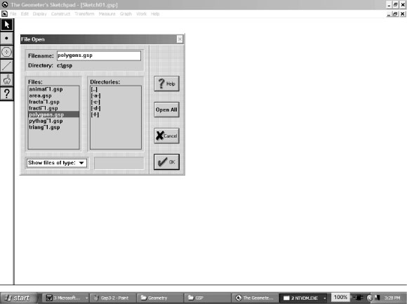
Opening an Existing Sketch
• On the File menu, click Open….
• Navigate to the directory where the sketch you wish to open
is saved.
• Click the name of the sketch you wish to open, and click OK.
Saving a Sketch
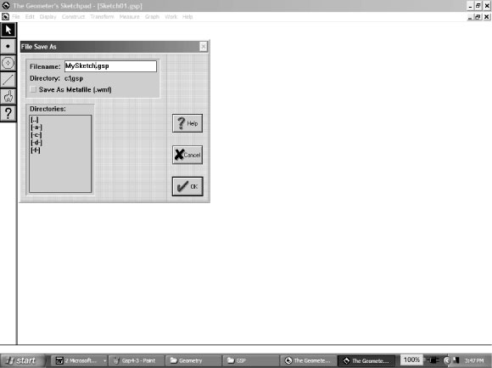
To save a sketch for the first time:
• on the File menu, click Save
• navigate to the directory in which you wish to save the sketch
• The Geometer’s Sketchpad ® will give the sketch a name in
the Filename text box. To use that one, click OK.
OR
• to give the sketch the name you wish, delete the given name, and type the name you want in the Filename text box. Click OK.
To resave a previously saved sketch:
• on the File menu, click Save.
Closing a Sketch Without Exiting The Geometer’s Sketchpad®
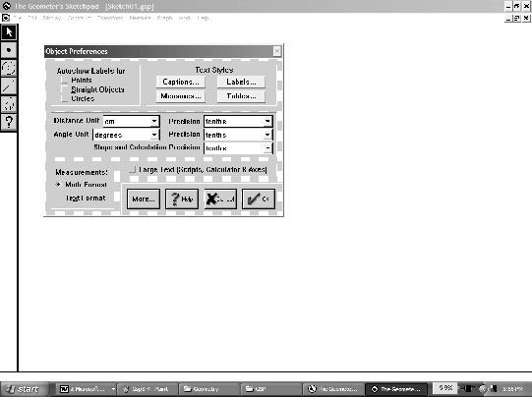
• On the File menu, click Close.
Exiting The Geometer’s Sketchpad®
• On the File menu, click Exit.
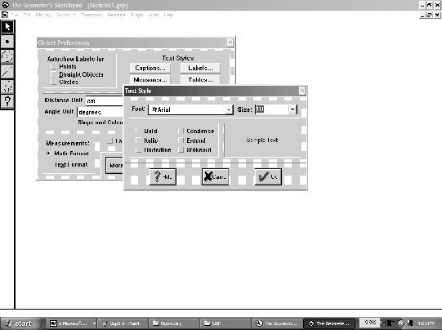
Setting Preferences
• On the Display menu, click Preferences….
• Select the desired units and precision for Distance, Angle,
Slopes, and Calculations.
• If you click any of the boxes under the Autoshow Label for,
the selected objects will automatically be labelled by The
Geometer’s Sketchpad ® at the time the object is created.
• The boxes under Text Styles allow you to change the style and size of the text used in Captions..., Labels..., Measures..., Tables….

The Geometer’s Sketchpad® 3
Selecting Points and Segments
• Click the Selection Arrow Tool. The mouse cursor will appear as an arrow.
• Move the cursor to the point or segment you wish to select. When the cursor becomes
a horizontal arrow, click once with the mouse, and the point or object will be selected.
• To select more than one point or segment, hold down the SHIFT key, and continue clicking
each point or object you would like selected.
Deselecting
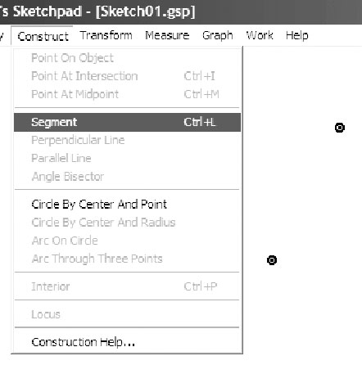
• To deselect a single point or segment, hold down the SHIFT key, and move the cursor to the point or segment you wish to deselect. When the cursor becomes a horizontal arrow, click and the point or object will be deselected.
• To deselect all selected items, click any white space.
Constructing Line Segments
• Click the Point Tool, and create two points in the workspace.
• Click the Selection Arrow Tool, and select both points.
• On the Construct menu, click Segment.
OR
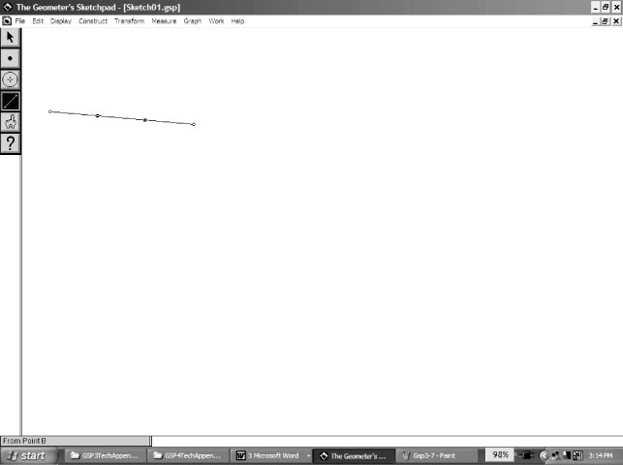
• Click the Straightedge Tool.
• Move the cursor to the workspace.
• Click and hold the left mouse button.
• Drag the cursor to form the segment.
• Release the mouse button.
Constructing Triangles
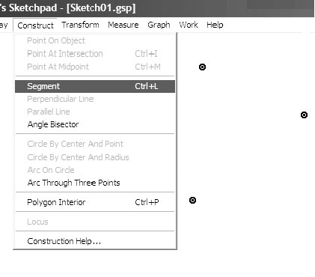
• Click the Point Tool. Draw three points in a triangular
shape in the workspace.
• Click the Selection Arrow Tool, and select the three points.
• On the Construct menu, click Segment.
The Geometer’s Sketchpad® 3
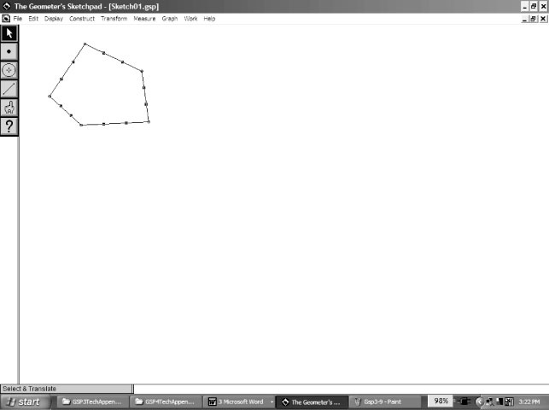
Constructing Polygons
• To construct a polygon: Click the Point Tool. Draw four or more points in the workspace.
• Click the Selection Arrow Tool, and select all the
points in either clockwise or counterclockwise order.
• On the Construct menu, select Segment.
Constructing Parallel Lines
To construct a line parallel to an existing line:
• click the Point Tool, and place a point above or below the existing line
• click the Selection Arrow Tool, and select the point and the line
• on the Construct menu, click Parallel Line.
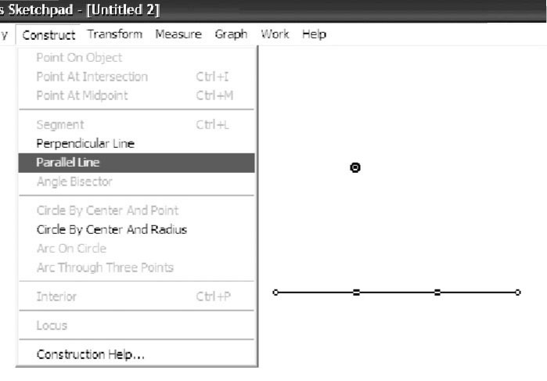 | 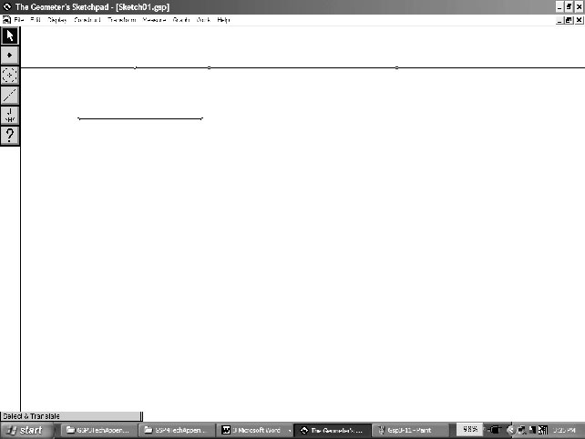
Constructing Perpendicular Lines
To construct a line perpendicular to an existing line:
• click the Point Tool, and place a point above or below the existing line
• click the Selection Arrow Tool, and select the point and the line
• on the Construct menu, click Perpendicular Line.
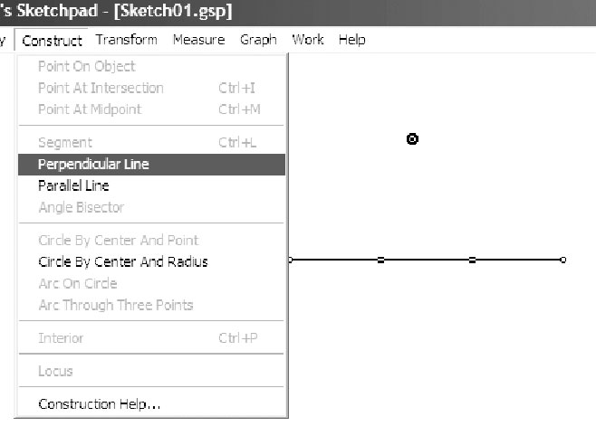 | 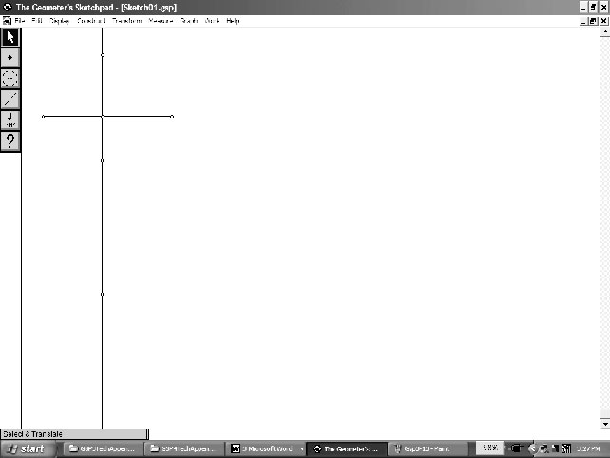
The Geometer’s Sketchpad® 3
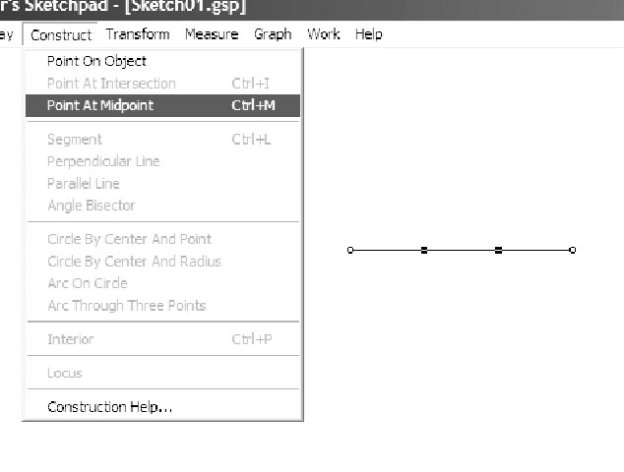
Constructing a Midpoint
• Click the Selection Arrow Tool, and select the line.
• On the Construct menu, click Point At Midpoint. A
point will appear on the line. That point will be fixed at the
middle of the line.
Finding Measures
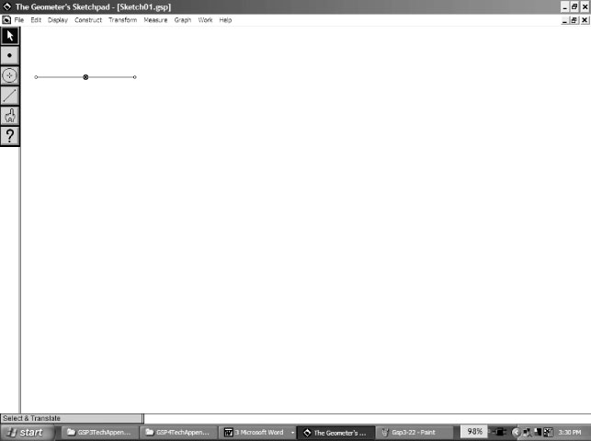
For all measures, The Geometer’s Sketchpad ® will display
the desired measure using the units and precision selected
in Preferences… on the Display menu.
To measure the distance between two points:
• ensure nothing is selected
• select the two points
• on the Measure menu, click Distance.
To measure the length of a line segment:
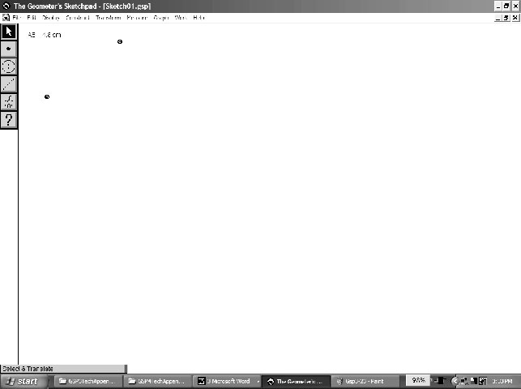
• ensure nothing is selected
• select the two points
• on the Measure menu, click Length.
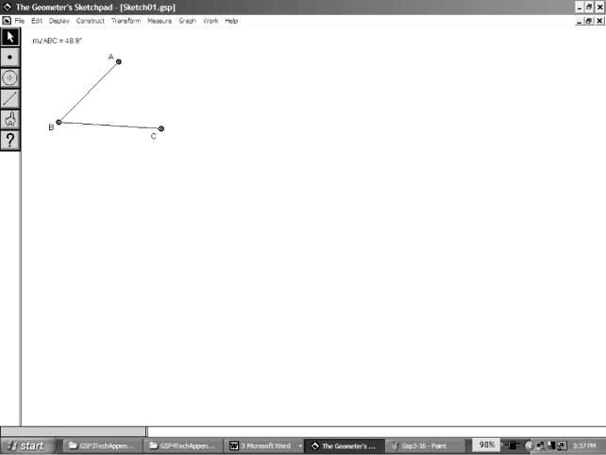 | 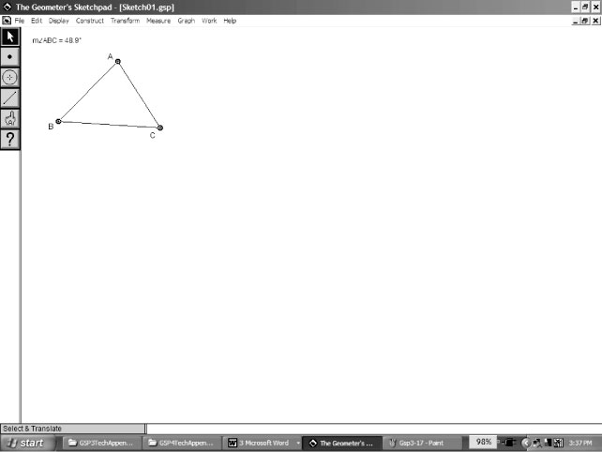
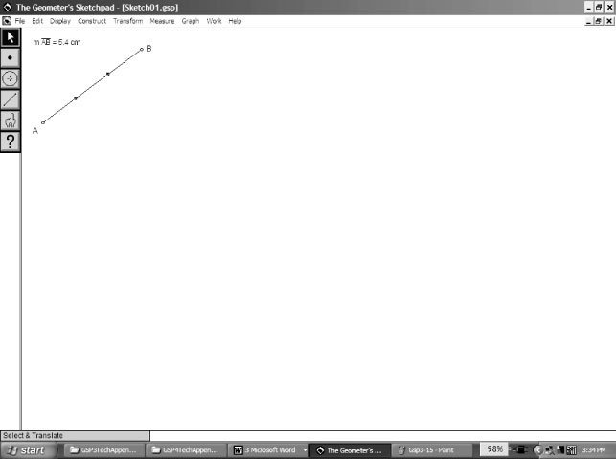
To measure an angle:
• ensure nothing is selected
• select the three points that form the angle. Make sure
that the second point selected is the vertex of the angle.
• on the Measure menu, click Angle.
The Geometer’s Sketchpad® 3
Constructing and Measuring Polygon Interiors
The Geometer’s Sketchpad ® will measure the perimeter and area of a polygon.
However, you must construct the interior of the polygon first.
To construct the interior:
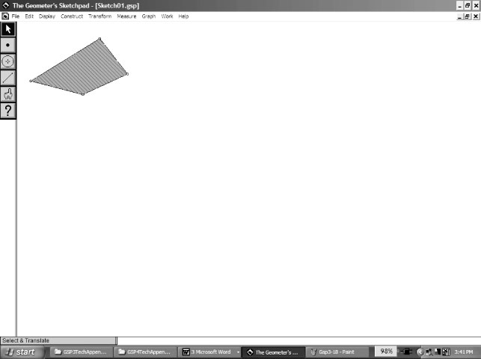
• select all the points representing the vertices of the polygon. Here we have a quadrilateral, so four points were selected.
• on the Construct menu, click Polygon Interior.
To measure the perimeter and area:
• click the polygon’s interior
• on the Measure menu, click Perimeter
• click the polygon’s interior
• on the Measure menu, click Area.
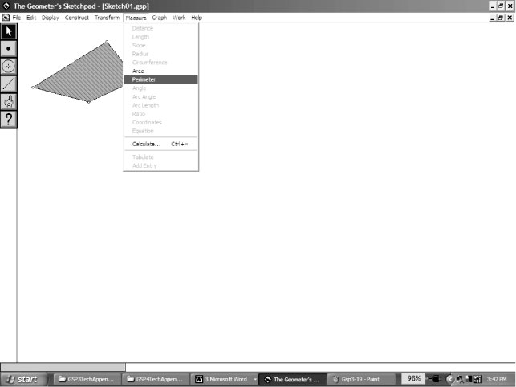 | 