Practice: Linear and Non-Linear Relations

1. Does each graph show a linear relationship or a non-linear relationship? Explain.
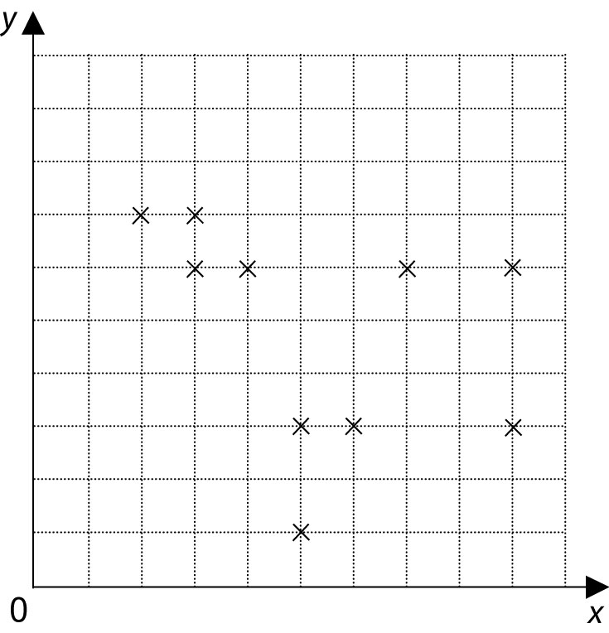
a)

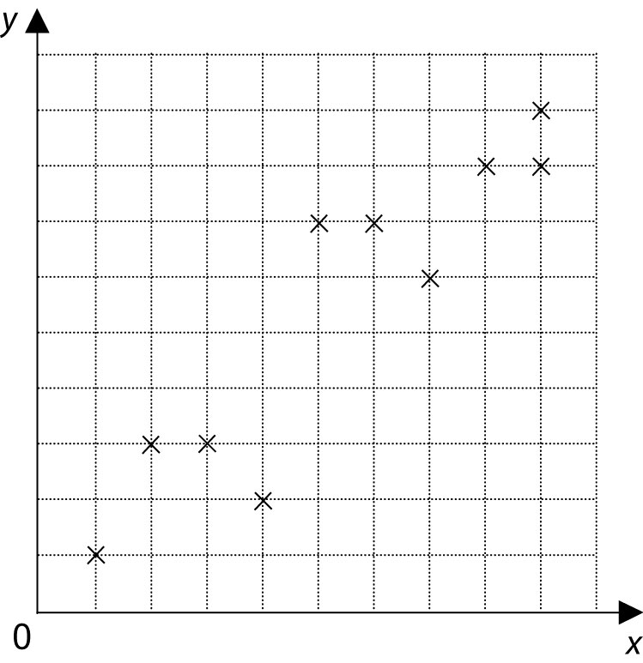
b)

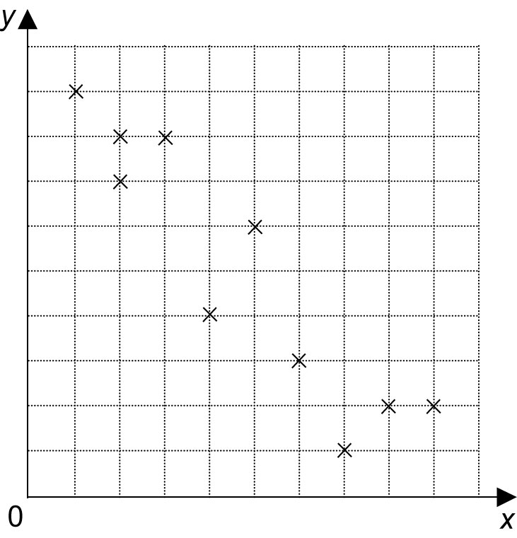
c)

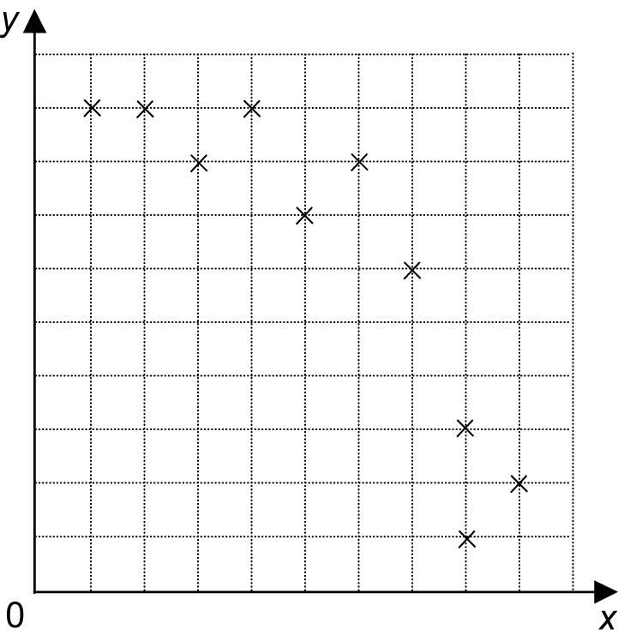
d)

2. Plot each set of points on a grid. Does
each set of points have a linear relationship?
a) (1, 2), (9, 7), (5, 9), (3, 2), (8, 1),
(8, 9), (7, 4), (2, 7), (6, 1), (4, 7)
b) (1, 9), (9, 6), (5, 7), (3, 8), (4, 9),
(2, 9), (6, 8), (8, 7), (7, 6), (8, 5)

3. Is each line of best fit a good model for the data? Why or why not?

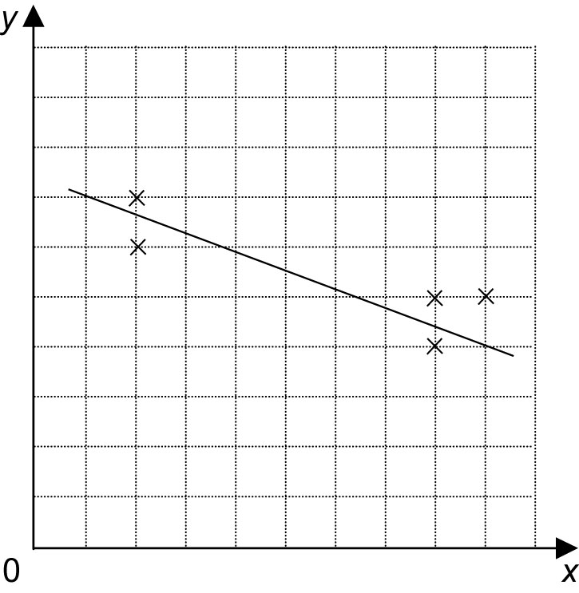
a)

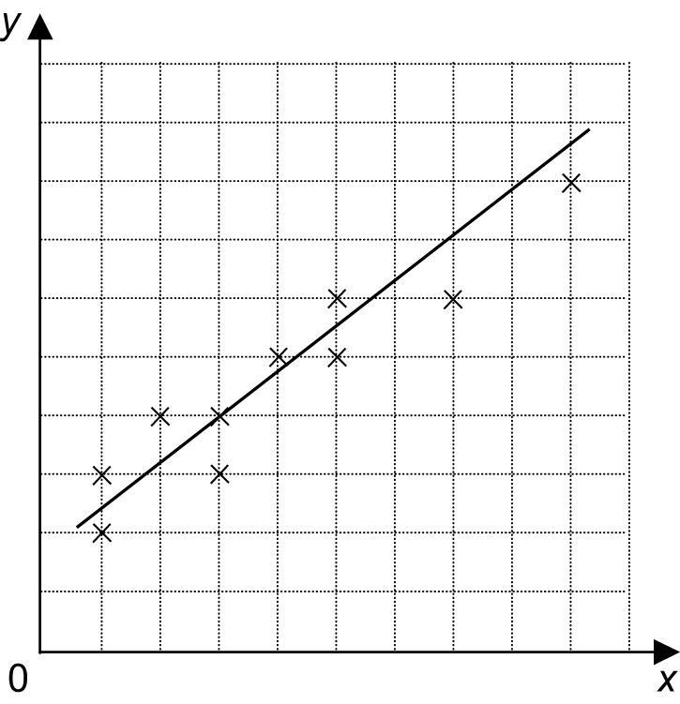
b)

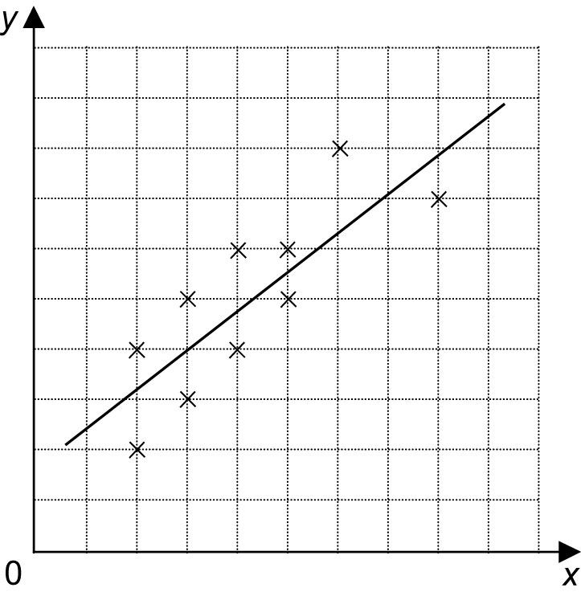
c)

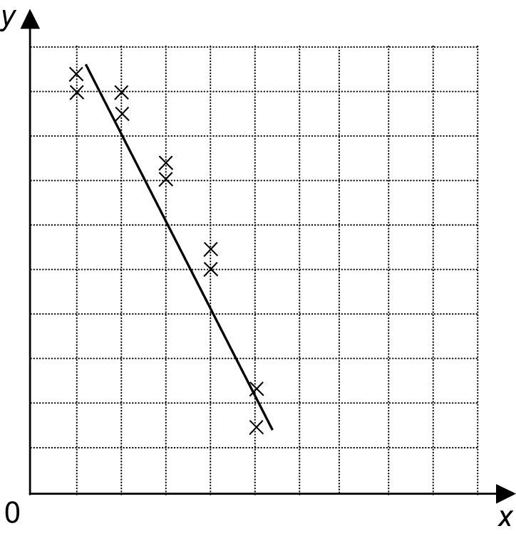
d)

4. Plot the points on a grid. Draw a line of best fit if the plot shows a linear relationship or a curve of best fit if the relationship appears non-linear.

x | 5 | 1 | 2 | 8 | 2 | 4 | 6 | 7 | 6 | 8
y | 6 | 7 | 7 | 4 | 6 | 5 | 5 | 3 | 4 | 3

