Practice: Distance-Time Graphs

1. Michelle is late for school. She runs halfway to school, then gets tired and stops for a short rest. Then, she walks the rest of the way. Which graph best matches the story?

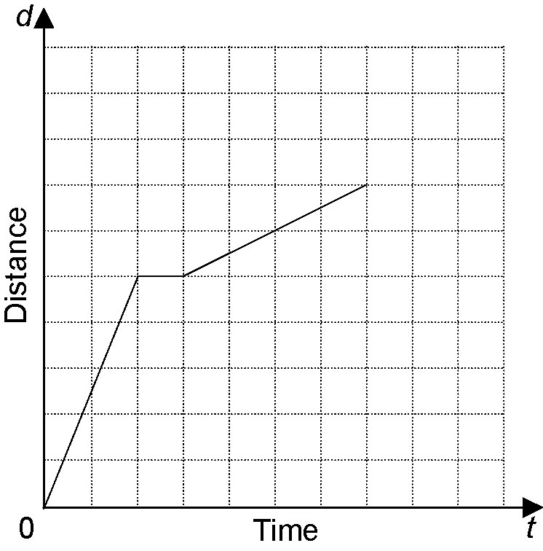
A

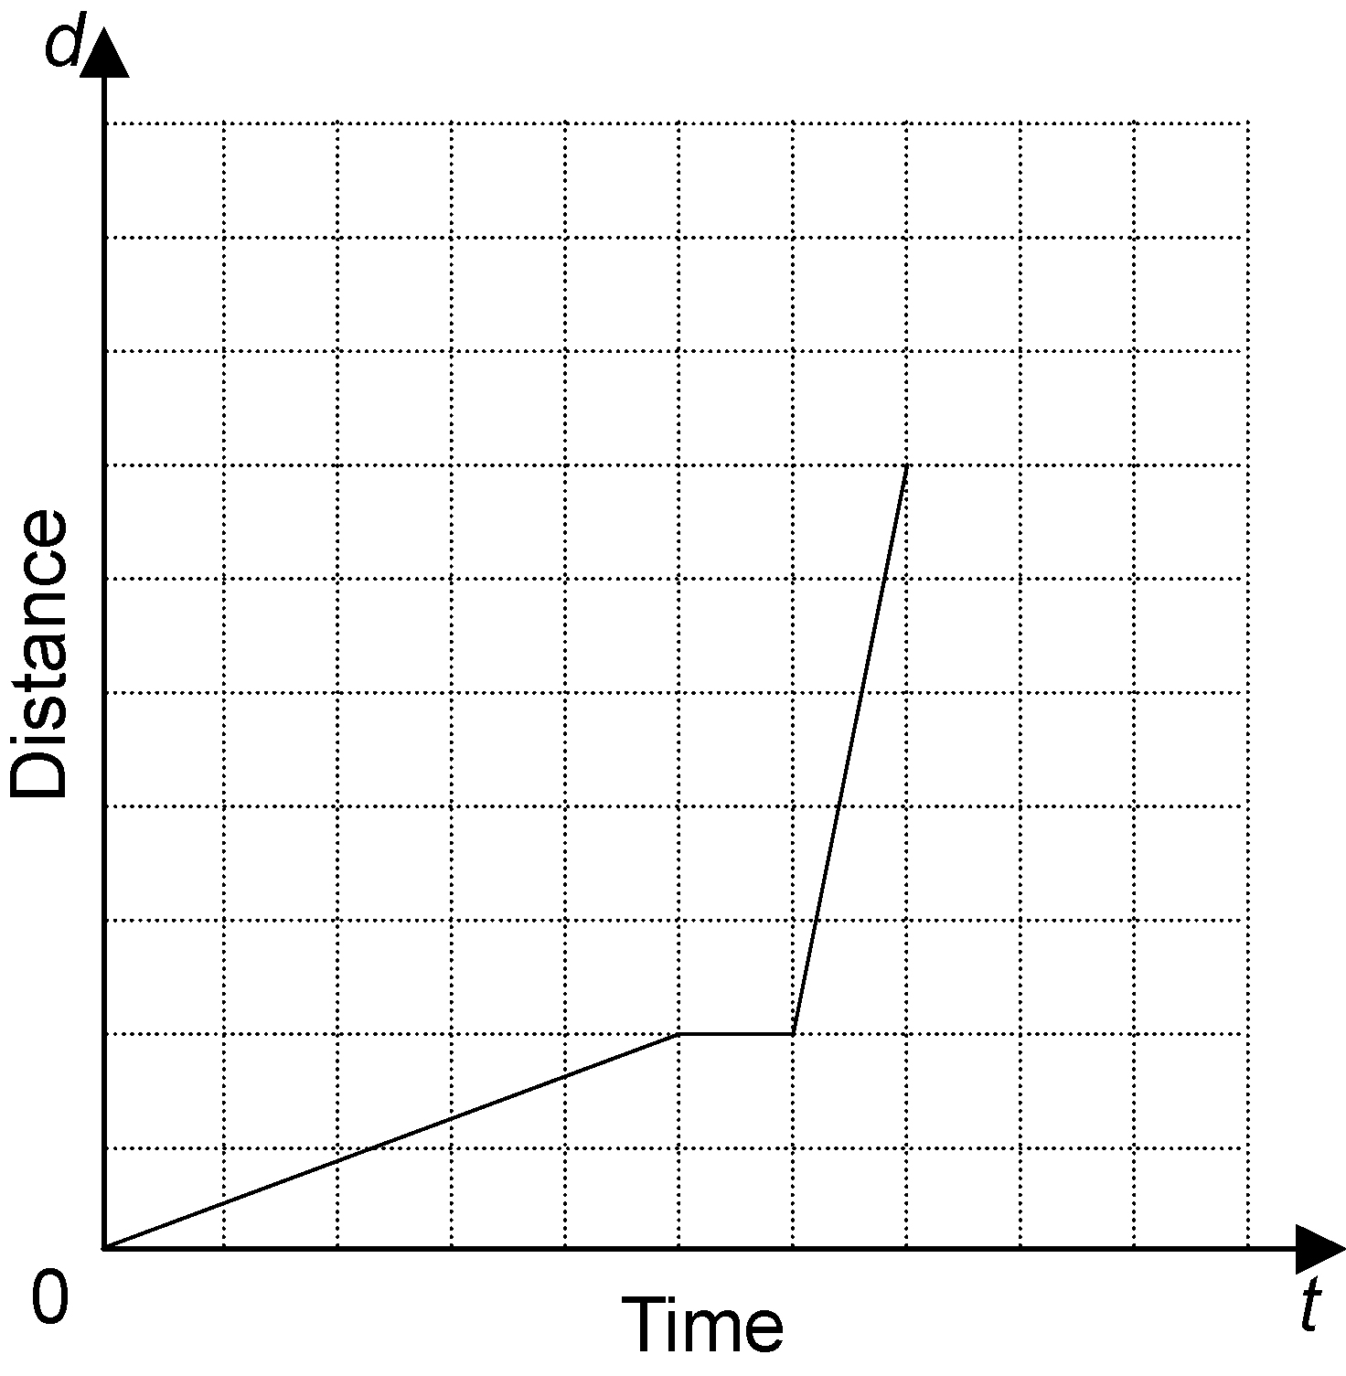
B

2. Describe a situation that could be represented by each graph.
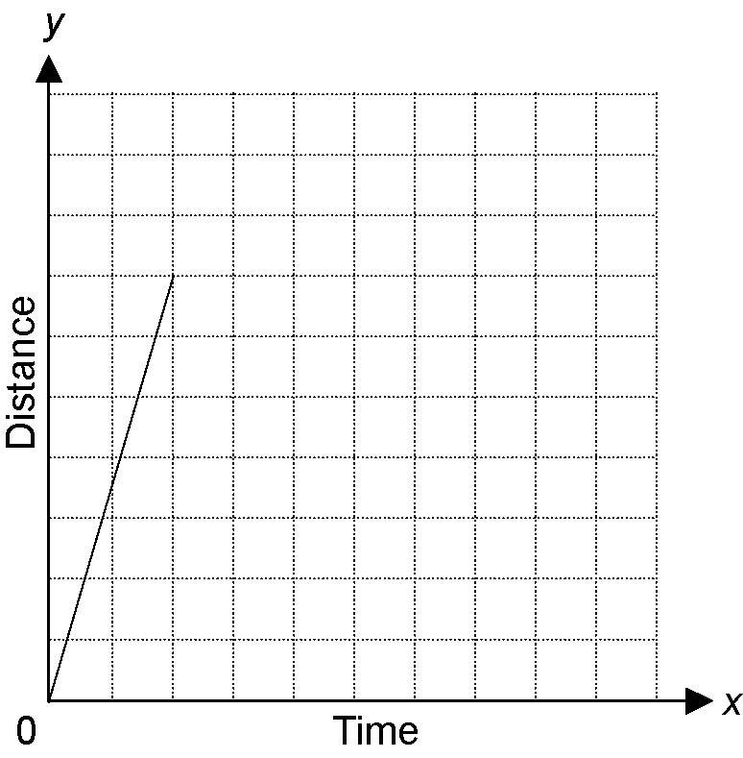
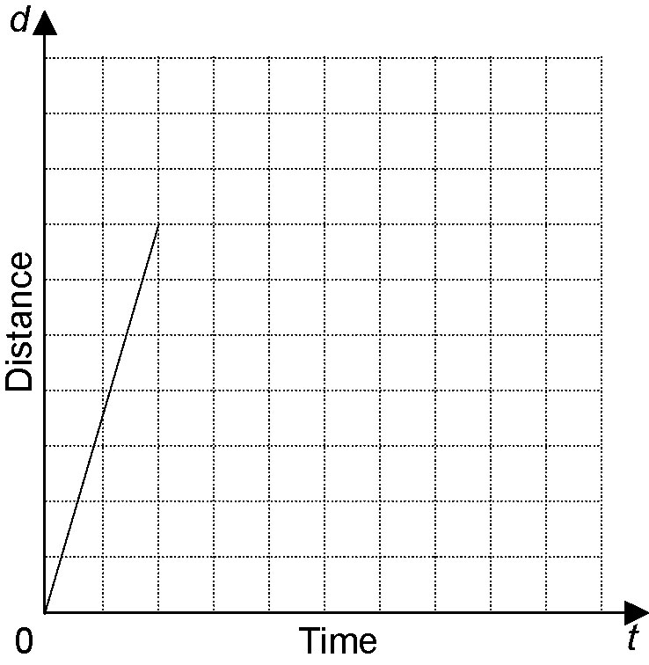
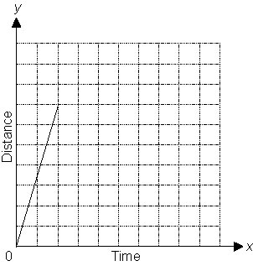
a)

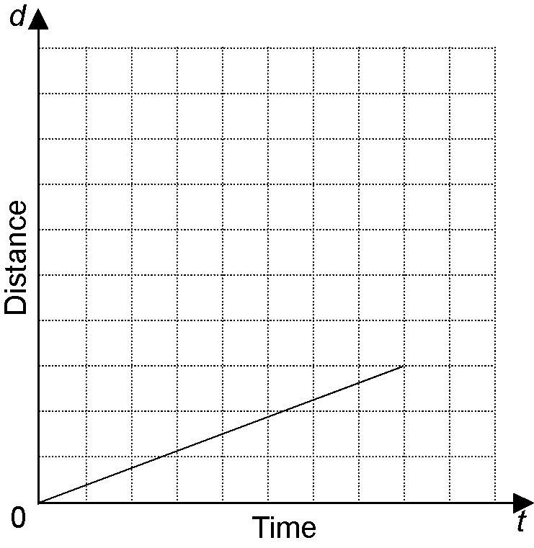
b)

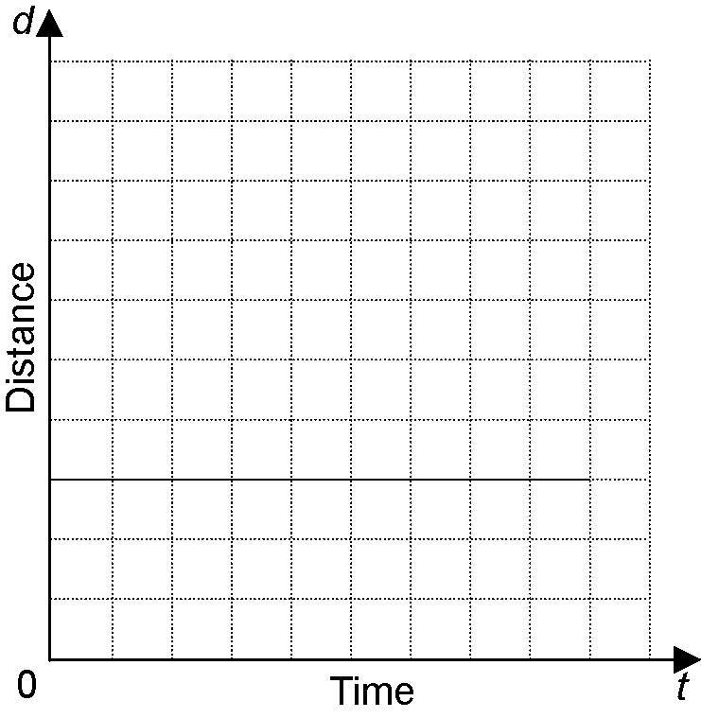
c)

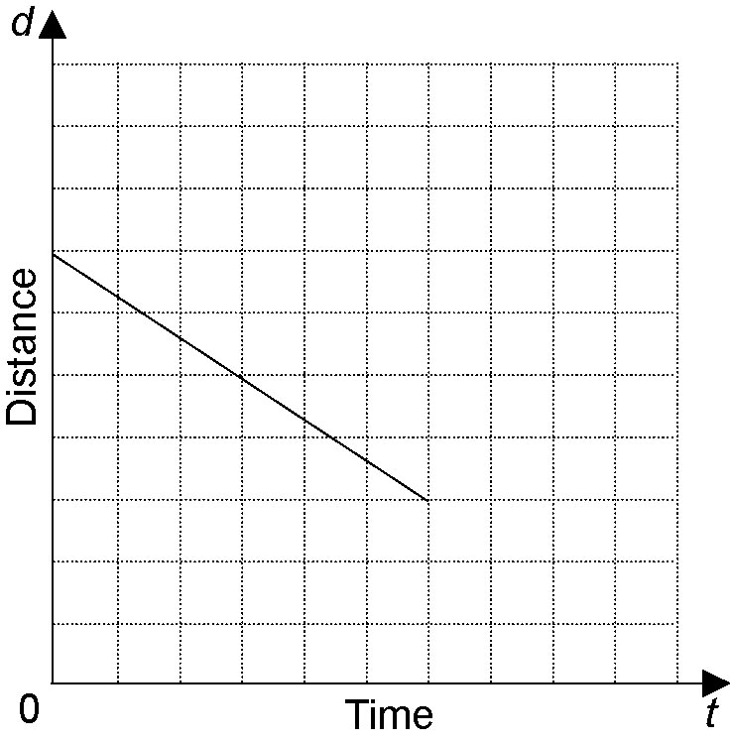
d)

3. Describe the motion represented by
each graph.

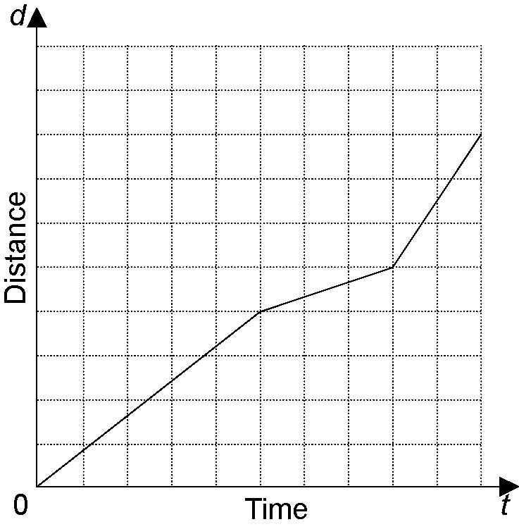
a)

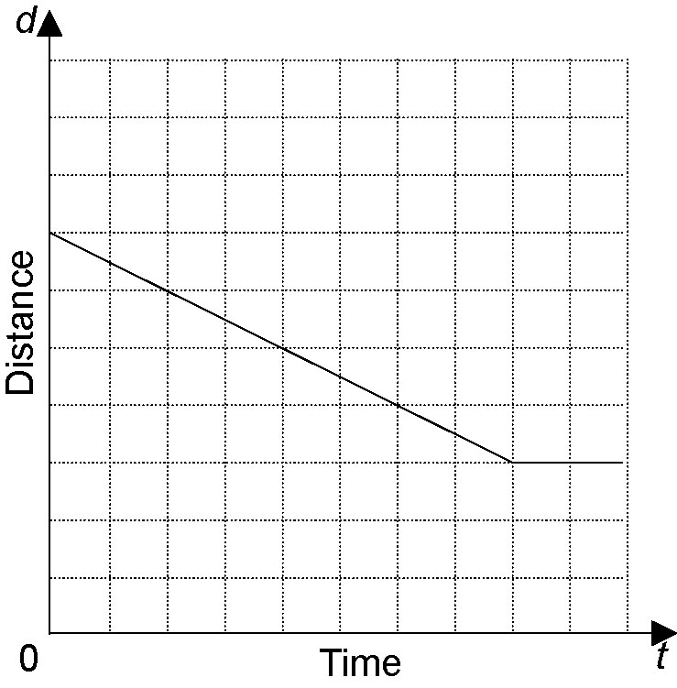
b)

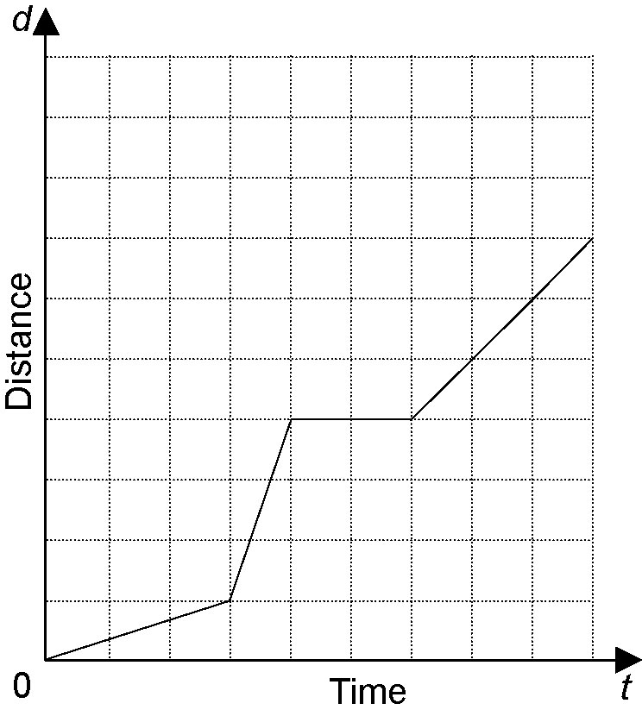
c)

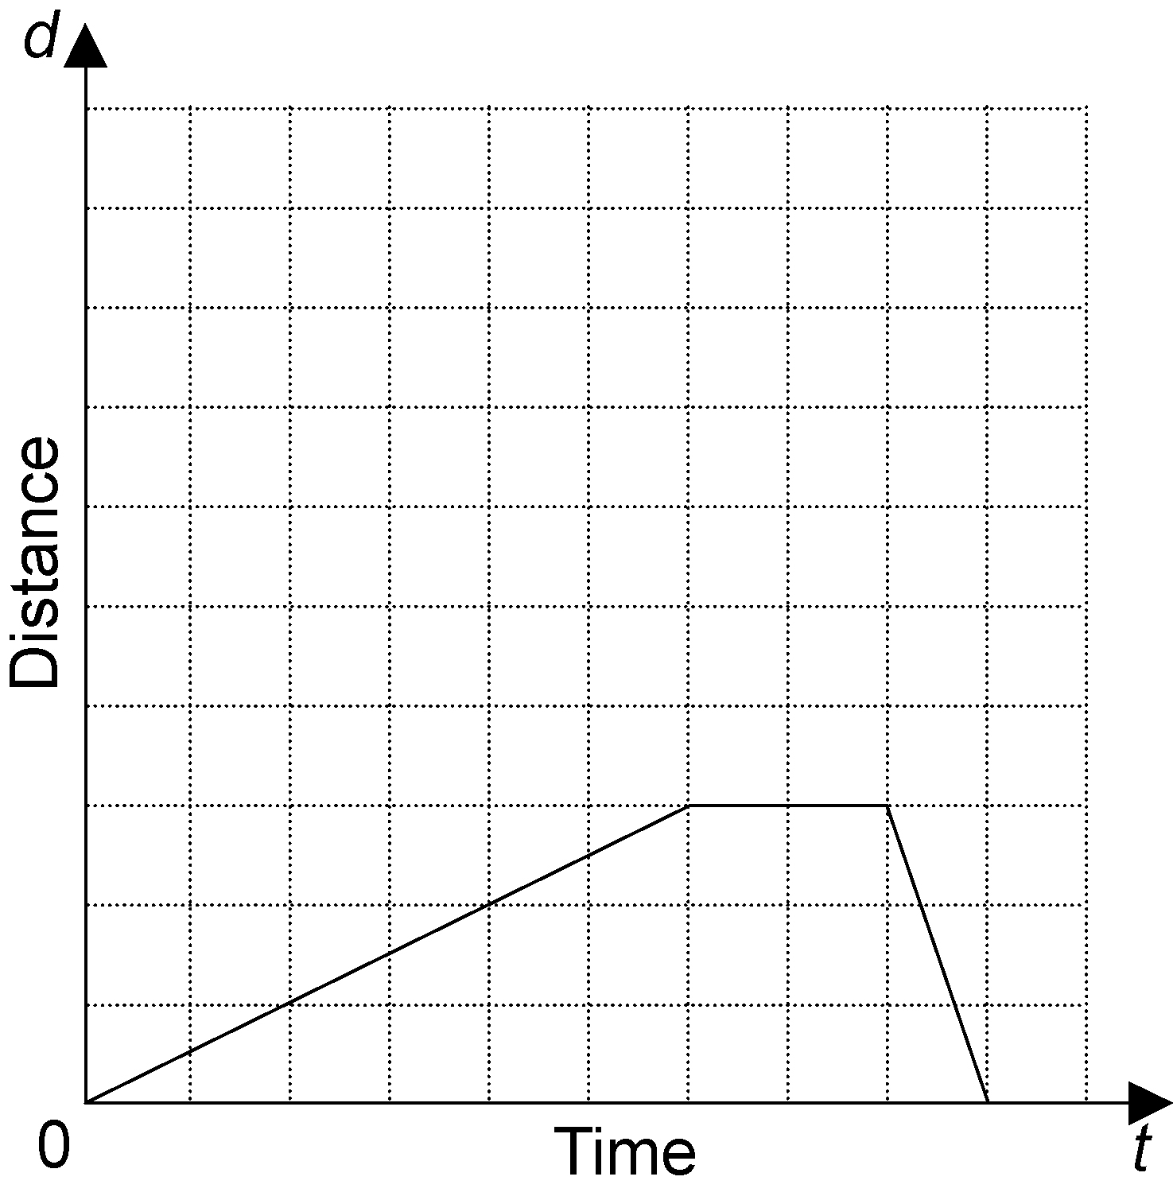
d)

4. Mark walks to his friend’s house. Partway there, he realizes he forgot a CD at home. He runs back home to pick up the CD, then walks back to his friend’s house. Construct a distance-time graph to represent this situation.

