Chapter 2 Review

  - Hypotheses and Sources of Data,
pages 42–47

1. State a hypothesis about a relationship between each pair of variables. Then, state the opposite hypothesis.
a) the cost of electricity and the consumption of electricity
b) the number of pets in a household and household income
2. Identify each source of data as a primary or a secondary source.
a) Conlyn used data collected by Canadian Blood Services to find out what proportion of Canadians have each blood type.
b) An investment advisor asked 50 clients which types of investments they prefer.
c) To decide which activities to run during Charity Week, the student council sent questionnaires to all the students in the school.
d) Researchers used data collected by Statistics Canada to determine the typical income of a Canadian family.
2.2 Sampling Principles, pages 48–55

3. You want to find out which charity students at your school wish to support
this year.
a) Identify the population.
b) Describe how you could use a stratified random sample to conduct the survey.
4. Teachers in the music department want to survey the students in the bands.
a) Identify the population.
b) Describe how you could select a random sample to conduct the
survey.
2.3 Use Scatter Plots to Analyse Data,
pages 56–67
5. The table shows the lengths of the tails and the shoulder heights for a group of dogs.

Shoulder Height (cm) | Length of Tail (cm)
66 | 32
42 | 15
33 | 5
30 | 8
41 | 14
62 | 26
65 | 34
39 | 12

a) Draw a scatter plot of the data.
b) Describe the relationship between the shoulder height of a dog and the length of its tail.
c) Should any outliers be discarded? Explain.
2.4 Trends, Interpolation, and
Extrapolation, pages 68–76

6. The table shows the profits of a small manufacturing company from 1955
to 2005.

Year | Profits ($1000s)
1955 | 48
1965 | 62
1975 | 87
1985 | 110
1995 | 117
2005 | 131

a) Make a scatter plot of the data.
b) Describe the trend in the profits.
c) Estimate the company’s profits
in 1980.
7. The table shows the population of a town.

Year | Population
1941 | 6800
1951 | 6690
1961 | 6505
1971 | 6003
1981 | 5899
1991 | 5542
2001 | 5307

a) Make a scatter plot of the data.
b) Describe the trend in the population.
c) Estimate the town’s population in 2011.

  - Linear and Non-Linear Relations,
pages 77–87

8. Plot each set of points on a grid. Does each set of points have a linear relationship?
a) (1, 0), (2, 3), (4, 7), (3, 3), (6, 9),
(5, 8), (6, 8), (3, 4), (4, 5), (2, 1)
b) (1, 9), (9, 6), (5, 7), (3, 8), (4, 9),
(2, 9), (6, 8), (8, 7), (7, 6), (8, 5)

9. Is this line of best fit a good model for the data? Why or why not?

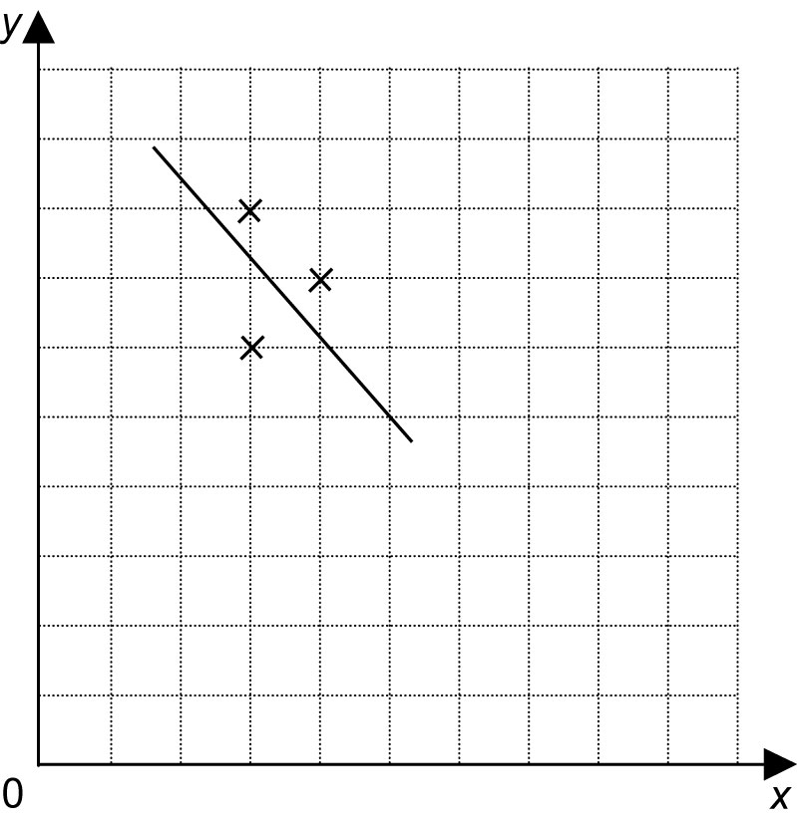
2.6 Distance-Time Graphs, pages 88–94

10. Write a story that could be represented by the graph.

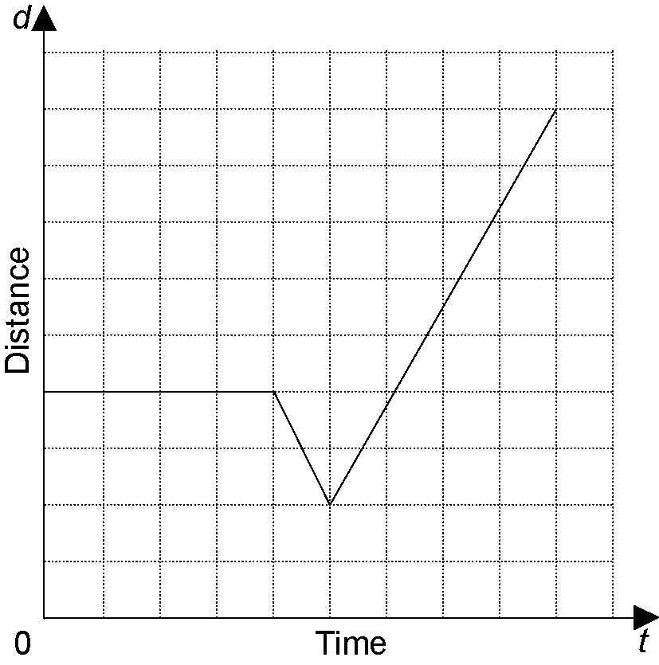

11. Draw a distance-time graph to represent this situation:
Chad went for a bike ride. He started riding against the wind. Then, the wind changed direction and was at his back.

