Practice: Get Ready

Bar Graphs

1. This graph shows the bank rate on the last Wednesday of each of the last six months of 2005.
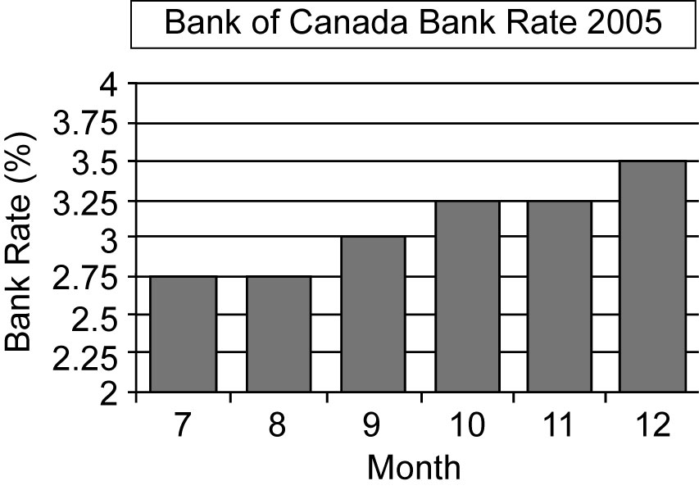
Source: http://www.bankofcanada.ca/en/rates
a) In which month or months was the bank rate the highest? The lowest?
b) What happened to the bank rate between July and December of 2005?

2. Alexis surveyed her class and displayed her results in this bar graph.
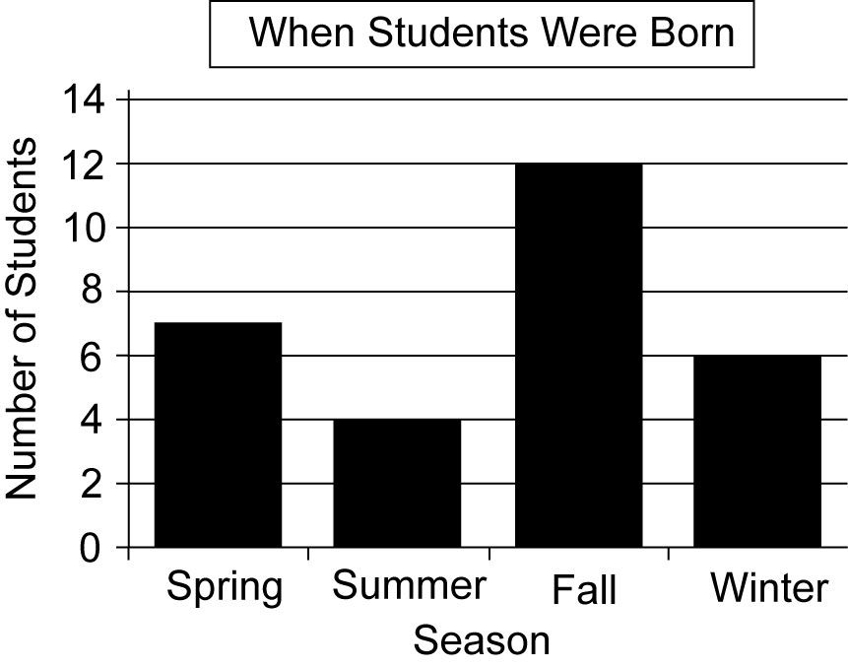
a) During which season were the greatest number of Alexis’s classmates born?
b) How many students are in Alexis’s class?

Scatter Plots
3. A conservation officer recorded the total number of trees that were cut down and the total number of seedlings that were planted each month for one year.
Trees Cut | 25 | 38 | 22 | 27 | 32 | 22
Seedlings Planted | 30 | 38 | 21 | 20 | 26 | 35
Trees Cut | 32 | 32 | 24 | 37 | 18 | 24
Seedlings Planted | 17 | 21 | 17 | 24 | 37 | 27
a) Draw a labelled scatter plot of the data. Put the number of trees cut on the x-axis and the number of seedlings planted on the y-axis.
b) Can you use the scatter plot to estimate the number of seedlings planted if 30 trees are cut? Explain.
4. The table shows the number of goals scored and the number of shots on goal for the top-scoring players on Nancy’s hockey team.
Goals Scored | 15 | 16 | 11 | 8 | 12 | 10 | 11
Shots  on Goal | 91 | 90 | 68 | 50 | 70 | 64 | 65
a) Draw a scatter plot of the data. Put the shots on goal on the x-axis and the number of goals scored on the y-axis. Label the axes and give the graph a title.
b) Suppose a player had 30 shots on goal. How many goals might she have scored?

Rates
5. Find each unit rate.
a) Kristy ran 45 km in 5 h.
b) Laundry detergent costs $24 for
an 8-kg box.
c) Logan can type 440 words in 8 min.
6. Calculate each unit rate.
a) Alexis skated 6000 m in 24 min.
b) Candace paid $8.70 for 3 kg of apples.
c) Colton can read 4 pages in 5 min.

